PRESS RELEASE
Schwaebisch Hall, February 14, 2019

New complete solution for films containing active pharmaceutical ingredients
ICE USA: OPTIMA Life Science introduces COMEDCO and other converting solutions

The COMEDCO production system is just what businesses need in order to start manufacturing, assembling, and packaging transdermal patches (TDS) and oral dispersible films (ODF). It has been developed by two companies, Coatema and Optima Life Science, which have combined their expertise in coating, converting, and services to found the COMEDCO alliance. Optima Life Science will also be showcasing its high-performance, ultra-flexible converting solutions at ICE USA.
The two specialist companies Coatema und Optima Life Science have come together to form the COMEDCO alliance. The COMEDCO system is suitable for use on any scale, from laboratory work to series production of TDS and ODF films. COMEDCO also acts as a development and technology partner for pharmaceutical companies wishing to market TDS and ODF products more efficiently. For example, tests in the companies' own laboratories and their many years of experience have all fed into the selection of the best film carrier materials and suitable application systems. The COMEDCO worldwide service network is already up and running.
In the processing of TDS and ODF products, active ingredients are applied to a carrier film and then dried. After that, the carrier film is cut and wound on to individual rolls. These rolls then move on to a web processing system. Depending on the product, existing carrier films will be removed, new ones applied and films cut to size, separated, and packaged.
The Optima Life Science booth will also provide information about some of the company’s other converting systems. These include, for example, production and packaging systems for modern wound treatment, operating theater, and allergy testing products. The company also makes high-performance systems with a capacity of up to 1200 items/min. and ultra-flexible solutions. Packaging machines for four-side-seal pouches, such as the OPTIMA 4SS, complete Optima Life Science’s range of converting products.
Optima Life Science with COMEDCO at ICE USA in
Louisville (Kentucky): 9-11 April 2019, Exhibition Hall,
booth no. 729

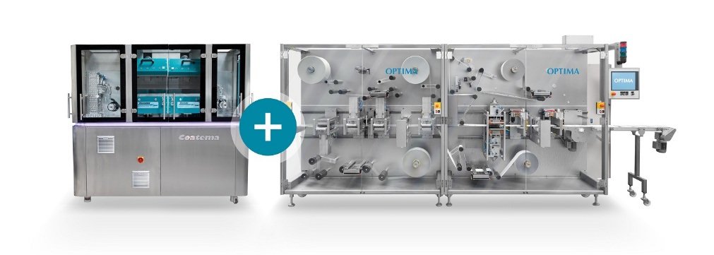

COMEDCO systems cover the entire manufacturing process for ODF and TDP products, including packaging. They are perfect for companies entering this segment.

Characters (incl. spaces): 2,113

Press contact:
OPTIMA packaging group GmbH
Jan Deininger
Editor
+49 (0)791 / 506-1472
jan.deininger@optima-packaging.com
www.optima-packaging.com
Thank you very much for your publication. We look forward to receiving a specimen copy.

