PRESS RELEASE
Schwaebisch Hall, July 9, 2019

Breaking new ground at FachPack
OPTIMA and other experts will discuss the key theme of the trade show: environmentally friendly packaging

Optima is breaking new ground at the 2019 FachPack trade show in Nuremberg. The focus is on exciting discussions about the industry's hot topics: sustainability and digitalization. External experts and partners offer a unique opportunity to engage in roundtable discussions on sustainability and to explore new ideas on the spot. The presentation on the TCAM portal is another highlight of the show. This platform combines all the Smart Services offered by the company to support customers throughout the entire machine life cycle.
At FachPack 2019, the Optima group of companies will be showcased as a provider of solutions to current issues affecting the industry – digitalization and flexible, efficient, safe, and, above all, customized machinery solutions. As the key theme of the trade show – environmentally friendly packaging – is extremely important to Optima, the company has invited along a number of external experts and partners who will be available to answer questions and discuss the topic of sustainability.
Sustainability – an important issue for all companies involved in the value chain
Ulrich Burkart, Director Sales Food Solutions at Optima explained, "Packaging manufacturers, packaging machinery manufacturers, retailers, and experts from a wide variety of sectors all have to pull together when it comes to sustainability." Each of the panel will be the experts on a key theme at the show. For instance, a representative from DSD – Duales System Holding GmbH & Co. KG, which established the “Green Dot” system in 1990, will attend the show. The Green Dot is the first dual system in the world to offer top-quality, consumer-oriented recycling for sales packaging and the company has been using this process ever since. The latest information on the new Packaging Act will also be available. An expert from Siemens will provide information on state-subsidized energy efficiency. The Wipf Group and the Swiss mechanical engineering company, säntis packaging, are experts on packaging materials. Among other topics, säntis packaging will answer questions on a key theme – The delicate balance between coffee capsules and sustainability.
Reduce costs: with sustainable packaging materials and the right machine technology
Burkart explained, “By using the right packaging material and the right machine technology, sustainable packaging offers the opportunity for huge cost reductions so that products can be sold more cheaply.” Optima is fully aware of its responsibilities and has already been working on recyclable and resource-efficient packaging for many years. The company is currently working with partners on areas such as monomaterials and developing packaging materials that are easier to separate so the individual components can be recycled more easily. Energy-saving machine concepts are also part of the discussion.
Round-the-clock service: presentation on the TCAM portal
In terms of digitalization, Optima is presenting the TCAM portal for the first time at FachPack. This platform offers customers round-the-clock access to the company's digital products. These products include documents and manuals, information on spare parts, videos and tutorials, maintenance tools, and the OPAL line management system, which improves the overall plant efficiency of entire production lines. Holger Frey, Team Leader Smart Services at Optima, explained, “Smart Services support our customers from delivery and throughout the entire life cycle of the machinery.” The permanent availability of Smart Services means that agile, digital working on machinery becomes a reality.
Optima at the 2019 FachPack trade show in Nuremberg: September 24 to 26, 2019, Hall 2, joint booth shared with Packaging Valley e.V.; booth number 2-213

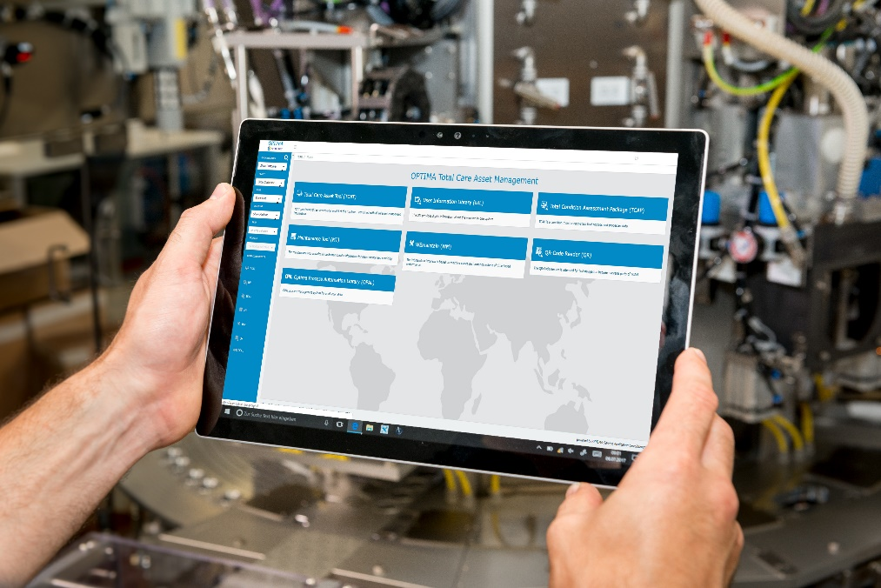Optima's TCAM portal provides access to documents and manuals, information on spare parts, videos and tutorials, maintenance tools, and the OPAL line management software directly at the machine via all possible kinds of output devices.

Characters (incl. spaces): 3,730

Press contact:
OPTIMA packaging group GmbH
Jan Deininger
Editor
+49 (0)791 / 506-1472
jan.deininger@optima-packaging.com
www.optima-packaging.com
Thank you very much for your publication. We look forward to receiving a specimen copy.

