PRESS RELEASE
Schwaebisch Hall, August 13, 2019

Highly flexible packaging solutions for fast-changing markets
OPTIMA at Pack Expo 2019

At Pack Expo, Optima Packaging Group will be presenting highly flexible packaging solutions for food, beverages, cosmetics, and pharmaceutical, chemical and medical products. The company is particularly skilled in developing complex turnkey systems. There will also be Optima experts available to answer questions about the company’s extensive Total Care services.
"Changing markets. Your Needs. Our Passion.", is Optima’s motto for the Pack Expo show. Machine requirements include small batch sizes, rapidly changing products and packaging designs, and individual product combinations. Optima offers a wide range of different filling and dosing methods. For example, paste-like and powdered foods are processed in portion packs similar to coffee packaging. For cosmetics, Optima has machine solutions ranging from mascara sticks and cream jars to bottles with atomizers. Detergents and water filters from the chemical industry are also included in Optima’s portfolio. Optima uses robotics, film, foil and plastic processing, as well as 'cobots' and converting functions, as required. The result is a wide range of flexible machines from entry-level to fully automated, highly efficient lines. Optima’s machine solutions are regarded as leading the field in many areas.
Turnkey solutions are in particularly high demand for pharmaceutical applications. At Pack Expo, Optima will be presenting projects involving the filling, closing of biopharmaceutical drugs, isolator technology, and freeze-drying. The company takes key responsibility for these projects, from the conception of all systems to site management and site acceptance tests (SATs). Optima uses Comprehensive Scientific Process Engineering (CSPE) to reduce time-to-market and optimize processes. Just a few weeks ago, Optima’s CSPE Center was opened in Schwaebisch Hall (Germany). From now on, complete acceptance tests (iFATs) will take place here. Filling and closing machines and isolators are tested and approved in the CSPE Center as a complete functional unit.
Optima's Total Care concept is based on the lifecycle of the machine, starting at the consulting phase and extending to the systems' retrofitting. Total Care also includes Smart Services, these include complex simulations during the project-planning phase, as well as the use of VR technologies for supporting maintenance and repairs. The OPAL line management system enables Optima to offer an additional component for highly efficient, long-term processes. The cross-manufacturer 4.0 industry application comprehensively generates and analyzes production data to systematically unlock productivity potential.
The Multipack Bagger concept from Optima is a machine with a wide range of applications. Whether it's pre-packed food, snacks, pet supplies or toilet paper a multipack bagger can do it. Experts from Optima Packaging Group’s US subsidiary, Optima Machinery Corporation, will be there to provide the Pack Expo visitors with detailed information. The Multipack Bagger was developed in the US and is also manufactured there. Service is also provided out of the Green Bay (Wisconsin) site.
Personal appointments with Optima's sales experts can be arranged under the following link:
www.optima-packaging.com/packexpo-vegas
Optima at Pack Expo, Las Vegas, USA: September 23 to 25, 2019, Stand No. C-1741

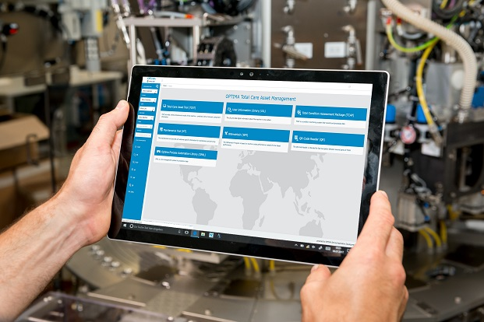
Smart Services from Optima: the TCAM portal provides access to documents and operating instructions, information on spare parts, videos and tutorials, maintenance tools and the line management software, OPAL, directly at the machine.

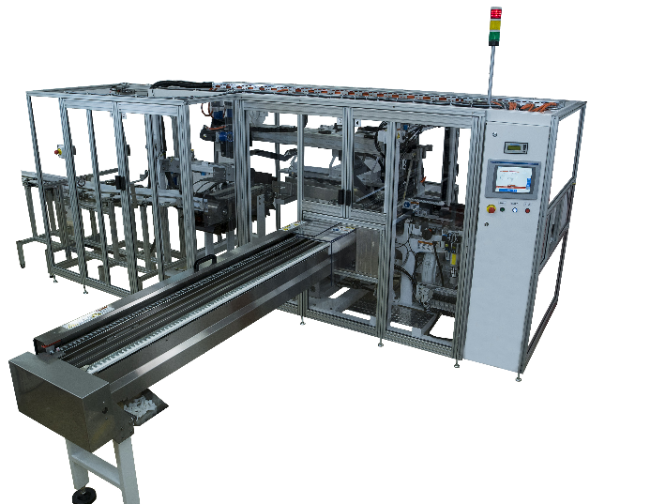

The Multipack Bagger is multi-talented. Optima's machine concept can handle a wide variety of products, from pet food and paper hygiene products to pre-packaged, multi-layer snack foods.

Characters (incl. spaces): 3.344

Press contact:
OPTIMA packaging group GmbH
Jan Deininger
Editor
+49 (0)791 / 506-1472
jan.deininger@optima-packaging.com
www.optima-packaging.com
Thank you very much for your publication. We look forward to receiving a specimen copy.

