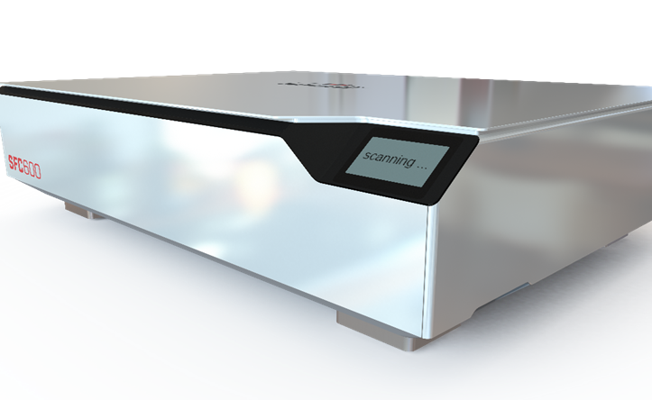

A quantum leap in laser system calibration technology
With the new SCAN FIELD CALIBRATOR high-precision and labour-saving calibration of laser process fields in machines can be carried out in an extremely short space of time

Weßling, Thursday, 11. November 2021: The additional manual laser system setup that is designed to meet challenging requirements and requires a scan field to be calibrated is increasingly reaching its limits. Especially in additive manufacturing and electromobility, conventional manual processes are often too inaccurate and require hours and days of time just to calibrate machine fleets and laser process fields correctly. The new SCAN FIELD CALIBRATOR from RAYLASE is defining a high level of perfection in terms of step, time, and accuracy savings. This new tool guarantees the industry both maximum precision and a maximum calibration process speed at the same time, so it’s proving to be an extremely useful industrial resource.

Lasers have become an indispensable part of modern manufacturing. They provide irreplaceable services in materials processing for cleaning, welding, cutting, structuring, marking and much more besides. One of the biggest requirements when integrating laser processing into a manufacturing process is enabling high precision and high throughput at the same time. This is achieved by several system components such as optical laser beam deflection units. The creation of what is known as a ‘scan field’ is absolutely essential if the machine and laser are to work hand-in-hand and do their job perfectly. This virtual scan field must map as perfect a laser process field as possible on the machine’s workpiece carrier.
Each deflection unit can produce one such F-Theta lens or pre-focusing depending on the optical elements used. The scan field must be calibrated to ensure that the deflection unit’s virtual scan field actually corresponds with the laser process field in the machine at as many points as possible. This is normally done with a digital correction file that is read out by the laser software. However, tolerances in the optical elements mean it may be necessary to perform manual measurements for applications with increased positioning accuracy requirements. This is done using coated plates that are sensitive to laser light to mark the calibration points. The measurement here is performed analogously with a magnifying ruler. When calibrating the scan field in the laser deflection unit in the machine, the calibration pattern must be measured line by line to the centre and to one another, and all the coordinates must be entered manually in the calibration file’s editor.

‘The best possible accuracy that can be achieved manually with a magnifying ruler is around ± 50 µm,’ stressed Wolfgang Lehmann (Product Manager at RAYLASE), before going on to add, ‘but in additive manufacturing, you want to achieve absolute accuracies of 10 – 20 micrometres. This simply cannot be done with manual calibration. So, you have to conduct lots of experiments to find out which position should be set so that the desired result can actually be achieved. This often takes up an immense amount of time and ties up specialists.’ That’s why RAYLASE’s digital scan field calibrator (SFC) offers the perfect solution to precisely solve this problem.
The scan field calibrator pays into the company’s time-saving account
Let’s assume that a car manufacturer wants all its similar laser machines to produce as identical quality as possible for an identical laser task. To do so, it runs 10 machines in parallel to precisely cut its workpieces, and its process fields are 300 x 300 mm². It places an unused, identically sized calibration plate in each of its machines.
Each machine is identified with its computer in a machine domain in the network. The SFC-600 is in the same network domain. It is designed for scan fields measuring up to 600 x 600 mm². Prompted by the SFC, our mechanical engineer now has all the laser machines mark the plates (i.e., laser them with the calibration job). Each calibration plate also receives a QR code. They then remove the ‘labelled’ calibration plates, insert them into the SFC one after the other and have them scanned. The SFC stores the data specific to the laser system. Now, after each scan, they decide whether corrections should be made or whether the deviations are within tolerance. If the user decides to make the correction, the correction is updated both on the control card and in the relevant directory on the local computer. The total time required, including a correction loop for all these steps on 10 machines, is only around 2 – 3 hours with the SFC from RAYLASE. In contrast, if 10 laser systems were to be calibrated manually, the resolution would have to be significantly reduced to typically 5 x 5 and max. 11 x 11 crossing points. Additionally, two passes would be absolutely essential and the parameters of working distance to focal plane and parallelism would also have to be measured mechanically. At least two to three hours per machine should be allowed for this. Conversely, this means two hours with the SFC compared to 20 – 30 hours of difficult manual work that calls for complete concentration.
An impressive improvement in work steps AND precision.
The result of the SFC looks even more impressive in additive manufacturing. Let’s assume here that we have a machine that can work either on four different workpieces with four lasers at the same time or on one workpiece with four beams. ‘Especially for this mode, the customer needs maximum precision and thus regular alignment of the scan fields,’ underlined Mr Lehmann. With a process field of 400 x 400 mm² overlaid by four identical virtual scan fields with corresponding sizes, calibration requires absolute perfection. In other words, the virtual scan fields must be optimally aligned with one another. The SFC runs and is connected in the same way as described above, and this takes no more than 60 minutes for all the calibrations of the aforementioned technical parameters. ‘If the user wanted to do this manually, they would fail because of the required accuracy of 48 x 48 interpolation points,’ stressed Mr Lehmann, before continuing: ‘Even accuracies of 21 x 21 interpolation points would no longer be realistically feasible manually.’
So, in practice, process fields are often lasered onto calibration plates and sent to the machine manufacturers who, with a great deal of effort and using camera-based axis systems, measure the calibration plates and send back correction files.
‘A whole week or more can pass while this is ongoing,’ said Mr Lehmann, underlining the huge amount of time lost when an SFC isn’t used.
Conclusion: The scan field calibrator from RAYLASE is a quantum leap in the laser process field calibration technology used in machine fleets. It provides impressively improved time and precision for increased requirements such as those needed in additive manufacturing and electromobility. Once again, the internationally positioned company RAYLASE from the Greater Munich Area is showing itself to be a reliable partner when it comes to innovative and sensible solutions for industry.

Multi-field calibration

Caption: Four process fields with clear misalignments and rotations
The figure shows four fields (black, red, blue, and green) of four laser units with four deflection units. They must be perfectly aligned with one another so that a common process field – grey in the picture – is created. All four lasers should be able to reach this while all four laser beams are working simultaneously.

About RAYLASE

RAYLASE GmbH is a highly innovative, international laser company based in Wessling near Munich. Founded in 1999, the Bavarian company offers high-precision opto-mechanical components, control cards and software for the rapid deflection and modulation of laser beams for laser material processing in industrial manufacturing. With over 130 employees worldwide, the RAYLASE Group stands for innovative technology of the highest quality. Since 2007, the company has a subsidiary and its own production facility in Shenzhen, China, as well as several international representatives in the US, Italy, Japan, Korea, and Taiwan.

The laser deflection units comprise opto-mechanical scanners and digital control electronics with an intuitive software interface. These form the core of industrial laser systems and enable more flexible, economical, and precise processing of a wide variety of materials such as metal, plastic, paper, textiles and many more. Opto-mechanical deflection units also offer excellent image processing for better calibration, simple automation, and exact monitoring of a range of laser processes.

Customers come from the electronic, automotive, photovoltaic, textile and packaging industries. RAYLASE’s current focus markets are electromobility, for example, in battery production, solar wafer production for photovoltaics in the solar industry and additive manufacturing. RAYLASE supports its customers primarily in four core applications: laser cutting, laser welding, laser surface processing and selective laser sintering or welding for additive manufacturing. In each of these areas, the company drives digital innovations by combining these with established technologies.

