Prestigious Award for Sandeep Sawant

LAUDA Presents the Dr.-Rudolf-Wobser-Medal to Indian Partner

Lauda-Königshofen, April 23, 2026 – LAUDA DR. R. WOBSER GMBH & CO. KG has honored Sandeep Sawant, Managing Director & CEO of Sawant Process Solutions Pvt. Ltd. from Mumbai, with the Dr.-Rudolf-Wobser-Medal. The family company's highest distinction was presented to him at an evening event during analytica 2026 in Munich, in the presence of invited guests. Dr. Gunther Wobser, President & CEO of LAUDA, personally conducted the ceremony.

LAUDA awards the Dr.-Rudolf-Wobser-Medal as its highest honor to individuals who have rendered extraordinary service to the family company. Sandeep Sawant is only the fourth external recipient in the history of this award, which Dr. Gunther Wobser established on the company's 60th anniversary and which has since been presented to a total of 22 individuals. The first two recipients were Dr. Gerhard Wobser, who attended the ceremony, and his brother Karlheinz – the two sons of the company's founder and the award's namesake, Dr. Rudolf Wobser.

The festive evening also provided an opportunity to look back on seven decades of company history: In 2026, LAUDA celebrates its 70th anniversary – from its founding by Dr. Rudolf Wobser in 1956 to its current position as the world market leader for temperature control equipment and systems.

The collaboration between LAUDA and Sawant Process Solutions began in 2009. What started as a classic sales partnership developed over the years into a close personal bond between the Wobser and Sawant families. A decisive turning point came with a visit in November 2023: Dr. Gunther Wobser traveled to India together with his wife at the invitation of Sandeep Sawant and his family – and experienced firsthand the potential that this market and this partnership hold for LAUDA. “Getting to know another culture and connecting with people is an important success factor for a family-run company where people are at the center of everything,” emphasizes Dr. Gunther Wobser.

The highlight of their shared history to date is the joint venture ‘Degree LAUDA Precision Pvt. Ltd.’, established in November 2025 and headquartered in Pune. Sandeep's daughter Devaki Sawant serves as a director of the joint company alongside Marco Hauser and Dr. Gunther Wobser. Devaki Sawant was also present at the award ceremony in Munich – a visible sign of the cross-generational dimension of this partnership.

Dr. Gunther Wobser underscored the significance of this relationship in his laudation: “What began as a sales partnership is today a bond built on mutual trust and genuine personal connection – one that LAUDA honors in the highest possible way with the Dr.-Rudolf-Wobser-Medal.”

LAUDA looks forward with confidence to the continued development of the joint company Degree LAUDA Precision and the partnership with Sawant Process Solutions in the high-growth Indian market.
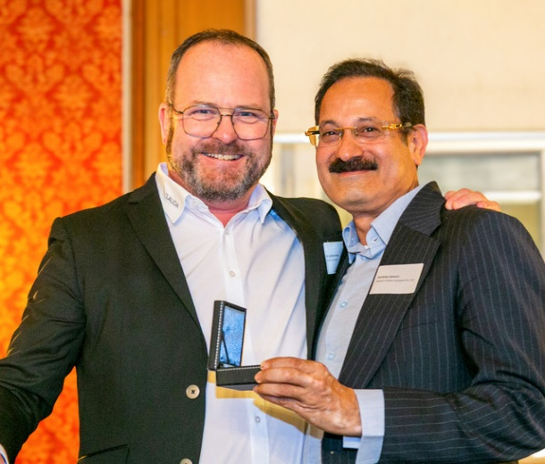

Picture 1: Dr. Gunther Wobser (left), President & CEO of LAUDA, presented the Dr.-Rudolf-Wobser-Medal to Sandeep Sawant, Managing Director & CEO of Sawant Process Solutions. © Jürgen Besserer

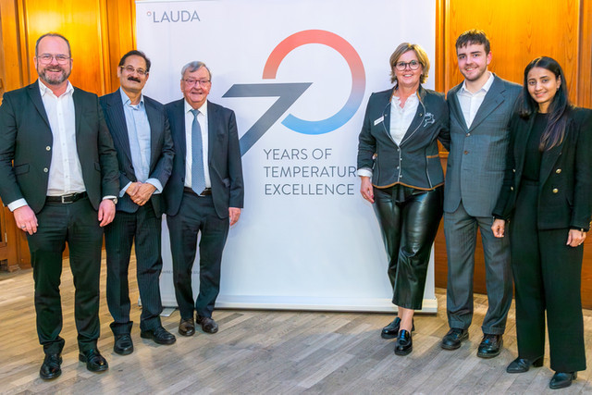

Picture 2: A sign of deep connection: (from left) Dr. Gunther Wobser, President & CEO of LAUDA, Sandeep Sawant, Managing Director & CEO of Sawant Process Solutions, Dr. Gerhard Wobser, Shareholder and Advisory Board Member of LAUDA, Manuela Wobser, Magnus Wobser, and Devaki Sawant, celebrating the award together on analytica 2026 in Munich. The photo brings together two entrepreneurial families who have maintained a close business and personal relationship since 2009. © Jürgen Besserer

We are LAUDA – the world leader in precise temperature control. Our constant temperature equipment and systems are at the heart of important applications, contributing to a better future. As a complete one-stop supplier, we guarantee the optimum temperature in research, production and quality control. We are the reliable partner for Aerospace, Electromobility, Hydrogen, Chemistry, Pharmaceuticals/Biotech, Semiconductors and Medtech. We have been inspiring our customers for over 70 years with our expert mentoring and innovative solutions – every day anew and all over the world.

In our company, we always go one step further. We support our employees’ development and are constantly developing ourselves: to create a better future together.

Press contact
We are more than happy to make prepared information about our company, the LAUDA Factory Gallery and our projects in the area of innovation promotion, digitalization and idea management available to the press. We look forward to hearing from you – just give us a call!

CHRISTOPH MUHR
Director Corporate Communications
T + 49 (0) 9343 503-349
christoph.muhr@lauda.de

LAUDA DR. R. WOBSER GMBH & CO. KG, Laudaplatz 1, 97922 Lauda-Königshofen, Deutschland/Germany. Limited partnership: Headquarters Lauda-Königshofen, Registration court Mannheim HRA 560069. General partner: LAUDA DR. R. WOBSER Verwaltungs-GmbH, Headquarters Lauda-Königshofen, Registration court Mannheim HRB 560226. Managing Directors: Dr. Gunther Wobser (President & CEO), Dr. Mario Englert (CFO), Dr. Marc Stricker (COO)

