Press release
Schwaebisch Hall, April 5, 2018

OPTIMA Schwäbisch Hall continues its success story
Expansion and interesting careers
The OPTIMA packaging group GmbH (Schwäbisch Hall) increased their revenue to 350 Mio. Euro in 2017. This is the highest revenue in the company’s history. 85 percent of the revenue was attained abroad. Optima employs more than 2,250 people worldwide – 100 more than in 2016. An increase in digital services and software related services is evident. Optima is expanding in this field and is offering many interesting career opportunities. The company invested in many locations and will expand further in 2018.
“We are on a very high revenue level for several years now”, Hans Bühler (CEO) states. “This is another reason to be happy about the increase in 2017”, Hans Bühler says. The majority of the employees are working at the headquarters in Schwäbisch Hall where the number increased to 1,650 in 2017.
Approximately 50 Mio. Euros are scheduled to be invested in construction projects over the next several years. The company is currently building a central logistics center in Schwäbisch Hall. “This will make the intercompany processes much more efficient and it will reduce the inner-city logistics between the different company locations in Schwäbisch Hall by about two-thirds,” Hans Bühler explains. The building is scheduled to be completed by the end of 2018 and will have about 6,000 square meters of space. Additional buildings are in the planning stage, amongst them are buildings for the central administration and additional offices and an assembly area for Optima Pharma. The subsidiary Metall+Plastic (Radolfzell-Stahringen) will also expand. Already completed is the expansion at the U.S. subsidiary in Green Bay, Wisconsin – here 1,200 square meters of space were inaugurated in September of 2017.
Digital: From development to service
“OptimaTotal Care” was introduced at the Interpack show, the leading trade show for the packaging industry, in 2017. This extensive service portfolio offers efficiency and safety for the lifecycle of the Optima equipment and will be developed further.
Digital technology is an important part of Total Care, for example: machine operators will be trained right after the design of the machine is completed. The machines can be displayed in detail in 3D at the Packaging Valley Virtual Reality Center in Germany. The operators learn when to use which command at the HMI (Human Machine Interface) or what has to be considered during the disassembly and installation of spare parts. Functions like the collision test ensure the safety. The training with virtual reality technologies supports a quick and smooth transfer into the production process.
OPTIMA TCAM is another tool that shows the trend to digital based services. The smart sensors continuously monitor the equipment and issue warnings automatically before any damage can occur. TCAM also supports service assignments using videos, 3D-displays and data glasses such as the Hololens from Microsoft.
The Optima OPAL software solution is the bridge between electronic business data (electronic resource planning systems like SAP) and production data. Therefore, users are able to organize complex production processes better and more safely.

The development of customer specific machinery at Optima is shaped by digital technology like e.g. simulations. This technology offers the calculation, presentation and optimization for e.g. flow patterns before the assembly of the machine.
Highly flexible and turnkey technologies are the future
The international trade show Achema in June of 2018 is an important event. During this leading trade show for the pharmaceutical industry Optima will seize the attention of the visitors with new technologies and processes. Solutions for the efficient processing of small batches with the highest pharmaceutical safety requirements are only one highlight. In addition, Optima will present itself as one of the leading turnkey manufacturers with combined solutions for pharmaceutical filling and closing machines, isolators and lyophilizing equipment.
Turnkey projects are also gaining more importance in other industries. For example, Optima delivers fully automatic, complete lines for state-of-the-art medical dressings, single-pack coffee packages or the cosmetic industry. From primary packaging to the ready-to-ship palette, turnkey projects cover all required tasks. Optima takes on the central responsibility from planner and manufacturer to service provider for the customer.
Well off for the future
Gerhard Breu (since July 2017) and Joachim Dittrich (since February 2018) enhance the Optima management team as fully authorized representatives. Gerhard Breu is responsible for the Optima Pharma division and Joachim Dittrich in charge of Optima Consumer and several holdings. Their responsibilities include the strategic development and additional internationalization of divisions and holdings at home and abroad. These and additional expertly filled managerial positions ensure the future success of Optima.
Optima relies on vocational training for their prospective human resource policy. Currently, more than 150 trainees are working at Optima, the majority at the Schwaebisch Hall location. Optima reinforces the significance of MINT-fields (mathematics, information technology, natural sciences and technology) by cooperating with schools and actively supporting robotic workgroups. In 2017, Optima was again an exhibitor in several career fairs and joined events like the “Trainee Night” where more than 500 interested young professionals came to the Optima training center in September.
Several certificates emphasize the activities of the company, e.g. the hallmark “Top Employer” or “berufundfamilie” (career and family) – one example was that Optima offered a “holiday camp” for children of the employees in 2017. The company also scores with extensive advanced training, including MBA certification.
Beyond the company borders Optima supports social objectives and institutions on a local, national and international level. During the traditional “family day” in the previous year, employees and family members had the opportunity to participate in the Optima Olympic Games. Employees collected points that were later traded to Euros by Optima. Therefore, 10,000 Euros were given to the DKMS (German Bone Marrow Donation Center). And at the end of the year a donation was presented to the international organization “Doctors Without Borders”.

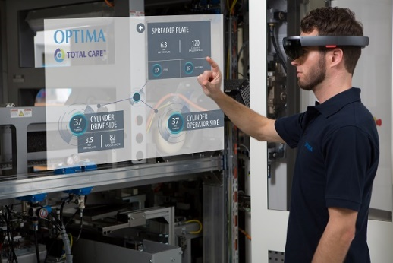
Digital service support from Optima: Quick and easy access to important information, i.e. video manuals or technical data.

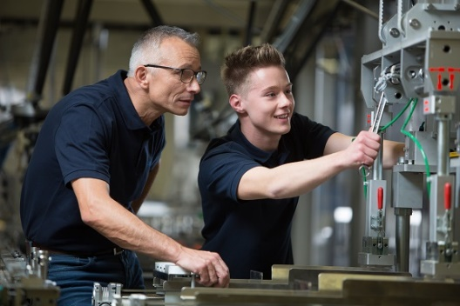
Training is an important tradition at Optima. Currently 150 apprentices are in Optima’s training programs.

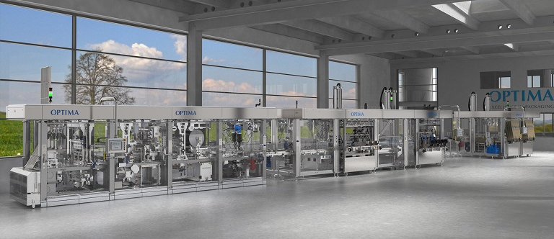
The requests for turnkey lines are increasing. Optima’s turnkey lines fill precisely weighed coffee into single packs and seal them. The machine also places the single packs into a sales package and subsequently into cartons ready-to ship.

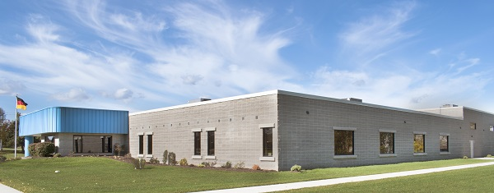
Optima is investing approximately 50 Mio. Euro throughout several years in construction projects. The largest part is in Germany at the Schwaebisch Hall location. In 2017, an extension of the subsidiary in Green Bay (USA) with 1,200 square meters was completed.

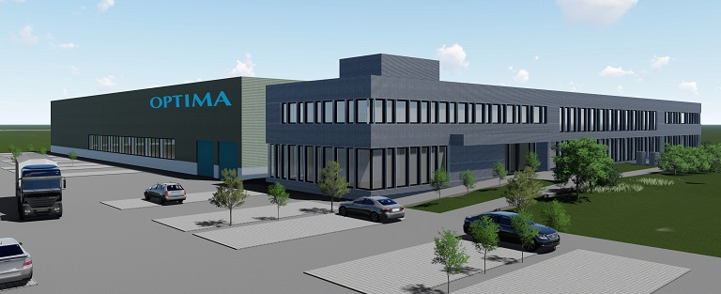
The new Optima logistics center in Schwaebisch Hall has a scheduled move-in date of the end of 2018. The logistics between Optima facilities will be reduced by two-thirds.

Characters (incl. spaces): 6,496

Contact:
OPTIMA packaging group GmbH
Sabine Gauger
Marketing Director
sabine.gauger@optima-packaging.com
www.optima-packaging.com
Thank you very much for your publication. We look forward to receiving a specimen copy.

