PRESS RELEASE
Schwaebisch Hall, October 31, 2018

OPTIMA consumer at all4pack 2018

Packaging Solutions for New Market Trends
Changing Markets. Your Needs. Our Passion. This is the motto under which Optima will be presenting itself at the all4pack trade show in Paris. Markets are moving increasingly dynamically. Growing cost pressure, shorter and shorter time-to-market, increasingly complex packaging processes and digitalization are the challenges faced by the industry. At the all4pack trade show, the experts from Optima will be informing about flexible solutions for the individual needs of customers.

With InlineCans and SoftCans and the "matching" packaging technology, Optima Consumer and its partners have rethought and implemented strong packaging solutions. Visitors at Optima Consumer’s booth will discover the benefits for users in various topic areas. In addition, portion packs, for which Optima Consumer also offers leading machines, are still a big trend.

Furthermore, Optima Consumer will be providing information on the entire range of products for the food, chemical and cosmetic industries, which includes stand-alone machines, turnkey lines and the Total Care service. One of the industry leading solution is, for example, the MODULINE, a true multi-talent packaging machine. The machine concept stands for flexibility like no other: fast format changes, large format ranges, processes that can be expanded and modified via plug & play, as well as many special functions are the basis for success. It is available for powdery and liquid products.

Optima is focusing its services on a new level: Total Care services from Optima support production efficiency optimally in each phase of the plant life cycle. The Total Care program contains several digital products and will be also presented at all4pack.

Optima Consumer at all4pack (Paris, France):
November 26 – 29, 2018: Booth No. 6 N 013

Characters (incl. blanks): 1,756
Contact:
OPTIMA packaging group GmbH
Jan Deininger
Editor
+49 (0)791 / 506-1472
jan.deininger@optima-packaging.com
www.optima-packaging.com

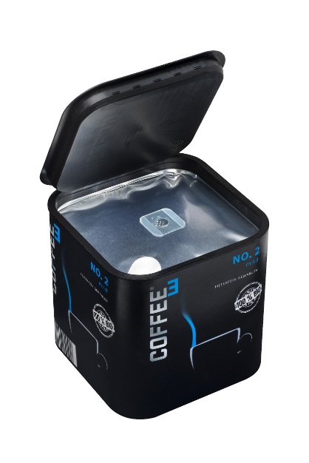
Thank you very much for your publication. We look forward to receiving a copy.

A new approach: InlineCans are produced, filled and closed inline. The marketing potential and reduced logistic costs are two of its main advantages. Optima delivers the machine solution.

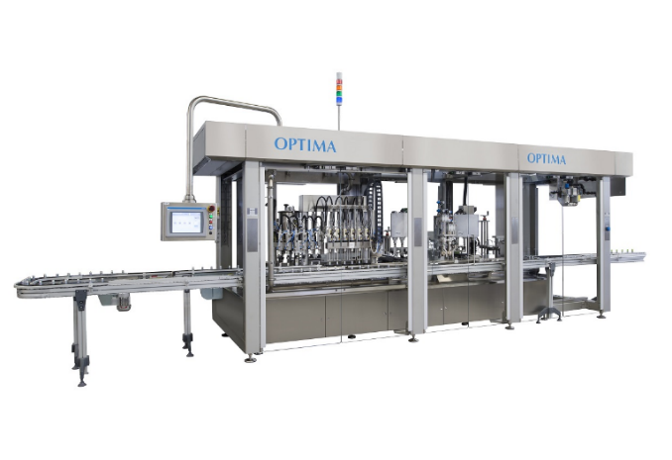

The OPTIMA MODULINE is a very flexible machine type. Liquid and dry products can be processed; various kinds of special functions are available.

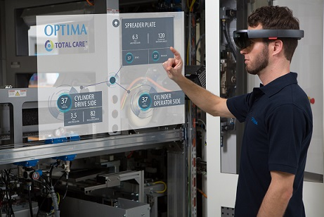

Material such as videos, information on components, operating manuals, circuit diagrams and much more is available directly at the systems via mixed-reality glasses.

