PRESS RELEASE
Schwaebisch Hall, March 08, 2023

“Where best partners meet”:
OPTIMA pharma at Interpack 2023
As a strategic innovation partner, OPTIMA will be showcasing its future-oriented technology portfolio, sophisticated processes and digital solutions for filling pharmaceutical products: The highlight of the trade show appearance will be the new OPTIMA FillCell filling and closing system for cell and gene therapeutics

From May 4 to 10, Düsseldorf will again become the international center for the packaging industry. As a strategic innovation and turnkey partner, the filling specialist Optima Pharma will be showcasing highly innovative technologies, processes and services. With one goal in mind: providing existing and new partners from the pharmaceutical and biotech industries valuable incentives for reaching their respective business and sustainability targets. A strong team of experts will provide live demonstrations on numerous exhibits of the opportunities that working with Optima can bring. Technology, service and sustainability topics will be further explored in the new, exclusive Expert Zone.
Quickly changing market requirements, ambitious sustainability goals, rising prices: Packaging and filling companies are facing growing challenges. As a responsible partner, Optima sees as its most important task demonstrating ways that can ensure success even in times of rapid change.
Maximum efficiency and productivity are essential along with compelling answers in the areas of the circular economy, resource conservation, digital technologies and product safety. Optima is ideally positioned for all of these issues, which are also the focal points of Interpack 2023. "As a strategic partner, we are working together with our customers to address these challenges and develop the right solutions," says Gerhard Breu, Chairman of the Optima Pharma Division. Visitors to Interpack will be able to see this for themselves with the help of exciting exhibits and cutting-edge technologies in the three main topics selected by Optima: technology, service and sustainability. "We're presenting a pioneering filling system for cell and gene therapeutic applications as well as customized service solutions – and we're showing our customers how to become game changers in sustainability," says Breu.

A new system for producing and filling cell and gene therapeutics: OPTIMA FillCell

The new, particularly flexible and modular OPTIMA FillCell has what it takes to make a lasting impact on the market. The system can fill valuable cell and gene therapeutics with maximum product yield. This includes viral vectors in particular. The costly medicines are seen as a beacon of hope in the fight against previously incurable diseases. A transport system without format change parts provides flexible, gentle and safe handling. Numerous digital features increase product and process safety, including, for example, camera systems for monitoring the machine interior and scanning systems for safe changing of format parts. This provides operators with optimum support and maximizes system availability.

Produce more safely and efficiently with digital technologies

Optima Pharma will also demonstrate a range of digital technologies in the Expert Zone. Trade show visitors will get a close look at how digital technologies can increase safety in pharmaceutical production. As a turnkey provider, Optima Pharma offers systems such as the OPTIMA FillCell in combination with an isolator. With the holistic CSPE approach for a short time to market, the systems are fully tested under production-like conditions in one of Optima Pharma's two CSPE Centers. This allows the systems to be up and running and qualified at the customer's site significantly faster. In addition to turnkey competence, the focus is on decontamination technologies, machine solutions for processing different container types and batch sizes, future-proof and more sustainable freeze-drying processes as well as system concepts for filling high-potency products. Visitors can thus get a comprehensive look into all these topics relevant to pharmaceutical production.

One partner for the entire system life cycle

Comprehensive and individualized service is becoming increasingly important from the customer's perspective. "We're on our partner's side, from the very beginning and over the entire service life of the systems," confirms Holger Burgermeister, Director Service at Optima Pharma. The comprehensive OPTIMA Total Care service program satisfies every customer need. With a worldwide service network, Optima oversees its customers' systems over the entire life cycle. The Lifetime Production Readiness approach provides customers with a customized service package that optimally combines conventional services with market-leading digital solutions. At Interpack, customers and others who are interested can dive into the fascinating world of services and discover the potential for improving production processes and the state-of-the-art options available for training employees.

Innovative leap for sustainable total solutions

Efficiency and reliable processes are important success factors in production. But they are by no means the only ones. After all, climate change and the energy crisis are drastically changing the rules of the game in the industry. That's exactly why Optima wants to make its partners game changers in sustainability and is developing sustainable total solutions for machines and packaging together with selected partners. With the help of its exhibits, Optima will demonstrate how to calculate, reduce and possibly compensate for a product carbon footprint and how it is making its own contributions to reducing material, energy and media consumption in the development and utilization phases of machines. In 2022, Optima was awarded the EcoVadis silver medal. The company is also working systematically on additional emission reduction goals using the approach of the Science Based Targets Initiative (SBTi).

Optima's major appearance at the leading trade show Interpack 2023: For Gerhard Breu, it's clearly "an excellent opportunity to get up to date quickly and concisely on the latest technologies and trends, as well as move into the future together as best partners with new energy."

Optima at Interpack 2023 (Düsseldorf), May 4 - 10, 2023: Hall 16, booth no. F54 and F55
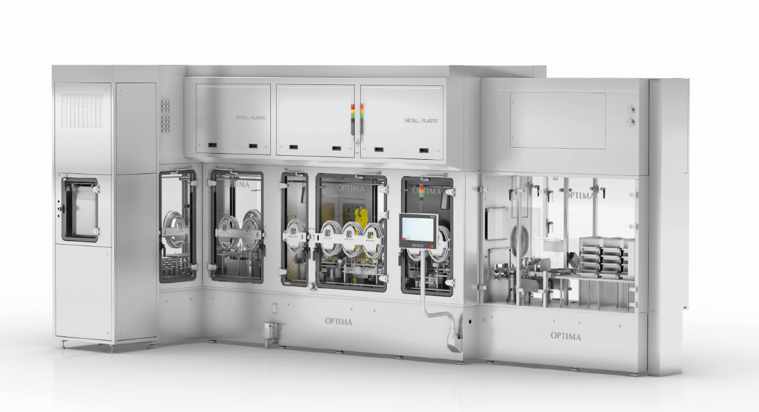
The flexible and modular OPTIMA FillCell can fill valuable cell and gene therapeutics with maximum product yield. (Source: Optima)

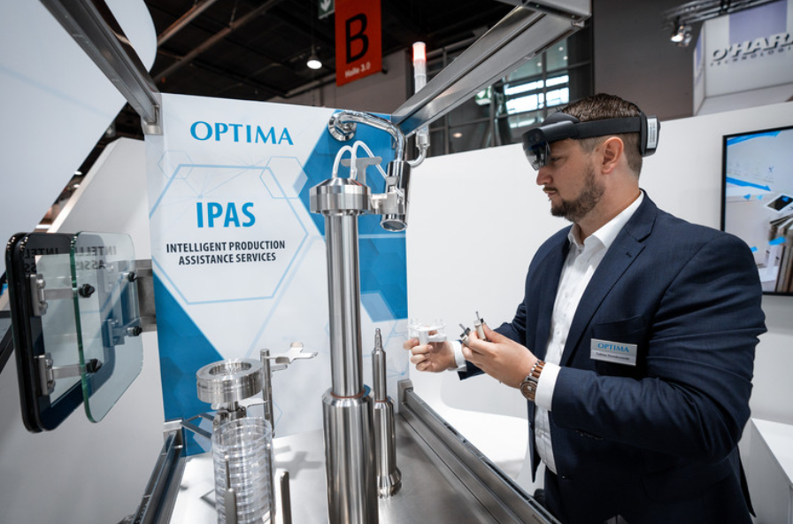
In the Expert Zone, trade show visitors will get a close look at how digital technologies increase safety in pharmaceutical production. (Source: Optima)

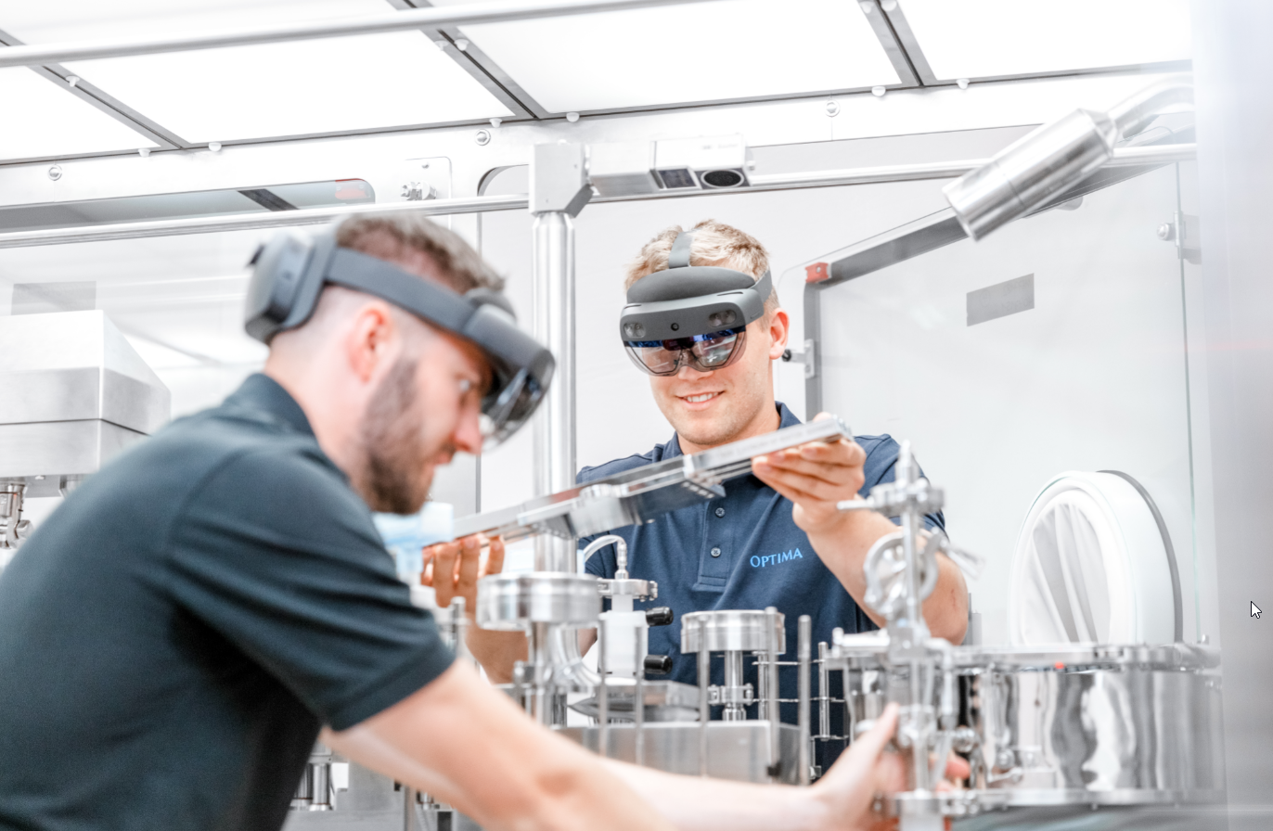
Augmented reality applications are an important tool in pharmaceutical production. Machine operators are guided step by step through format changes. As a result, the risk for machine downtimes drops and machine availability increases. Therefore, production losses are reduced to a minimum. (Source: Optima)

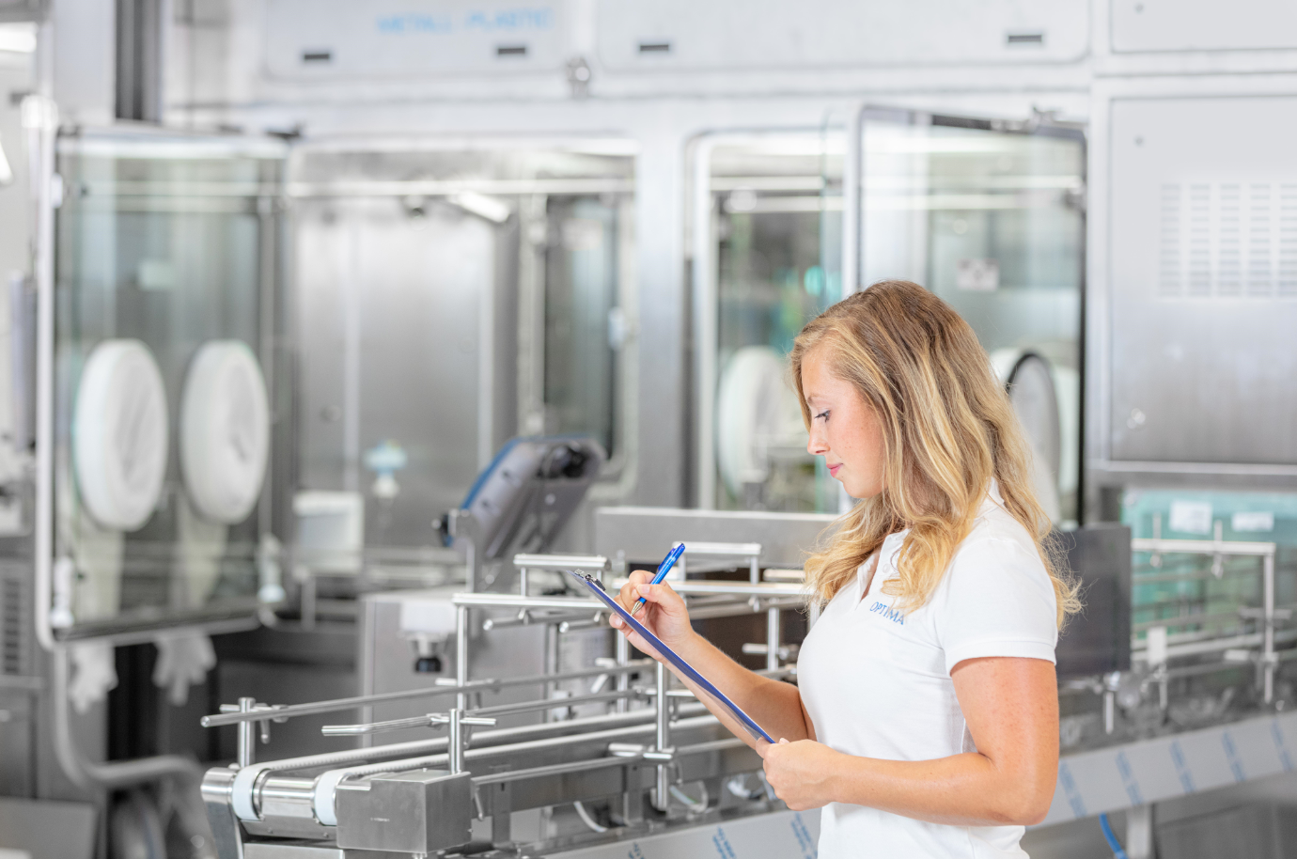
Optima Pharma is now able to carry out even more comprehensive qualification measures in-house as part of the enhanced CSPE approach. This further reduces the time between installation and the start of production at the customer's site. (Source: Optima)

Characters (incl. spaces): 6,336

Press contact:
OPTIMA packaging group GmbH
Jan Deininger
Group Communications Manager
+49 (0)791 / 506-1472
pr-group@optima-packaging.com
www.optima-packaging.com

About OPTIMA
Optima supports companies worldwide with flexible and customer-specific filling and packaging machines for pharmaceuticals, consumer goods, paper hygiene and medical devices markets. As a provider of solutions and systems, Optima accompanies these companies from the product idea through to successful production and throughout the entire machine life cycle. Over 3,000 experts around the globe contribute to Optima's success. 20 locations in Germany and abroad ensure the worldwide availability of services.

Thank you very much for your publication. We look forward to receiving a digital specimen copy.

