PRESS RELEASE
Schwaebisch Hall, April 12, 2021

Annual Report 2020/2021

OPTIMA continues its growth curve
In 2020, the Optima Group reports record figures
for sales and staff numbers

The Optima Group closed the 2020 financial year with record figures. The consolidated revenue stood at over €420 million. The workforce increased to over 2,650 last year – also a record figure. To allow the Optima Group to continue to grow, construction work is scheduled for 2021 at the headquarters in Schwaebisch Hall, Germany. The workforce is also expected to grow even larger.
Optima can look back on a successful financial year 2020, despite the ongoing challenges posed by the COVID-19 pandemic. "We are continuing to grow and we have a high backlog of orders," reports Hans Buehler, Managing Director/CEO of the Optima Group. The majority of the revenue is generated abroad, with exports accounting for over 85 percent. There are over 2,650 employees working for Optima worldwide, with over 2,300 in Germany and over 1,850 in Schwaebisch Hall. Even during the pandemic, Optima is training an above-average number of young people. Over seven percent of the workforce (over 190) are apprentices and students. "Thanks to the encouraging business conditions, we can offer our apprentices and students a good future, and our employees around the world have secure, exciting jobs, and we are constantly on the lookout for skilled professionals worldwide to enable us to continue to expand," says Buehler. The pandemic has affected Optima's operations as well, but the flexibility and adaptability of the staff has enabled the company to make it through the crisis unscathed. Optima is fulfilling its duty of care as an employer in a specific way during the pandemic. The measures taken to protect staff have always been much more thorough-going than those imposed by the authorities. This has been confirmed by the Schwaebisch Hall County Health Department. A Group company agreement that has been in place since 1 January 2020 means all members of staff can work remotely if there are no operational reasons against it. Active use was made of this.
The pandemic is creating momentum in numerous market segments
The pandemic is resulting in high utilization of capacity, especially in the pharmaceutical sector. Alongside filling and closing systems for vaccines, therapeutics and diagnostic test kits, Optima is also supplying systems for manufacturing masks and filters. Since the start of the pandemic, existing systems have been adapted as rapidly as possible for vaccine filling, and new systems have been built, with high levels of commitment from staff. This is how Optima is contributing to increasing vaccine filling capacity as quickly as possible, so making a significant contribution to tackling the COVID-19 pandemic. Virtual machine acceptances and numerous digital services means that Optima can ensure that systems are delivered on time, and is able to provide customers with the best possible support. In other market segments too, strong shifts in demand caused by the pandemic are positively impacting Optima's business. Optima Consumer also has a high backlog of orders. This is where filling and packaging machines for consumer goods are produced.

Construction work at the headquarters in Schwaebisch Hall
In 2021, Optima is investing in its headquarters in Schwaebisch Hall in order to be able to process the high backlog of orders. In the course of the year, an assembly hall, similar to the existing CSPE Center, will be built in Schwaebisch Hall-Hessental. It should be possible to move in by the end of the year. The new construction is a major investment in the future, because orders that were pushed back in the wake of the pandemic are anticipated for 2022.
Two new subsidiaries: Senning and Emkon
Since October 2020, Senning GmbH has been a part of the Optima Group. The Bremen-based company specializes in the production and packaging of paper and tissue products. "The production and packaging technology for paper handkerchiefs and napkins developed by Senning constitutes the perfect expansion for our product portfolio," says Buehler. Optima has already successfully implemented machine projects for the paper and tissue sector. Through integration and associated synergy effects, Optima is strengthening its market position for turnkey solutions. In doing so, Optima has gained 47 new employees.
In August of last year, EMKON automation GmbH became part of the Optima Group. There are 50 people employed by the company from Kirchlinteln (in the district of Verden in Lower Saxony). Among other things, Emkon manufactures packaging machines for the food and beverage, cosmetics and hygiene sectors. The technologically driven company with a high degree of digitalization reinforces Optima's market position in turnkey solutions. Over the past twenty years, Emkon has been steadily expanding its portfolio and market presence, delivering both stand-alone machines and turnkey solutions. "We are excited about the company's growth due to the addition of Senning and Emkon and look forward to working on joint projects," says Buehler.
Award-winning innovations: OPTIMA EGS and Remote Assist
In 2021, Optima will continue to focus on the issues of Flexibility, Safety, Digitalization and Sustainability, and will live up to its claim of being a leader in technology. In the coming year, Optima will be continuing to expand its business in the areas of Sustainability and Digitalization in particular. In 2020, with the newly developed OPTIMA EGS, a new milestone was established in terms of production reliability. Baby milk powder producers now have at their disposal a safe, efficient and resource-efficient machine solution. Following its successful market launch at the end of 2020, in February 2021 the machine was already awarded the most prestigious innovation prize in the field of international food technology – the International FoodTec Award – by the German Agricultural Society (DLG).
The continuing digitalization of the company has not gone unnoticed in professional circles either. On-site service assignments have become more difficult due to the pandemic and machines have to be set up or serviced. With the "Remote Assist" software solution, Optima has found the right solution for the current situation. The Annual Multimedia Award's expert jury also thinks so. The support software was awarded the Silver Award in the category "Best Use of Creative Technology/Digital Services". Optima's software experts developed the application in collaboration with a digital agency. The software simply, quickly and securely establishes an audio and video link between the customer and Optima Support. It also features a chat function, a practical drawing function and the ability to send data. The intuitive application is complemented by encrypted communication and external hosting. More and more digital technology is also being used in Optima's machines. This increases process reliability and provides support for the operating staff.
The effect of the pandemic as a driver for greater digitalization
What the pandemic shows most clearly is that the investment in Optima's ongoing digitalization was the right call. This meant that the basic conditions were in place for staying in touch with customers and employees in the best way possible during the pandemic and for enabling remote working. The pandemic has improved acceptance of digital technology and new ways of working. Optima's Basic and Smart Services support its customers throughout the machine's entire lifecycle. The Digital Innovation Center is demonstrating its worth, providing digital communication formats that can complement or even replace on-site visits. The OPTIMA Total Care life-cycle management program is completed by virtual factory acceptance tests. Digital products and communication formats are now and will continue to be an important add-on for Optima if they bring benefits to customers, as well as reducing travel costs and carbon emissions. Of course, personal contact cannot always be replaced, especially when it comes to the assembly, delivery and commissioning of machines, as well as any service calls that may be necessary.
The sustainability strategy is having an impact
Optima 2021 is continuing to focus specifically on the issue of sustainability. As a family-owned company, Optima is particularly committed to environmentally friendly, fair and successful long-term business operations. More than ever, packaging issues need to be reconciled with social responsibility, without compromising on design and the protection of products. The Sustainability Department was set up in 2020 to successfully drive forward the first projects under the central slogan of "Circular Packaging". A major step in the development of long-term, sustainable and honest packaging solutions has been achieved thanks to a development partnership with a paper machine manufacturer. Cooperation along the entire value chain is needed to develop optimized packaging. In another project involving two partners, Optima has developed the GreenLution sustainable capsule system. It involves a capsule that is fully recyclable and a corresponding resource-efficient packaging system. This development means that Optima and the partner companies are promoting a sustainable closed-loop system from production and use through to recycling of the packaging.
Certifications and successful customer projects bear witness to the success of the sustainability strategy. The company's machines can be flexibly adapted to suit a variety of packaging materials. 100% paper packaging, packaging made of recycled plastic, biologically-based and biodegradable plastics are already used in Optima systems today. Optima's subsidiaries are also providing appropriate solutions. In addition to the packaging, the focus is also on the machine. The efficient use of materials, optimal utilization of packaging materials, greater output from a smaller footprint and reduced energy consumption are all essential.
Social responsibility: We care for people
In 2020, Optima remained true to its corporate credo "We care for people," especially during the pandemic. Alongside comprehensive safeguards for staff, the company has also continued its social commitment. For the third time, Optima employees participated in the "Christmas in a Shoebox" charity campaign. Optima fulfills its social responsibility by making donations to social organizations like Doctors Without Borders and through the sponsorship of a range of cultural and sporting events. With a view to offering candidates for the Baden-Wuerttemberg state parliament elections the opportunity to exchange views, even during the pandemic, and to support democratic decision-making procedures, Optima engaged in a virtual dialogue with candidates from the SPD (German Socialist Party), Buendnis 90/Die Gruenen (Alliance 90/The Greens), CDU (Christian Democratic Union) and FDP (Free Democratic Party). In these difficult times, it is particularly important for the company to promote social participation and cohesion and to reinforce democracy.
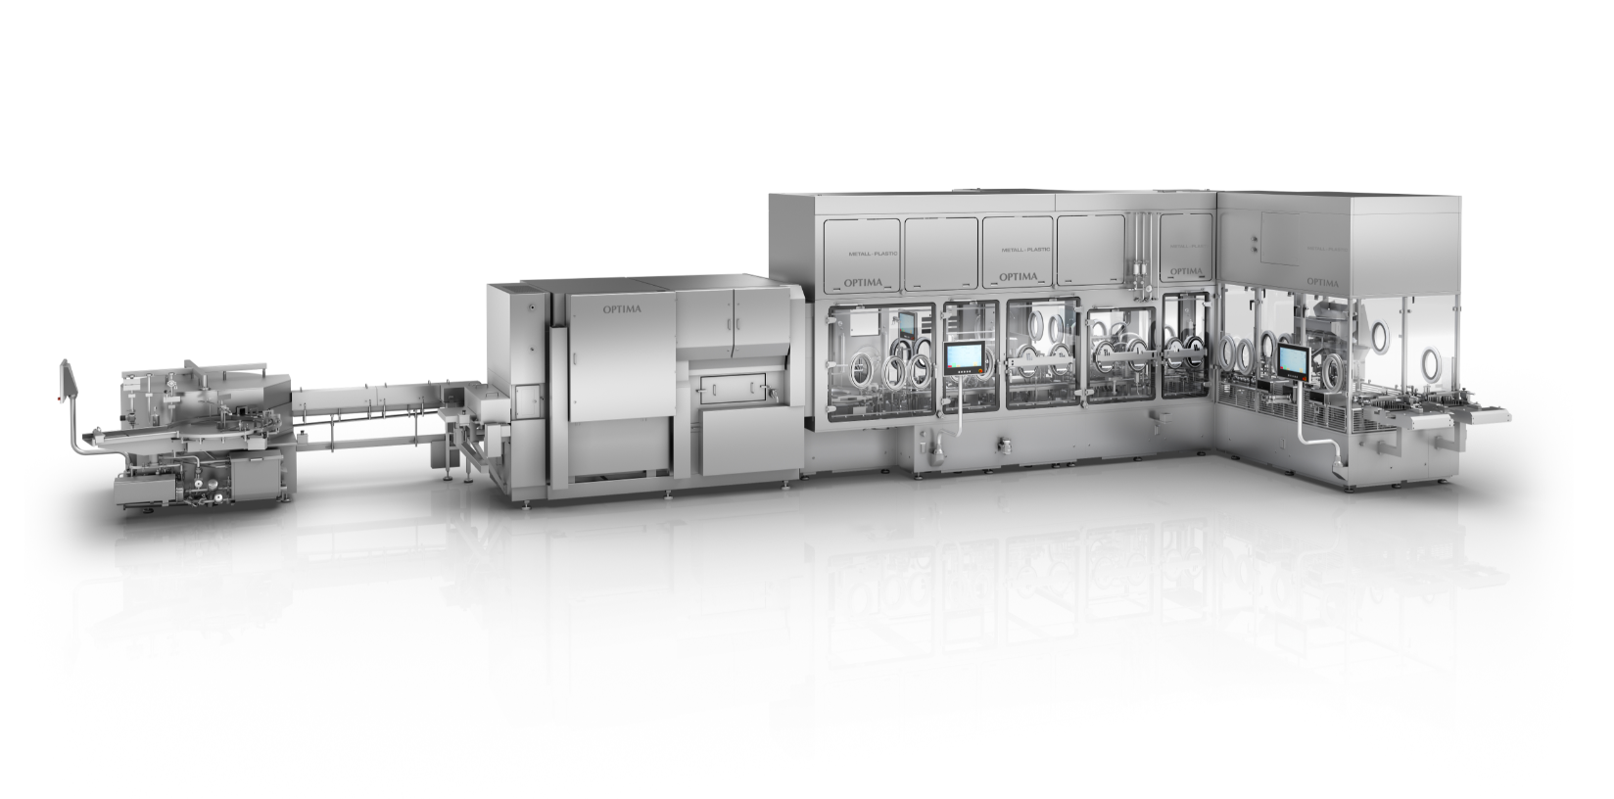
Optima has worked with numerous pharmaceutical companies to modify filling and closing systems under construction and design new ones in record time. Optima Pharma's vaccine filling and closing lines are capable of washing, sterilizing, filling, and closing vials under an isolator. (Source: Optima)

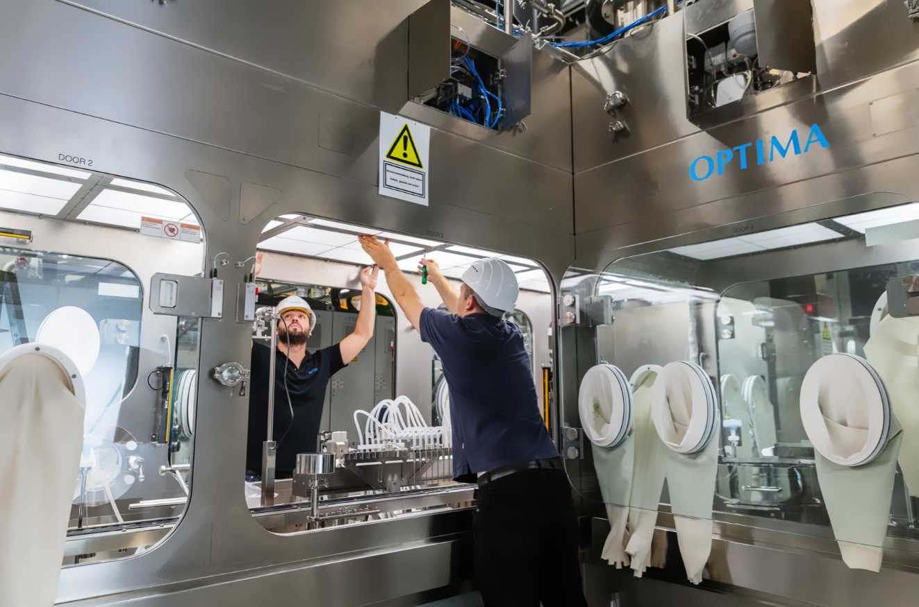
At Optima Pharma in Schwaebisch Hall, the system components – consisting of filling and closing equipment and isolator – come together and are commissioned under real-life conditions. This means a considerable time saving before production starts on the customer's premises. (Source: Optima).

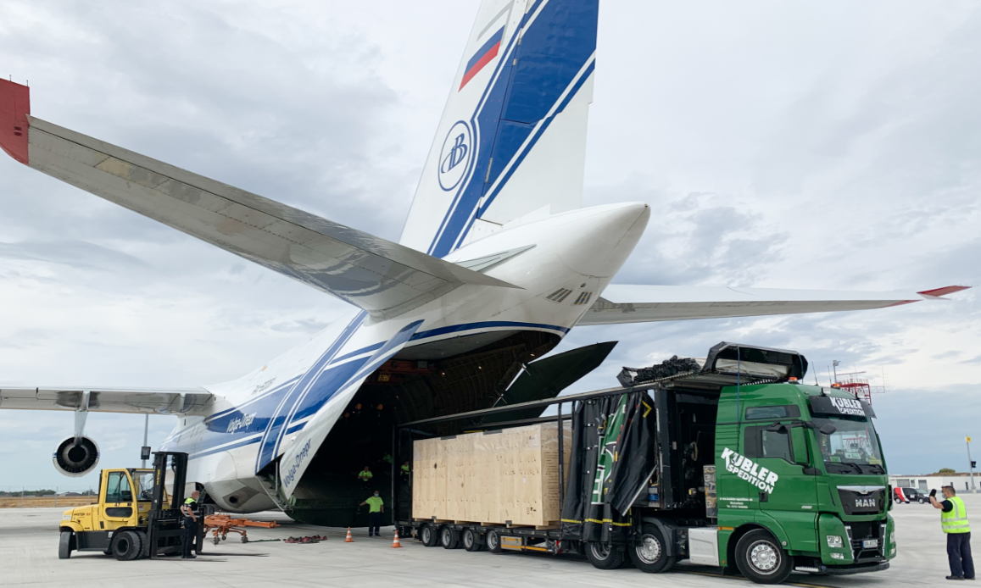
Optima pulled out all the stops to deliver filling systems for COVID-19 vaccines – for example, shipping to Bloomington, the biologics site of the US company Catalent. For the first time in company history, Optima chartered one of the world's largest cargo aircraft – the Antonov An-124. (Source: Spedition Kuebler)

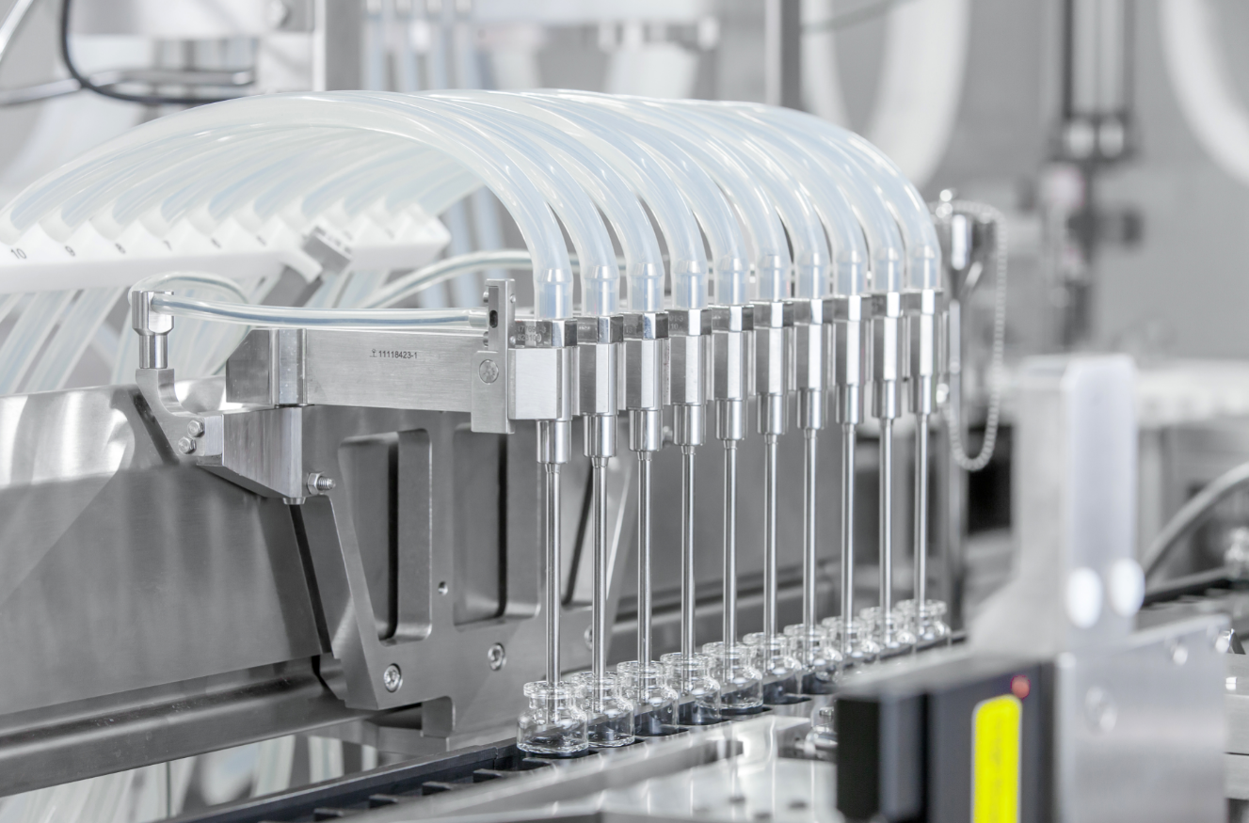
The vaccine is dosed multi-digit into the vials. Different filling technologies suited to different liquids ensure the greatest possible flexibility when filling different pharmaceuticals. (Source: Optima)

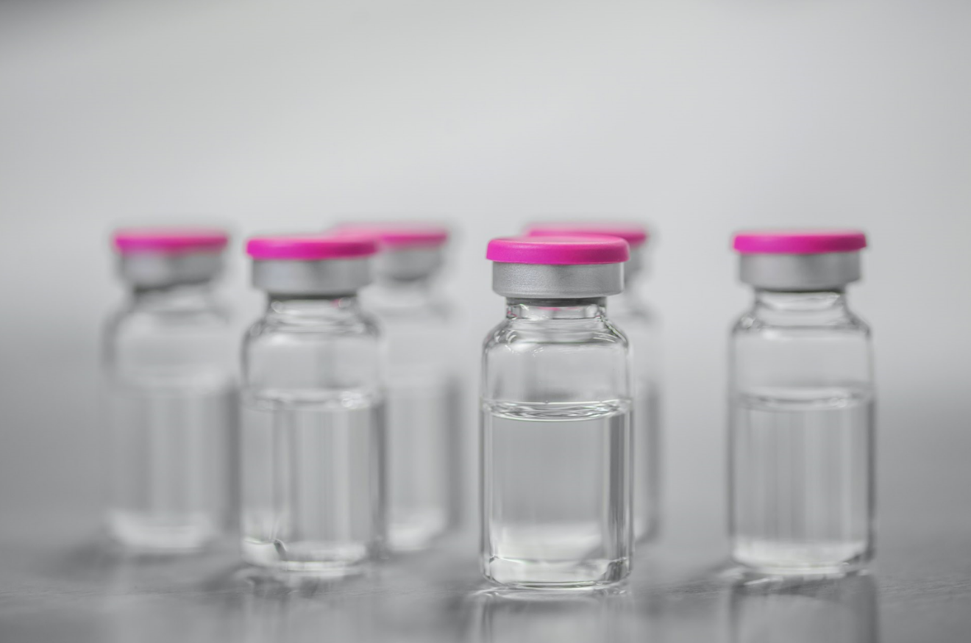
The filled and closed vials are then packed into trays. (Source: Optima)

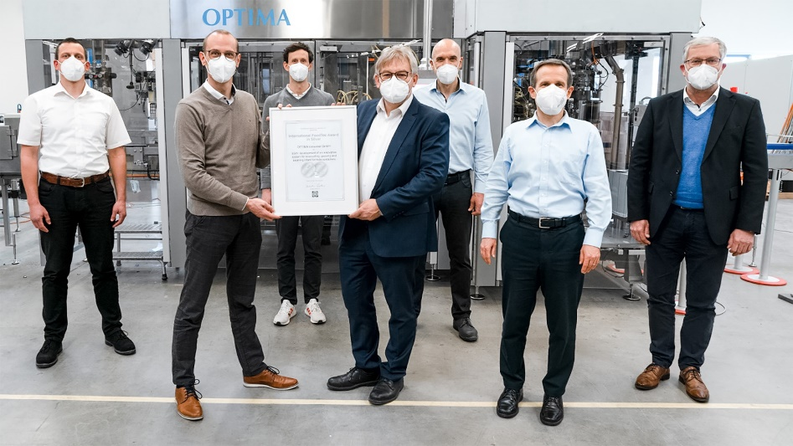
When developing the OPTIMA EGS, great importance was attached to the issues of production reliability, product quality and conservation of resources. The system was awarded with the prestigious International FoodTec Award 2021. (Source: Optima)

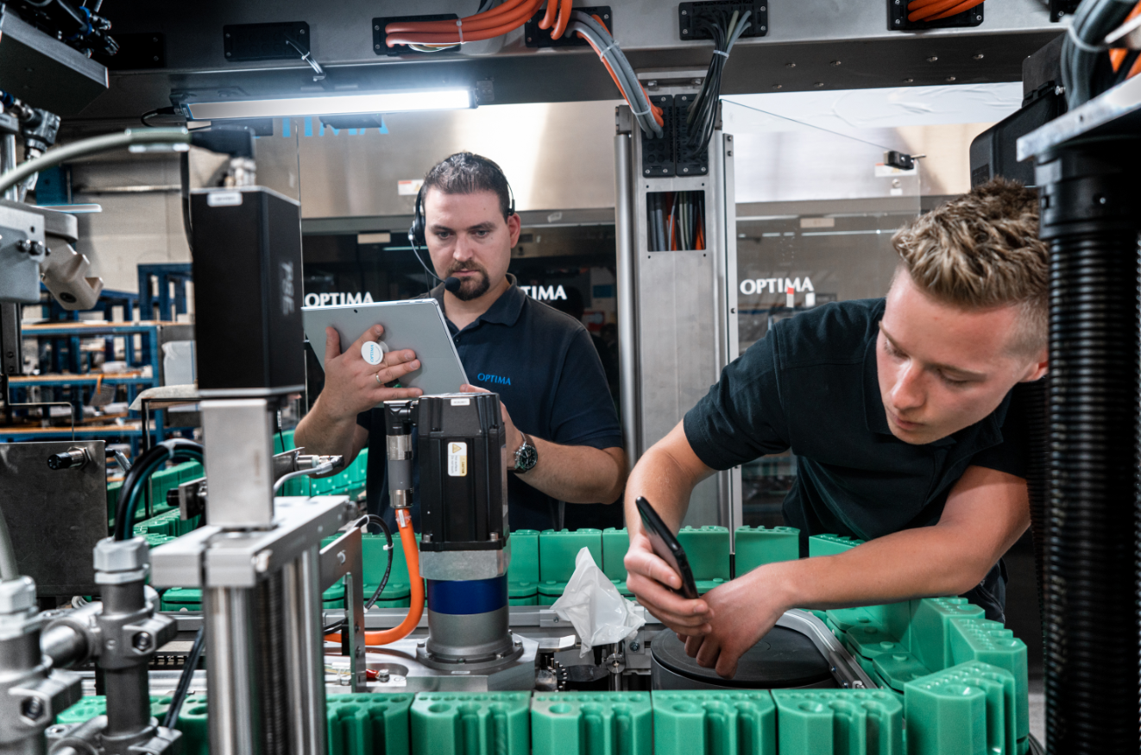
The strengths of the Remote Assist software solution have particularly come to the fore during the COVID-19 pandemic. Any challenges that may arise can be solved quickly and cooperatively, directly on the machine. The Annual Multimedia Award 2021 was awarded for this. (Source: Optima)

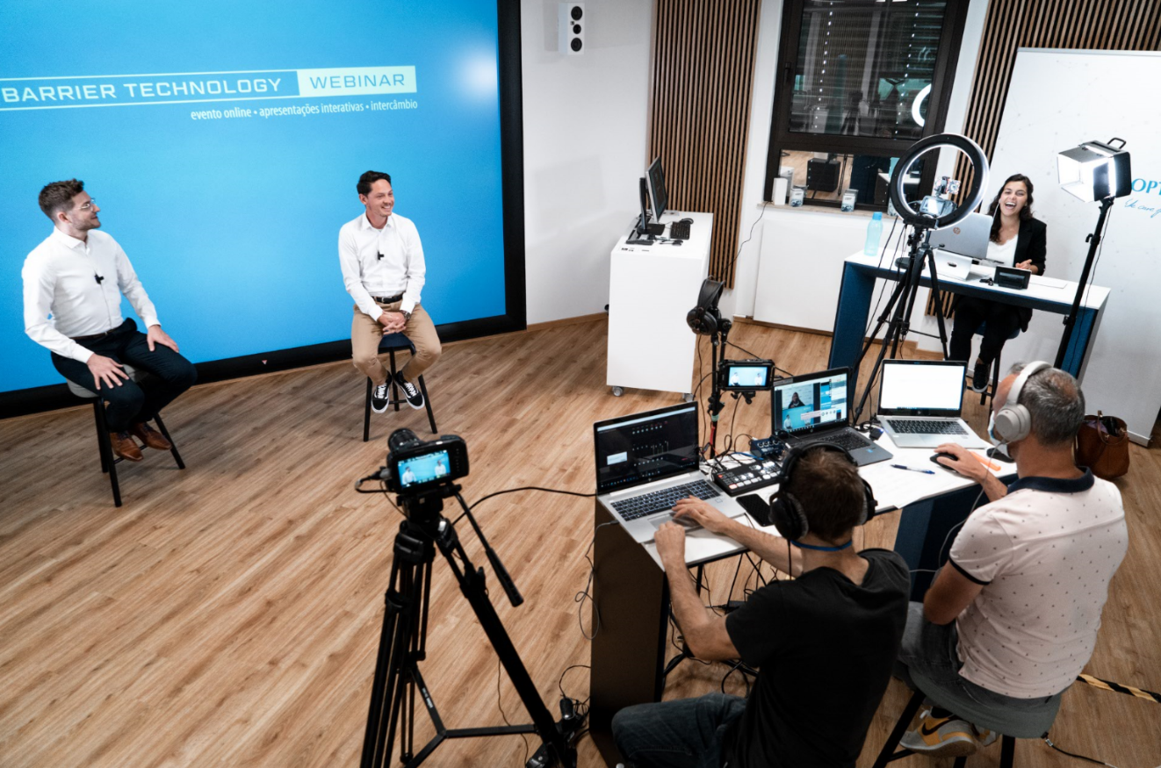
Optima is an industry pioneer in virtual communication formats. Within a very short timescale, Optima's Sales and Marketing teams organized professional webinars to keep in touch with customers. (Source: Optima)

Characters (incl. spaces): 11,104

Press contact:
OPTIMA packaging group GmbH
Jan Deininger
Group Communications Manager
+49 (0)791 / 506-1472
jan.deininger@optima-packaging.com
www.optima-packaging.com

About OPTIMA
Optima supports companies worldwide with flexible and customer-specific filling and packaging machines for pharmaceuticals, consumer goods, paper hygiene and medical devices markets. As a provider of solutions and systems, Optima accompanies these companies from the product idea through to successful production and throughout the entire machine life cycle. Over 2.650 experts around the globe contribute to Optima's success. 19 locations in Germany and abroad ensure the worldwide availability of services.

Thank you very much for your publication. We look forward to receiving a specimen copy.

