PRESS RELEASE
Schwaebisch Hall, May 4, 2020

RIANTA packaging systems expands its presence in the United States
Jeff Privatt represents the Germany-based packaging machinery manufacturer

Optima Machinery Corporation is excited to be representing Rianta Packaging Systems in the United States. Rianta has 55 years of experience providing packaging solutions for food and bakery goods. To intensify its sales activities in North America, from now on a the experienced Sales Manager Jeff Privatt will represent the Germany-based company in North America at Optima Machinery Corporation in Green Bay, Wisconsin. Headquartered in Schwaebisch Hall, Rianta Packaging Systems became part of Optima Packaging Group in March of 2019.
With the backing of the Optima Group, Rianta Packaging Systems has sales and service representatives located in Europe and North America. Optima Machinery Corporation in Green Bay, Wisconsin, is proud to represent Rianta offering sales and support for the US and Canadian markets. Optima Machinery Corporation has welcomed Jeff Privatt as a Sales Manager focused on representing Rianta in the United States and Canada. Jeff comes to Optima with five years of experience in the bakery industry. He has extensive experience with conveyors, ovens (DGF, convection, and hybrid), proofers, coolers, finishing, and extrusion equipment for bakery products including bread, buns, tortillas, snack foods, confections, pastries, and pasta.
Rianta Packaging Systems provides modular and flexible packaging machine designs for bakery products including breads, buns, tortillas, pasta, confections and more. They provide machines in a variety of sizes and speeds from small batches to large, automated capacities with specialties in slicing, bagging, and closing. With their proprietary ClipStrip plus closing system, Rianta provides tamper evident solutions for bakery products.
Optima Machinery Corporation is celebrating 35 years in Green Bay, Wisconsin, in 2020. With over 70 employees nationwide and support from the corporate Optima Group in Schwaebisch Hall, Germany, Optima Machinery Corporation provides sales and service support for packaging machines across the United States and Canada.

About RIANTA packaging systems
Rianta packaging systems GmbH has been developing semi and fully automatic packaging and closing machines for the bread, food, luxury food and consumer goods industry since 1963. Cutting and welding machines, transport equipment, checkweighers and case packers are also part of the portfolio and are often integrated into the lines. All machines are characterized by reliability, robustness, easy operation and service convenience. Rianta Packaging Systems employs over 20 people in Schwaebisch Hall. Since March 2019, the company has been a wholly-owned subsidiary of the internationally operating Optima Group and thus benefits from a variety of synergy effects, the holistic life cycle management program OPTIMA Total Care, a worldwide service network and 19 branches in Germany and abroad.

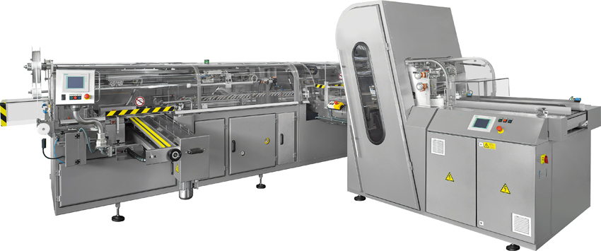
Rianta’s combination bagger and slicer with capabilities of processing up to 70 products per minute. (Source: Optima)

Optima Machinery Corporation is excited to welcome Jeff Privatt as a Sales Manager focused on Rianta’s bakery packaging systems. (Source: Optima)

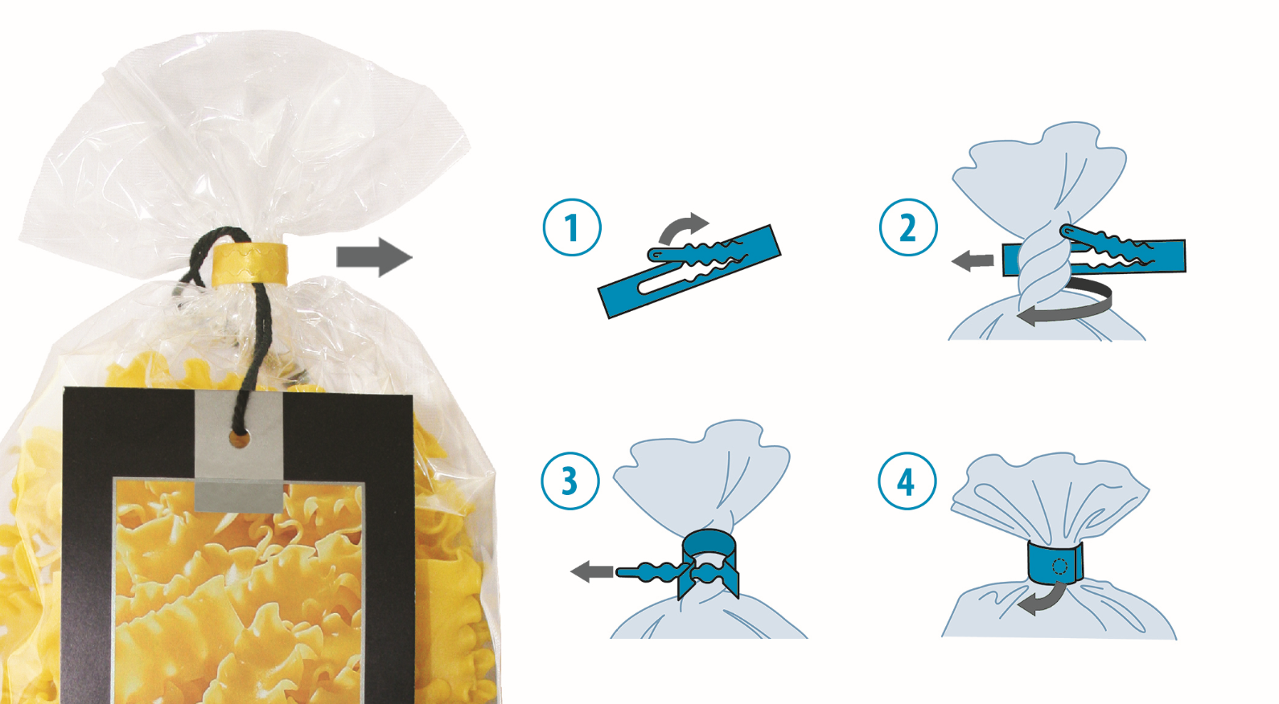
Rianta’s ClipStrip plus closing system provides tamper evident closures for bakery products. (Source: Optima)

Characters (incl. spaces): 2,162

Press contact Optima Packaging Group:
OPTIMA packaging group GmbH
Jan Deininger
Editor
+49 (0)791 / 506-1472
jan.deininger@optima-packaging.com
www.optima-packaging.com

Local contact:

OPTIMA Machinery Corporation
Melissa Kuhn
Marketing Manager
920-983-3133
melissa.kuhn@optima-packaging.com
Thank you very much for your publication. We look forward to receiving a specimen copy.

