Press release
Schwaebisch Hall, February 13, 2018

OPTIMA pharma and METALL+PLASTIC at the Interphex Show

STISO: A New Sterility Test Isolator for a Safe Pharma Production

The new sterility test isolator from Metall+Plastic has its world premiere at the Interphex show. Several features distinguish the STISO: Well-designed ergonomic operator concept, flexibility due to its modular design, fast installation and an integrated glove testing system built into the HMI. By means of a catalytically air circulation and the new DECOjet® technology the STISO achieves extremely short cycle times during decontamination. STISO is low maintenance due to the H2O2 flash evaporation. The STISO is available for aseptic and aseptic-toxic applications.
Optima Pharma will be presenting the MultiUse filling and closing machine platform at the INTERPHEX Show 2018. The MultiUse platform is an innovative machine solution focused on maximum flexibility for processing of Ready to Use vials, syringes and cartridges. A high degree of automation, robotic technology and a state of the art transport system enables agile pharmaceutical manufacturing and ultimate flexibility to all market and production demands. The MultiUse platform can easily be integrated with Optima Pharma’s latest isolator technology for highest product and operator safety. The modular design concept allows for flexibility in line configuration along with the integration of pharmaceutical lyophilization systems enabling superior level of aseptic process control and quality assurance.
As a turnkey specialist, Optima Pharma offers their clients a total turnkey approach to their project investment. Central project management is a critical component of this proven approach. This involves full responsibility for all technical tasks internal and external, including site implementation, SAT and qualification services.
Optima Pharma utilizes state-of-the-art engineering technologies like Flow Visualization and CFD-Technology, which will also be presented at Show.

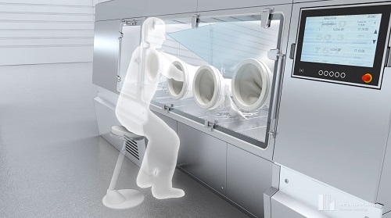

Metall+Plastic Sterilty Test Isolator STISO – designed for optimal work conditions.

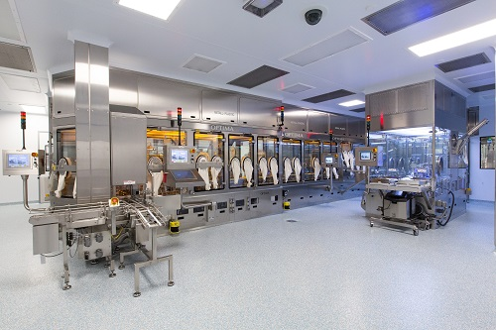

OPTIMA pharma MultiUse Filler

Characters (incl. spaces): 1,987

Contact:
OPTIMA packaging group GmbH
Sabine Gauger
Marketing Director
sabine.gauger@optima-packaging.com
www.optima-packaging.com
Thank you very much for your publication. We look forward to receiving a specimen copy.

