New development at LAMILUX Composites

Establishment of the new division "Business Unit Building and Construction"

LAMILUX Composites, a leading company in the manufacture of fibre-reinforced composites, is pleased to announce the launch of its new division “LAMILUX Business Unit Building and Construction”. This step marks a significant milestone for the company and enables LAMILUX Composites to achieve a stronger position in the building industry.

In order to achieve this goal, LAMILUX Composites is introducing a new organisational structure and establishing a specialised team with a clear focus on the building industry. These changes are necessary to meet the different customer needs and target groups. The previous LAMILUX Composites division will therefore be divided into two separate business units: "Business Unit Mobile Applications and Industry" and "Business Unit Building and Construction".

The “Business Unit Mobile Applications and Industry” will continue to provide reliable support to the industries served to date. The newly created “Business Unit Building and Construction” is led by a dedicated team consisting of Alexander Hoier as head of the “LAMILUX Business Unit Building and Construction”, supported by Michaela Böhm as marketing consultant and Axel Gläsel as project manager. The application focus of the new business area is on the use of glass fibre reinforced plastic (GRP) as wall cladding, i.e. the cladding of walls in hygienically sensitive areas such as hospitals, commercial kitchens or food processing companies, instead of conventional materials such as tiles.

In order to be able to respond flexibly to customer needs and changing market situations, the team relies on a start-up mentality and agile working methods in the development of the business unit. “LAMILUX Composites is confident that the introduction of the new division Business Unit Building and Construction and the increased entry into the building industry will further consolidate and expand our position as a global leader in the GRP industry,” said Oliver Liebsch, Sales Manager of LAMILUX Composites.

…

www.lamilux.com

About LAMILUX Composites GmbH
LAMILUX Composites GmbH has been producing fibre-reinforced plastics for around 70 years. The medium-sized company is the leading European producer thanks to its technologically advanced continuous production process, large manufacturing capacities and wide product range. LAMILUX supplies customers around the globe in a wide range of sectors, such as the building industry, the automotive and recreational vehicle sectors, refrigerated store room and cell construction, and many other industrial sectors. LAMILUX strives to be the innovation and performance leader in all areas relevant to its customers. Headquartered in Rehau, Germany, the family-owned company is managed by Johanna and Dr. Alexander Strunz in the fourth generation, currently employs around 1,300 people, and in 2022 generated sales of around 392 million euros.

Image description
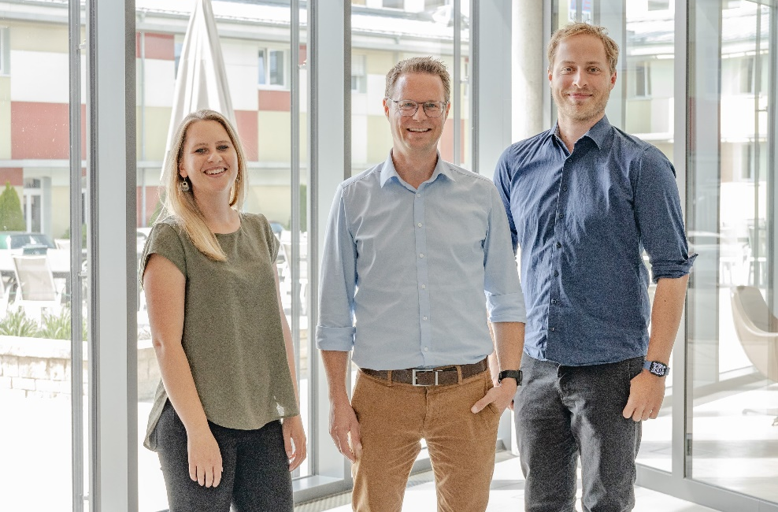

f.l.t.r.: Michaela Böhm (Marketing Officer, Alexander Hoier (Head of Business Unit Building and Construction) and Axel Gläsel (Project Manager)

