Energy saving food processing

GEA expands CookStar portfolio with compact spiral oven for small to mid-sized food production

Düsseldorf (Germany), February 11, 2026 – GEA has introduced the CookStar First, a compact twin-zone spiral oven designed for small to mid-sized food production operations seeking to transition from linear to spiral cooking and want to benefit from the advantages. The new oven extends the GEA CookStar product family and addresses requirements for consistent product quality, controlled processing conditions, and improved resource efficiency from initial start-up. The machines are designed to create the ‘home cooked’ experience for a broad range of applications, including steam-cooked products, coated poultry, plant-based foods, baked or grilled items, and ready meals.

Uniform heat distribution and reduced cooking times
The new GEA CookStar First features a twin-zone spiral configuration with integrated booster impingement. By combining horizontal and vertical airflow, the system achieves more uniform heat transfer across the conveyor belt. According to GEA, the core temperature variation across the belt is limited to approximately 1°C, compared with deviations of up to 6°C in conventional ovens. This uniformity enables cooking times to be reduced by 10 – 30 percent while maintaining consistent product color and internal doneness. Throughput can reach up to 1,700 kg per hour, and more stable thermal conditions contribute to yield improvements of up to three percent.

Focus on energy efficiency
Improving energy efficiency in spiral ovens requires a better oven balance. GEA engineers introduced a new intelligent active exhaust system, changes to the oven design, and adjustable product gates to the GEA CookStar First to minimize air leakage. These features work together to ensure consistent cooking conditions throughout the oven. More efficient water flow enables water reuse. Together, these features reduce energy and water consumption by up to 12%, earning the GEA CookStar First the “Add Better” label for resource efficiency, based on independently validated performance criteria.

Process transparency and digital connectivity
CookStar First is equipped with GEA SmartControl HMI, providing operators with access to real-time process data, alarm management, and a 24-hour timeline for tracking events and parameter changes. The system supports consistent operation and data-driven optimization and is compatible with GEA Insight Partner technology for remote diagnostics, service intervention, and maintenance planning.

Compact footprint and scalability
With an overall height of less than 3.9 meters, CookStar First is designed for installation in existing facilities, including brownfield sites with limited ceiling height. The oven’s cooking technology supports a wide variety of products and process parameters.

Position within the CookStar range
The broader CookStar family includes the original CookStar model, which adds smoking functionality and higher capacity, as well as the CookStar Turbo for large-scale applications with capacities of up to 12,000 kg per hour and roasting capability. All CookStar systems share a common footprint and can be integrated into existing CookStar production lines.

Technical support and services
GEA supports the CookStar range with application expertise from food technologists, operator training, and a global service organization. These services are intended to support commissioning, process optimization, and long-term operational reliability.

gea.com

Picture Overview (Download link for high resolution versions of 6 pictures)
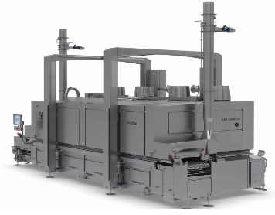

Pic. 1: New GEA CookStar First – compact spiral oven for small to mid-sized food production. Source: GEA

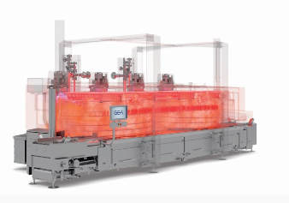

Pic. 2: The GEA CookStar First offers uniform heat distribution and reduced cooking times compared to conventional ovens. Source: GEA

Application pictures. Source: GEA

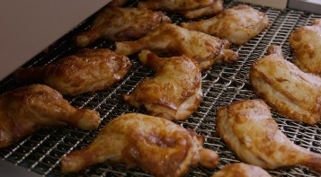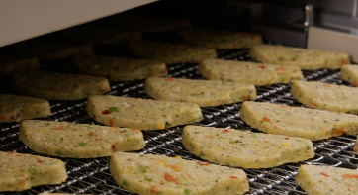
GEA CookStar First in action with roasted poultry. GEA CookStar First in action with plant-based products.

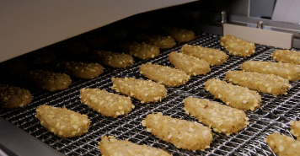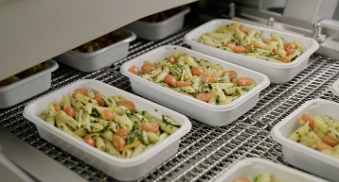
GEA CookStar First in action with coated poultry. GEA CookStar First in action with ready meals.

NOTES TO THE EDITORS
- Further information about GEA
- To the GEA Media Library
- Features on current topics
- Overview press events
- Follow GEA on  

Media Relations
GEA Group Aktiengesellschaft
Nicole Hoffmann
Ulmenstraße 99, 40476 Düsseldorf, Germany
Phone +49 211 9136-1503
nicole.hoffmann@gea.com

About GEA
GEA is one of the world’s largest suppliers of systems and components to the food, beverage and pharmaceutical industries. The international technology group, founded in 1881, focuses on machinery and plants, as well as advanced process technology, components and comprehensive services. For instance, every second pharma separator for essential healthcare products such as vaccines or novel biopharmaceuticals is produced by GEA. In food, every fourth package of pasta or every third chicken nugget are processed with GEA technology. With more than 18,000 employees, the group generated revenues of about EUR 5.5 billion in more than 150 countries in the 2024 fiscal year. GEA plants, processes, components and services enhance the efficiency and sustainability of customers’ production. They contribute significantly to the reduction of CO2 emissions, plastic usage and food waste. In doing so, GEA makes a key contribution toward a sustainable future, in line with the company’s purpose: ”Engineering for a better world.”

GEA is listed on the DAX, the STOXX® Europe 600 Index and is also a constituent of the leading sustainability indices DAX 50 ESG, MSCI Global Sustainability and Dow Jones Best-in-Class World.

More information can be found online at gea.com.
If you do not want to receive any further information from GEA, please send an e-mail to pr@gea.com.

About the GEA Foundation
The GEA Foundation, established in 2025 by GEA Group, supports global and local projects in STEM education, child poverty reduction, infrastructure access and disaster relief. Through its Mission 30 strategy, GEA commits to donating one percent of annual net profit to build resilient communities.

More information can be found online at gea.com/foundation.

