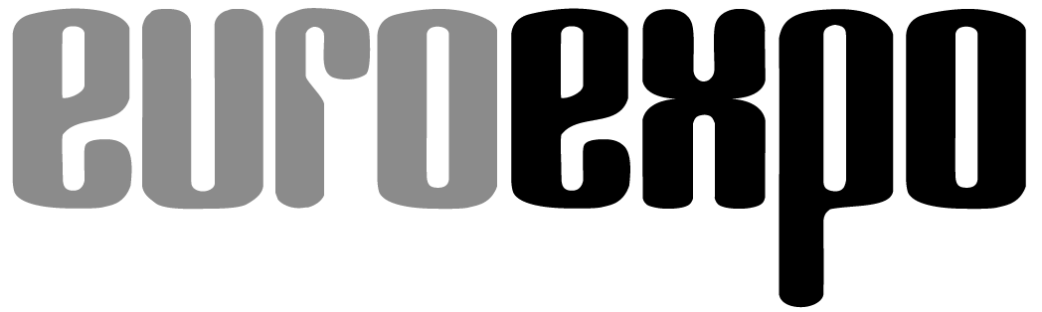
Messe- und Kongress-GmbH
Joseph-Dollinger-Bogen 7
D-80807 Munich, Germany
Phone: +49 89 32 391 259
Fax: +49 89 32 391 246
www.euroexpo.de/en
www.logimat-messe.de/en
www.logimat.digital

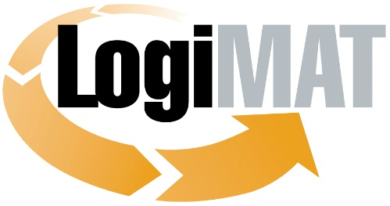

International Trade Show for
Intralogistics Solutions and Process Management

Munich, June 22, 2021

Press Release

DO NOT RELEASE BEFORE
June 22, 2021, 8:00 PM (CEST)

BEST PRODUCT for Excellence in Intralogistics

An omnidirectional undercarriage AGV that autonomously locates product storage devices, an innovative RFID label to permanently identify containers, and a smart workstation that lets you digitize manual processes in pursuit of a zero-error strategy: These were the three winners of this year’s prestigious BEST PRODUCT Award, presented as part of the LogiMAT.digital Summer Summit in Stuttgart. The Awards Ceremony was livestreamed on the Intralogistics Community platform LogiMAT.digital on the evening of June 22, 2021.

An independent jury of scholars and journalists reviewed over 100 submissions and chose three winners that fully live up to the name of BEST PRODUCT as outstanding manifestations of the award criteria: They enhance productivity, reduce costs, and streamline operations in logistics.

The three awards were presented to the proud winners Grenzebach Maschinenbau GmbH, inotec Barcode Security, and KNAPP AG live at the Messe Stuttgart convention center and simultaneously livestreamed as part of the LogiMAT.digital Summer Summit on the evening of June 22. This gave thousands of industry professionals in the LogiMAT.digital Intralogistics Community the opportunity to experience the excitement live.

Dr. Robert Schulz, Director of the Institute of Mechanical Handling and Logistics (IFT) at the University of Stuttgart, took the opportunity in presenting the awards to pay tribute not only to the winners but to all applicants who had competed for the prize this year despite the absence of a live event, and emphasized the innovative power of the industry.
In the category of “Conveying, Lifting, and Storing Technology,” the prize went to Grenzebach Maschinenbau GmbH for its OL1200S omnidirectional undercarriage AGV for autonomous parts transport.
The OL1200S combines omnidirectional travel with the ability to autonomously locate product containers. It also features 360° range monitoring. The high degree of maneuverability combined with the container location feature makes it possible to autonomously retrieve even displaced storage devices in tight locations—all without the need for additional sensors on the AGV or equipment on the containers. Docking and transfer stations become a thing of the past. Users will enjoy the reduced space requirements, low investment costs, and quick setup. The AGV adapts quickly and easily to existing systems. The additional 3D range monitoring lets the OL1200S also detect obstacles in the AGV’s path, taking into account the speed, directions of travel, and load. This helps eliminate damage during transport. The device stores schematic image data to analyze disruptions and precisely optimize workflows. The OL1200S offers the full package to help you greatly streamline autonomous parts transport and especially the transport of long product containers.

In the category of “Identification, Packaging and Loading Technology, Load Securing,” the BEST PRODUCT prize went to inotec Barcode Security GmbH for its RFID in-mould label.

The inotec RFID in-mould label lets you permanently mark plastic pallets, trays, and containers such as the new GS1 SMART-Box. In-mould labels are resistant to abrasion, UV light, cleaning products, weak acids, and other chemicals. They are also permanently bonded to the container and absolutely hygienic, satisfying the stringent hygiene requirements of the food and pharmaceutical industries and GS1-certified throughout the industry for meat container labeling. The single-layer label with integrated barcode, printed RFID antenna, and mounted RFID chip is inseparably bonded to the load carrier during the injection molding process. This means that the RFID tag is an integral part of the load carrier and tamper-proof. RFID in-mould solutions are also the perfect solution for reading data from a distance or without line-of-sight contact.

In the category of “Software, Communications, IT,” the prize went to KNAPP AG for the ivii.smartdesk assembly workstation.

The ivii.smartdesk is an assembly workstation equipped with an image recognition and processing system for 100% software-supported assembly operations. The ivii.smartdesk’s real-time feedback system monitors every work step. This enables a zero-error strategy and end-to-end traceability for assembly processes in production, for example. The image recognition and processing system captures all components required for assembly. Each work step is checked and validated. The next work step can follow only after the previous step has been recognized as “OK” by the image processing system. This ensures that all components are assembled in the correct order and quality. A real-time feedback system gives workers immediate feedback on the quality of the work step. A “gamification” of the work steps motivates employees, helps engender a learning culture, and enhances employee satisfaction. The ivii.smartdesk can also be used in receiving to check whether all goods have been delivered in the appropriate quantity and quality. The delivery is documented and stored to help with any subsequent burden of proof. This not only saves time, it also reduces the costs associated with returns.

Organizer: EUROEXPO Messe- und Kongress-GmbH
Joseph-Dollinger-Bogen 7 | 80807 Munich, Germany
Phone: +49 89 32 391 259 | Fax: +49 89 32 391 246
www.logimat-messe.de | www.logimat.digital

For more information, please visit: www.logimat-messe.de

5,159 characters (with spaces)

Stuttgart, June 22, 2021—This text may be reprinted free of charge, but please send a copy to EUROEXPO Messe- und Kongress-GmbH, Press and Public Relations Department, 80912 Munich.
Background information:

The BEST PRODUCT Award was initiated 17 years ago by the organizers of LogiMAT to honor the outstanding achievements of the exhibitors, many of whom are small or medium-sized businesses. Since that time, the award has honored innovative products that have made a significant contribution to streamlining processes, cutting costs, and enhancing productivity in the internal logistics of businesses. The BEST PRODUCT award is presented in three categories:
- Software, Communications, IT
- Order Picking, Conveying, Lifting, and Storing Technology
- Identification, Packaging and Loading Technology, Load Securing
In the run-up to LogiMAT, an independent jury of scholars and journalists critically evaluates the submissions based on the aforementioned criteria, then selects the winners. The award has since been recognized as one of the most coveted distinctions in the intralogistics industry. Winners receive a medal and a certificate.
Members of the BEST PRODUCT award jury:
Prof. Johannes Fottner (Dr.-Ing.), Chair of the Institute for Materials Handling, Material Flow, Logistics at the Technical University of Munich (Jury President)
Jan Kaulfuhs-Berger from the industry journal Technische Logistik – Hebezeuge Fördermittel
Prof. Rolf Jansen (Dr.-Ing.), Institute for Distribution and Retail Logistics (IDH) at the Society for the Promotion of Innovation in Logistics (VVL e.V.)
Matthias Pieringer from the industry journal LOGISTIK HEUTE
Prof. Wolf-Michael Scheid (Dr.-Ing.), Association of German Engineers, Society for Production and Logistics (VDI-GPL)
Tobias Schweikl from the industry journal LOGISTRA

