PRESS RELEASE
Schwaebisch Hall, April 3, 2020

Cohesion in the crisis
OPTIMA supports the company Wrapping Solutions in the production of protective masks

The Corona crisis poses a very special challenge for every individual and also for companies. In order to make their contribution to overcoming the situation, companies from the Schwaebisch Hall county have decided to enter into an unusual cooperation.
The company Wrapping Solutions from Rosengarten near Schwaebisch Hall specialises in producing interior fittings for cars. In the face of the corona crisis, the company decided to produce mouth and nose protection masks. Since 23 March, a maximum of 24,000 masks per day are sewn at 20 workplaces. In the long term, the company plans to expand to 40 sewing workstations. The aim is to produce in two-shift operation. "According to estimates, around 14 million protective masks are needed in Germany every day", says Managing Director Wolfgang Schaller.

Folding device increases production capacities

Optima now supports operations by optimizing the work processes. "We have built a device for folding face masks and successfully put it into operation at Wrapping Solutions on March 31," reports Werner Volk, who is responsible for new applications at OPTIMA life science GmbH. This was previously done manually and proved to be a bottleneck in production. The machine-made fabric blanks are folded in the station and ultrasonically welded on both sides. In the last work step loops are sewn to the masks.

"We are very pleased with the technical support from a special machine manufacturer like Optima," says Schaller. This is a first step towards accelerating the production of the masks, he says. In order to further increase the company's production capacity, talks are currently underway on possible automation of this process.

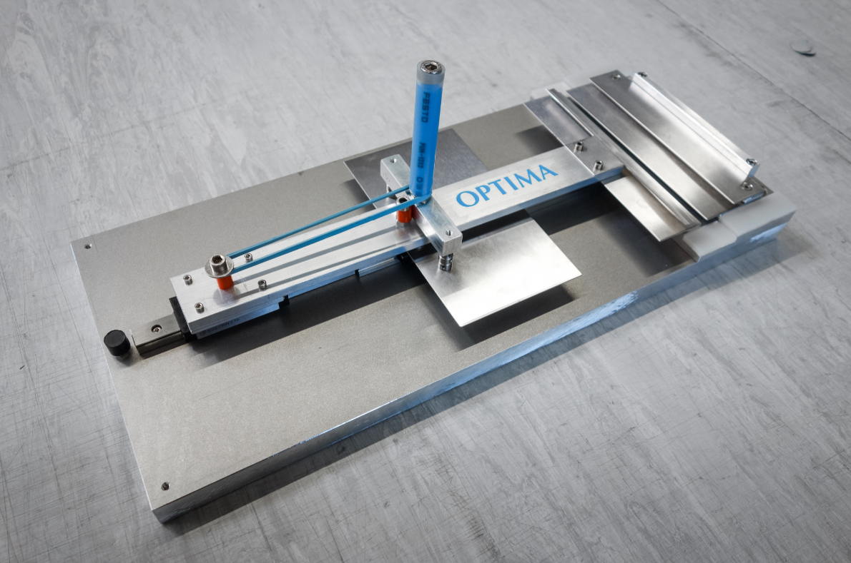
With the folding device, the production of oronasal protection masks can be accelerated. (Source: Optima)

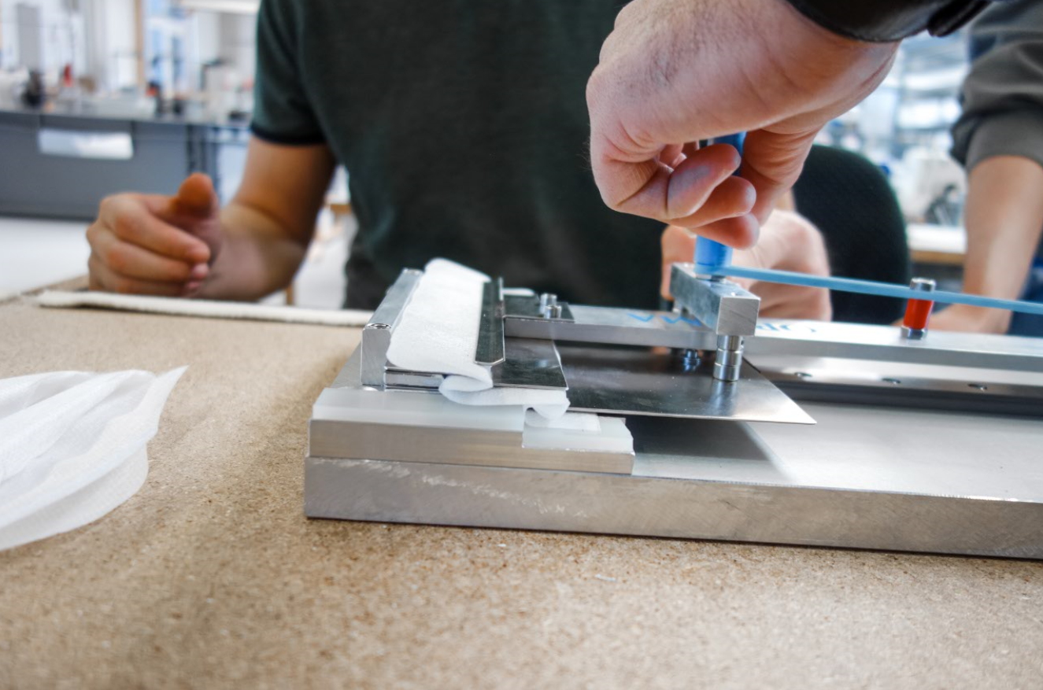
The machine-made fabric blanks are inserted into the device and folded with just one movement. (Source: Optima/Wrapping Solutions)

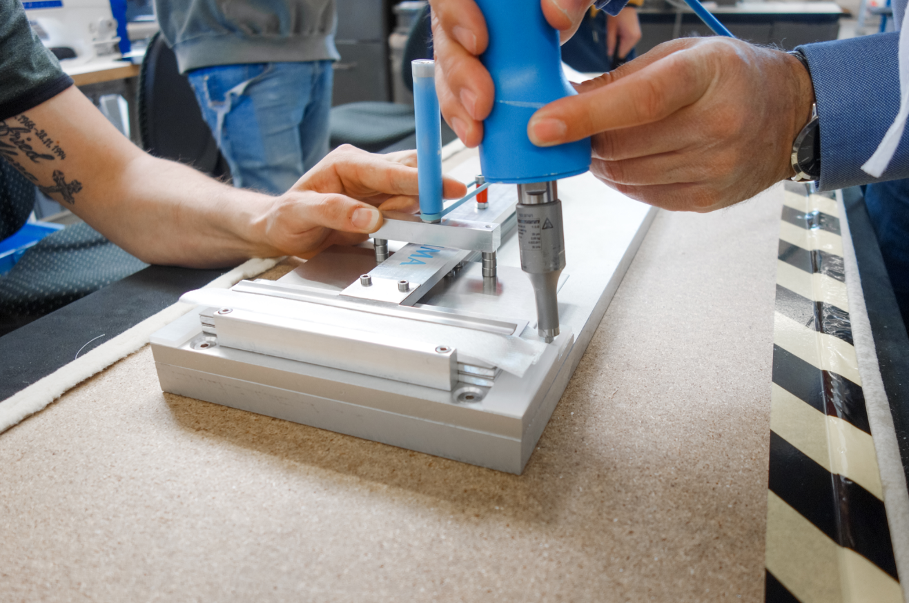
The edges of the mask are ultrasonically spot-welded by hand before the loops are sewn on. (Source: Optima/Wrapping Solutions)

Characters (incl. spaces): 1,789

Press contact:
OPTIMA packaging group GmbH
Jan Deininger
Editor
+49 (0)791 / 506-1472
jan.deininger@optima-packaging.com
www.optima-packaging.com
Thank you very much for your publication. We look forward to receiving a specimen copy.

