GEA: ALUS® automatic loading and unloading systems for freeze dryers
Duesseldorf (Germany), February 11, 2026 – When loading a freeze dryer, human intervention increases the risk of contamination by the operator or the product. ALUS® automatic loading and unloading systems minimize this risk while reducing processing times, improving productivity, and lowering operating costs through the use of state-of-the-art monitoring systems.

GEA as a pioneer in the field of freeze drying

As a pioneer in the field of freeze-drying innovation, GEA has been developing, updating, and improving the ALUS® system for more than 35 years. GEA was the first technology company to develop this equipment and create permanently installed units (conveyor-slider systems). Further advances include flexible, automatically guided transfer carts (AGVs) and the placement of a loading system within an isolator. GEA's many years of experience have resulted in a validated base of more than 350 production-scale ALUS® systems installed worldwide, seven patents, and an ongoing research and development program to optimize handling and maintenance.

Efficient, safe, and reliable performance

ALUS® offers maximum flexibility in terms of containment, layout, and product flow, including loading and unloading from one or two sides (pass-through design). In addition, multi-purpose lines are available for a wide range of products and formats. Loading can be performed using a fixed push-pull system with an isolator or RABS, and unloading can be performed using a transfer cart in open RABS-based systems (oRABS).

ATEX-compliant versions and systems

ATEX-compliant versions and systems for handling highly effective products or those containing organic solvents are also available. In addition, ALUS® can integrate a variety of third-party filling and sealing options both upstream and downstream. Thanks to its compact and adaptable design, the space required for the system is significantly reduced, minimizing construction costs and greatly simplifying retrofitting.

Photos:

Photo 1:

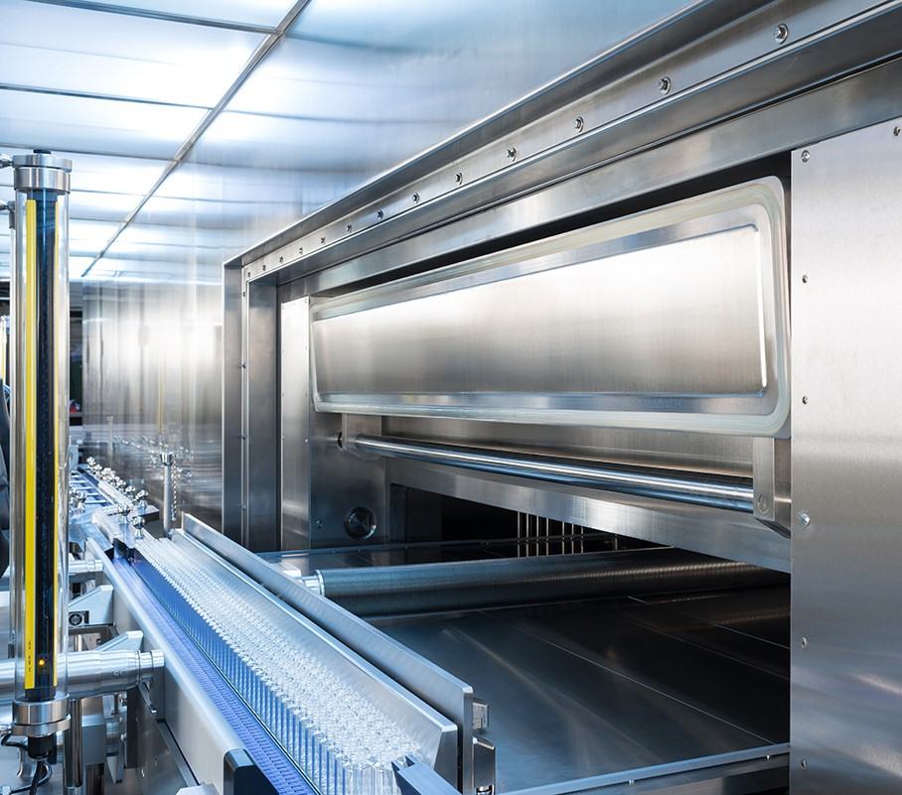

Photo 1, caption: As a pioneer in the field of freeze-drying innovation, GEA has been designing, updating and improving the ALUS® system for more than 35 years. (Photo: GEA)

Photo 2:

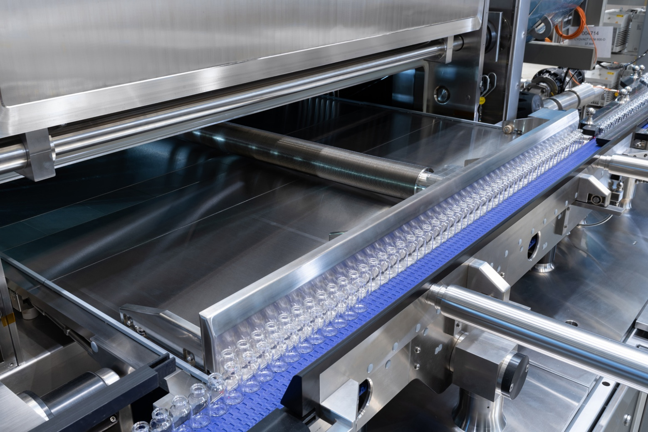

Photo 2, caption: ALUS® provides maximum flexibility in terms of containment, layout and product flow, including loading and unloading from either one side or two (pass-through design). (Photo: GEA).

About GEA
GEA is one of the world’s largest suppliers of systems and components to the food, beverage and pharmaceutical industries. The international technology group, founded in 1881, focuses on machinery and plants, as well as advanced process technology, components and comprehensive services. For instance, every second pharma separator for essential healthcare products such as vaccines or novel biopharmaceuticals is produced by GEA. In food, every fourth package of pasta or every third chicken nugget are processed with GEA technology. With more than 18,000 employees, the group generated revenues of about EUR 5.5 billion in more than 150 countries in the 2024 fiscal year. GEA plants, processes, components and services enhance the efficiency and sustainability of customers’ production. They contribute significantly to the reduction of CO2 emissions, plastic usage and food waste. In doing so, GEA makes a key contribution toward a sustainable future, in line with the company’s purpose: ”Engineering for a better world.”

GEA is listed on the DAX, the STOXX® Europe 600 Index and is also a constituent of the leading sustainability indices DAX 50 ESG, MSCI Global Sustainability and Dow Jones Best-in-Class World.

More information can be found online at gea.com.
If you do not want to receive any further information from GEA, please send an e-mail to pr@gea.com.

NOTE TO EDITORS

- Further information about GEA
- To the GEA Press page
- To the GEA Media Center
- Background information on current topics can be found at Features
- Follow GEA on  

GEA
Media Relations GEA
Dr. Michael Golek
Ulmenstraße 99, 40478 Düsseldorf
Phone +49 211 91361505
Tel. +491736205746
michael.golek@gea.com

