GEA Extends Sustainability Credentials with New “Add Better” Awards

Duesseldorf (Germany), March 17, 2025 – Helping pharmaceutical manufacturing companies to comply with the stringent requirements of ISO 14021, GEA has verified the power-saving potential of its first-in-class tablet compression technology.

GEA, one of the world’s largest suppliers of systems and components to the food, beverage and pharmaceutical industries, has further improved the planet friendly operation of equipment designed for the large-scale production of oral solid dosage forms. According to defined criteria from TÜV Rheinland — a leading testing service provider — the NexGen Press® 45 has been externally audited to qualify for two of GEA’s recently introduced “Add Better” labels.

The newly launched NexGen® Press range from GEA Pharma & Healthcare represents the cutting edge of tablet compression technology for the pharmaceutical industry. These performance-driven innovations facilitate machine selection and offer fast product changeovers with unrivaled containment and functional excellence.

The Add Better label showcases GEA solutions that are significantly better than their predecessors when it comes to operational excellence and environmental impact. They represent the organization’s most resource-efficient solutions and demonstrate in a tangible way that a specific model is more cost-effective and environmentally friendly to run than previous ones.

Initially, the high-throughput NexGen Press® 45 was tested in standalone mode and compared with a MODUL S machine. Following a series of trials, TÜV representatives certified that, in terms of electric power usage, operational utility savings of up to 27% could be made. This result builds on the performance of the inaugural NexGen Press® 30 model that, in 2023, was also awarded an Add Better label for average power savings of 21% (compared with a base machine configuration).

Subsequently, data from the NexGen Press® 45 test was combined with supplementary statistics (derived from the feeders and blenders) from a ConsiGma® CDC200 Continuous Direct Compression model. When adjusted to accurately represent the correct operational setup and theoretical power consumption, energy savings of 30% were calculated (compared with a MODUL-equipped CDC50 combination).
“These results are impressive,” said Dr. James Holman, Senior Director Technology Management (Pharma Solids GEA) “and represent GEA’s unfaltering emphasis on sustainability. It’s testament to the ingenuity and dedication of our scientists and engineers who are committed to innovation and driving positive change within the organization and the greater pharmaceutical manufacturing sector.”

“Sustainability in the global healthcare industry is no longer optional. Manufacturing drugs has a significant environmental footprint owing to resource consumption, waste generation and the emissions associated with production, packaging and distribution. The industry’s desire to embrace more planet-friendly practices will help the entire value chain to tackle pollution, climate change and resource depletion. We’re delighted to qualify for these Add Better labels and continue to contribute to a better world,”

Note to editor

The ConsiGma® CDC 50 is currently supplied with an integrated MODUL S tablet press. Future variants with the energy saving NexGen Press® 45 will be rebranded as the CDC 200.

Photo:
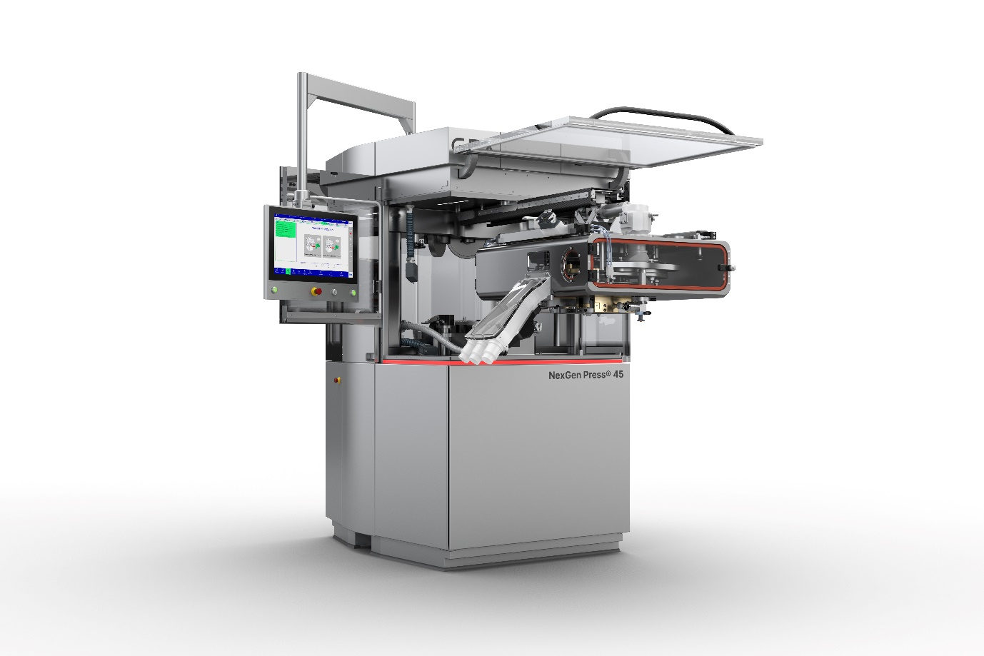

Photo, caption: The NexGen Press® 45 has been externally audited to qualify for two of GEA’s recently introduced Add Better labels. (Photo: GEA)

NOTE TO EDITORS

- Further information about GEA
- To the GEA Press page
- To the GEA Media Center
- Background information on current topics can be found at Features
- Follow GEA on  

About GEA
GEA is one of the world’s largest suppliers of systems and components to the food, beverage and pharmaceutical industries. The international technology group, founded in 1881, focuses on machinery and plants, as well as advanced process technology, components and comprehensive services. For instance, every second pharma separator for essential healthcare products such as vaccines or novel biopharmaceuticals is produced by GEA. In food, every fourth package of pasta or every third chicken nugget are processed with GEA technology. With more than 18,000 employees, the Group generated revenues of about EUR 5.4 billion in more than 150 countries in the 2024 fiscal year. GEA plants, processes, components and services enhance the efficiency and sustainability of customers’ production. They contribute significantly to the reduction of CO2 emissions, plastic usage and food waste. In doing so, GEA makes a key contribution toward a sustainable future, in line with the company’s purpose: ”Engineering for a better world.”

GEA is listed on the German MDAX, the European STOXX® Europe 600 Index and is also a constituent of the leading sustainability indices DAX 50 ESG, MSCI Global Sustainability and Dow Jones Best-in-Class World.

More information can be found online at gea.com.
If you do not wish to receive any further information from GEA, please send an e-mail to pr@gea.com.

Media Relations GEA
Dr. Michael Golek
Peter-Müller-Str. 12, 40468 Düsseldorf
Phone +49 211 91361505
Tel. +491736205746
michael.golek@gea.com

