PRESS RELEASE
Schwaebisch Hall, March 24, 2021

OPTIMA offers sustainable packaging solutions for napkins
The subsidiary Senning's machines can be flexibly converted from film to paper

In 2021, Optima is continuing to drive its sustainability strategy forward. The company focuses on honest packaging solutions that take into account circular economy principles and deliver true sustainability. Paper packaging is one possibility. Effective immediately, the new Bremen-based subsidiary Senning is offering paper product packaging lines such as napkins that can be flexibly converted from paper to film and vice versa. Retrofits are also possible.
"One of our main focuses is developing sustainable packaging solutions. Paper that does not contain composite materials such as plastic is a promising alternative to film packaging," says Dominik Broellochs, Group Sustainability Manager at the Optima Group. In line with this, in addition to Optima Nonwovens, Senning GmbH from Bremen now also offers corresponding retrofit options for existing machines. The company joined the Optima Group in October 2020 and specializes in paper and tissue product production and packaging. To enable producers to switch flexibly between paper and film packaging, new lines can also be designed on request. This is possible thanks to an integrated gluing station. The retrofit is carried out with minimal effort. This makes Senning's investments in machine technology exceptionally future-proof.

Unique full wrap paper packaging
What makes these machines special is that Senning is the only supplier to offer full wrap paper packaging solutions for paper and tissue products. Paper can be used that is 100 percent paper, with no composite materials, therefore making it completely recyclable. As a result, Senning can now also meet the demand for greater sustainability in paper and tissue production. "It is also possible to use packaging made from recycled plastics, bio-based plastics and biodegradable plastics," Annette Bengs, Managing Director of the Senning GmbH, adds.
Further information on sustainability at the Optima Group can be found at: www.optima-packaging.com/sustainability

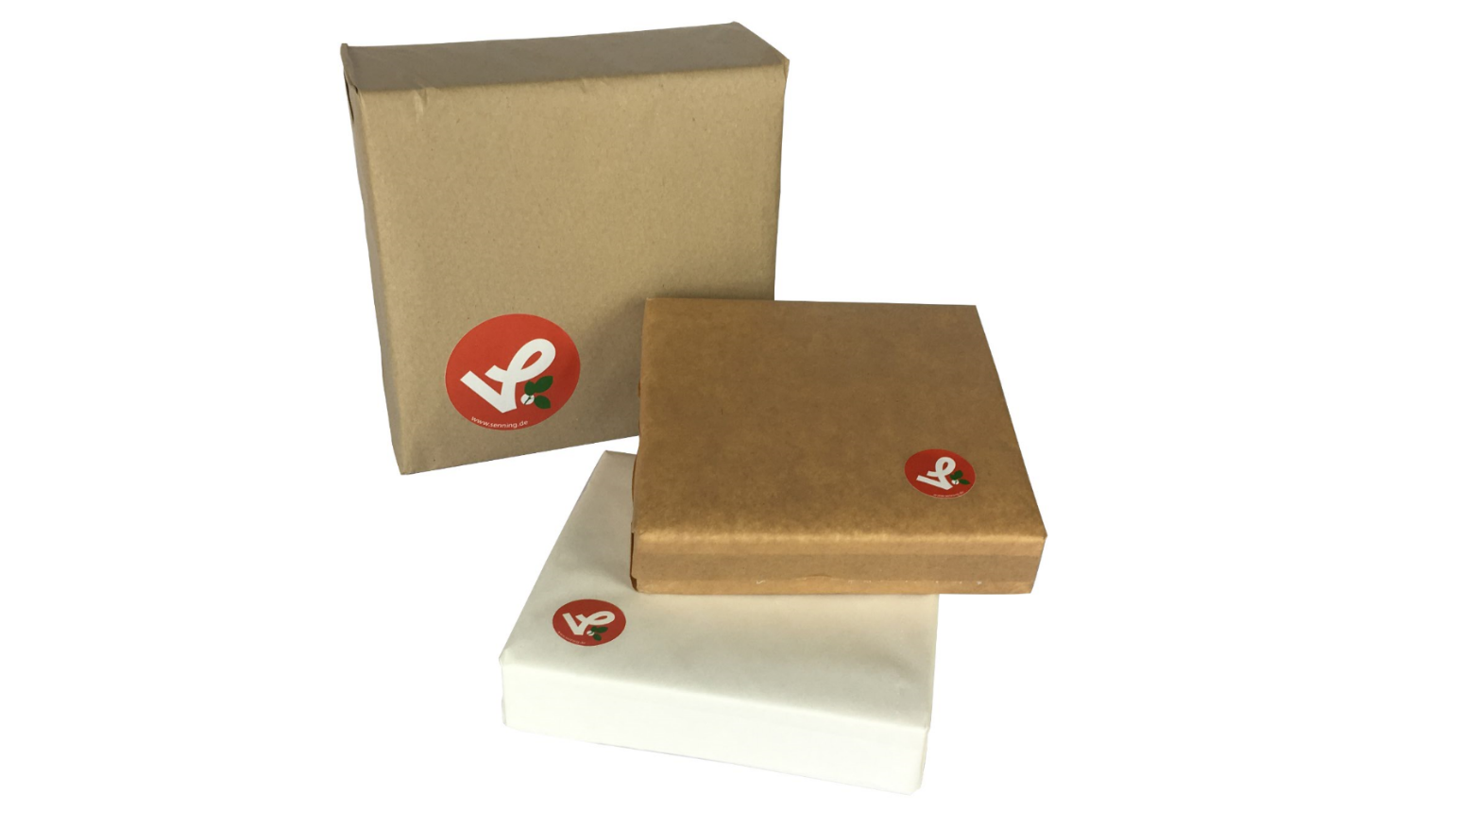
One of Senning's latest packaging projects: Napkins in paper packaging. The paper and tissue industry is increasingly using paper as a more environmentally friendly alternative packaging material. (Source: Senning)

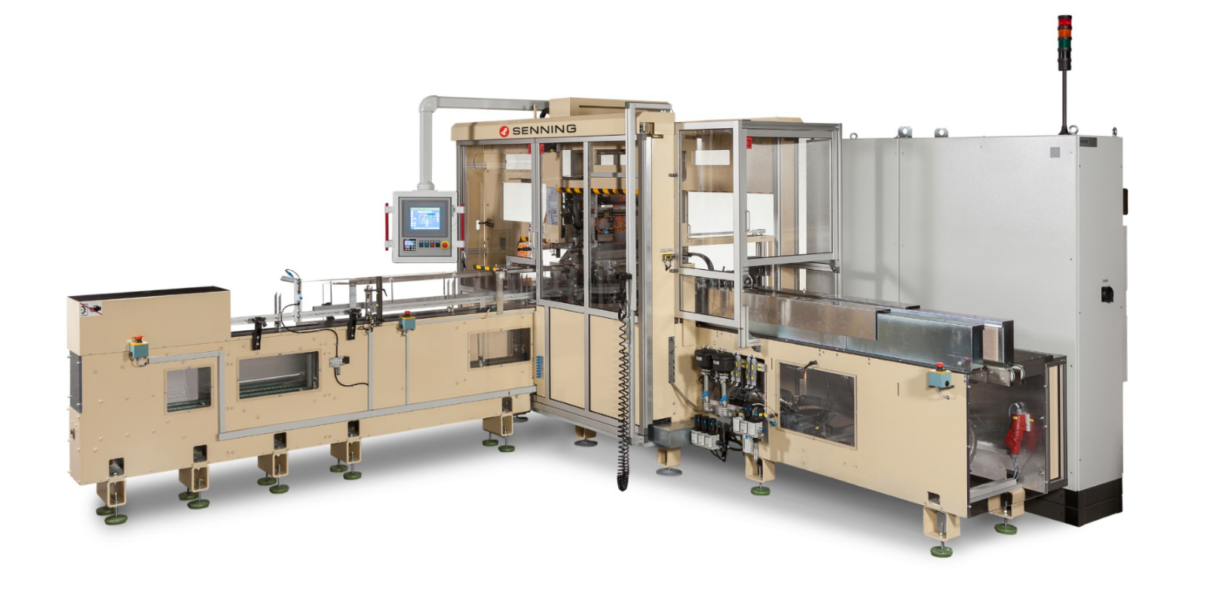
Senning's SE660 series machines can be flexibly converted from film to paper packaging. (Source: Senning)

Characters (incl. spaces): 2,122

Press contact:
OPTIMA packaging group GmbH
Jan Deininger
Group Communications Manager
+49 (0)791 / 506-1472
jan.deininger@optima-packaging.com
www.optima-packaging.com

About OPTIMA
Optima supports companies worldwide with flexible and customer-specific filling and packaging machines for pharmaceuticals, consumer goods, paper hygiene and medical devices markets. As a provider of solutions and systems, Optima accompanies these companies from the product idea through to successful production and throughout the entire machine life cycle. 2,450 experts around the globe contribute to Optima's success. 19 locations in Germany and abroad ensure the worldwide availability of services.

Thank you very much for your publication. We look forward to receiving a specimen copy.

