PRESS RELEASE
Schwaebisch Hall, February 5, 2019

Turnkey expertise for filling and sealing processes for syringes, vials, and cartridges
Turnkey solutions are the focus for OPTIMA pharma at Pharmintech in Bologna

Pharmintech in Bologna (Italy) will be taking place in mid-April. Experts from Optima Pharma will be on hand in the expert zone to showcase a range of solutions, including the company's core competency: turnkey systems that use filling and closing machines and isolator and freeze-drying technologies. High-performance filling systems for pre-filled syringes will also be discussed. The OPTIMA SV 125 filling and sealing machine will be on show at the company's booth.
Optima Pharma develops and implements complex production lines with filling and sealing technologies, isolator technology, and freeze drying. This includes planning and implementation, the integrated factory acceptance test (iFAT), site management, and the site acceptance test (SAT) through to comprehensive services for all the machines and components involved in the filling and closing line. The latest engineering technologies such as flow visualizations and simulations also come into play here. In the case of integrated FATs, the complete systems including the isolator and freeze-drying system are assembled and tested at Optima Pharma’s headquarters in Schwäbisch Hall (Germany). The Comprehensive Scientific Process Engineering (CSPE) method is used to ensure that as little time as possible elapses from when the order is placed to when production begins. This revolutionizes the planning and implementation of pharmaceutical filling systems. The systems include filling and closing machines that cover a wide performance range up to very high speeds.
Reducing decontamination times even further
Optima Pharma’s portfolio is complemented by experts from Metall+Plastic, an Optima Group subsidiary. Some of the latest developments include the extreme shortening of isolator cycle times or the particularly user-friendly and modular STISO sterility test isolator, for example. With DECOpulse®, the company recently presented a new, innovative process, which halves the duration of the overall decontamination cycle and, by using less H₂O₂, reduces the exposure of materials, active ingredients, and products to H₂O₂. Using e-beam tunnels to sterilize tub surfaces is another of Metall+Plastic’s strengths.

Compact freeze dryer for small and medium quantities

The Optima Pharma division’s freeze-drying expertise originates in Gladenbach-Mornshausen (Hesse, Germany). Ultra-modern freeze-drying systems are assembled at Optima Pharma’s subsidiary there. One of its latest innovations is the CS freeze dryer. This is tailored to products that are new to the market and are initially produced in small and medium quantities. The space-saving CS freeze dryer is optimized for installation in existing buildings. Experts from Gladenbach-Mornshausen round off the turnkey portfolio with modern SCADA systems for controlling entire production lines.

Optima Pharma at Pharmintech in Bologna, Italy: April 10 to 12, 2019, hall 16, booth no. A4–B3
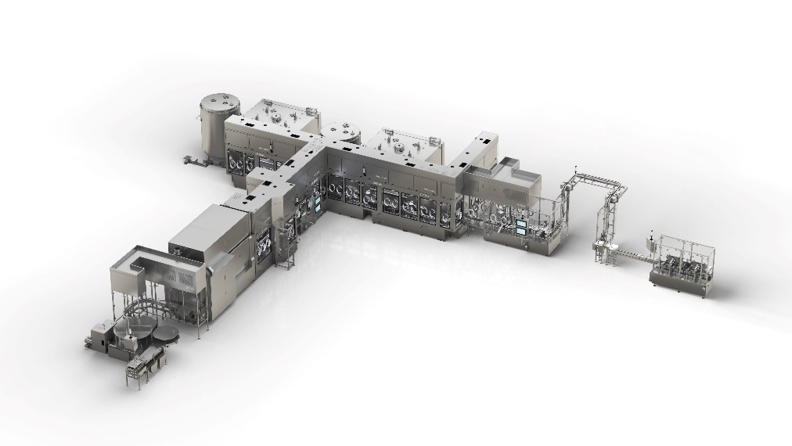
Integrated complete systems consisting of filling and closing machines, isolator and freeze-drying technology are core competencies at Optima Pharma. These systems are assembled in Schwäbisch Hall, put into operation and delivered.

Characters (incl. spaces): 2,982

Press contact:
OPTIMA packaging group GmbH
Jan Deininger
Editor
+49 (0)791 / 506-1472
jan.deininger@optima-packaging.com
www.optima-packaging.com
Thank you very much for your publication. We look forward to receiving a specimen copy.

