IN THE YEAR 2022: Great response to Laser World of Photonics Munich
The industry met at the futuristic RAYLASE stand to discuss the countless production-saving innovations on the topic of "laser deflection units
"In the 18 years that I have been going to the laser trade fair, I have never experienced such a rush of visitors to our stand - right from the very first day," emphasised Wolfgang Lehmann, Product Manager at RAYLASE. May it be due to the fallen Corona rules, the longing for real contacts or the booming electromobility, the laser industry called for the presence event and international and European interested parties came in numbers to the leading laser world fair in the Bavarian capital. This year's Laser World of Photonics in Munich from 26-29 April attracted 900 exhibitors from 30 countries and more than 15,000 visitors. RAYLASE Marketing & Sales Director Harnesh Singh: "We are very satisfied with the outcome of the trade fair. Not only did our new stand concept get a lot of positive attention, but also our numerous product solutions for the solar, AM and electromobility sectors were also well received by the trade public.”

Laser technology provider RAYLASE's focus this year was on its RAYGUIDE software, which was represented and well received at the stand. It helps to fundamentally make the precision of laser systems in manufacturing more efficient. This allows the effort required for resources to be reduced. Together with the SP-ICE-3 control electronics, it offers high functionality for solar applications and perfect solutions for welding processes in electromobility. It is used for cutting electrode foils as well as for scoring packaging foils and cutting paper packaging and cardboard boxes. "The new architecture generally makes it possible to achieve the goal faster and more flexibly while at the same time ensuring high product stability and the greatest possible user-friendliness," Robert Kachel, Product Manager Software at RAYLASE, emphasises its advantages.

The AXIALSCAN FIBER-50 pre-focusing deflection unit with the latest digital and highly dynamic RAYVOLUTION DRIVE focus axis also attracted great interest from the trade fair audience. In addition to the smallest spot diameters with large field sizes, it enables direct laser-fibre connection and process monitoring without optical or chromatic distortions. The RAYLASE monitoring module RAYSPECTOR can be added as an option. Both together help machine builders in the field of "contacting battery cells" not only to find the exact position of the cells using coaxial camera technology, but also to connect welding monitoring systems for quality assessment of the weld seams.

Visitors to the stand were also impressed by the elegant design and usability of the SFC 600, the SCAN-FIELD-CALIBRATOR, on display at the stand. The SFC takes over the fully automated calibration of "scan fields" where manual processes reach their limits and are too inaccurate, too time-consuming and error prone. Especially for machine builders who must calibrate many large process fields in the AM sector, the device pays for itself very quickly. "Our new SFC is currently unique on the market and defines an unsurpassed level of perfection in terms of saving steps, time and accuracy," Singh emphasises the benefits.

In addition, under the slogan MEET THE ORIGINALS, the company had an offer at the trade fair for career starters and experienced people to find out more directly from the RAYLASE experts. Interested parties were able to arrange meetings with RAYLASE department heads via a social media campaign and by emailing universities and institutes. The heads of Purchasing, Project and Product Management, Mechanical & Optical Development, Software Development, Electronics and Control Engineering and the Technical Competence Centre (TCC) were present.
__________________________________________________________________________

About RAYLASE
RAYLASE GmbH is a highly innovative, international laser company based in Wessling near Munich. Founded in 1999, the Bavarian company offers high-precision opto-mechanical components, control cards and software for the rapid deflection and modulation of laser beams for laser material processing in industrial manufacturing. With over 130 employees worldwide, the RAYLASE Group stands for innovative technology of the highest quality. Since 2007, the company has a subsidiary and its own production facility in Shenzhen, China, as well as several international representatives in the US, Italy, Japan, Korea, and Taiwan.

The laser deflection units comprise opto-mechanical scanners and digital control electronics with an intuitive software interface. These form the core of industrial laser systems and enable more flexible, economical, and precise processing of a wide variety of materials such as metal, plastic, paper, textiles and many more. Opto-mechanical deflection units also offer excellent image processing for better calibration, simple automation, and exact monitoring of a range of laser processes.

Customers come from the electronic, automotive, photovoltaic, textile and packaging industries. RAYLASE’s current focus markets are electromobility, for example, in battery production, solar wafer production for photovoltaics in the solar industry and additive manufacturing. RAYLASE supports its customers primarily in four core applications: laser cutting, laser welding, laser surface processing and selective laser sintering or welding for additive manufacturing. In each of these areas, the company drives digital innovations by combining these with established technologies.

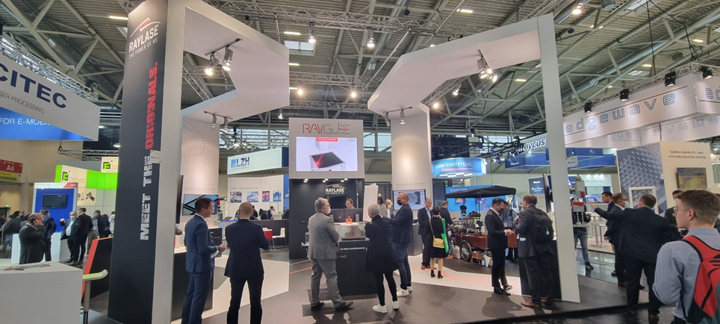

There was a lot of interest at the RAYLASE stand. The focus was on the RAYLASE software RAYGUIDE, which is used in many industries such as solar, AM and electromobility.

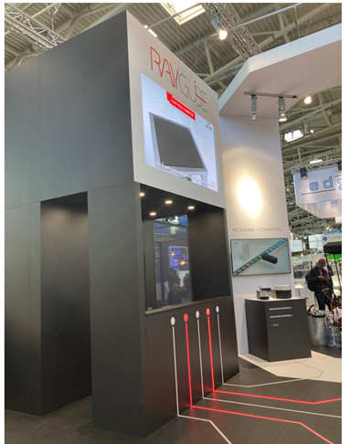

The RAYLASE stand is reminiscent of a compact laser deflection unit. In the centre was the software RAYGUIDE, from which various laser beams led to the individual product groups, such as solar, AM, electromobility, etc.

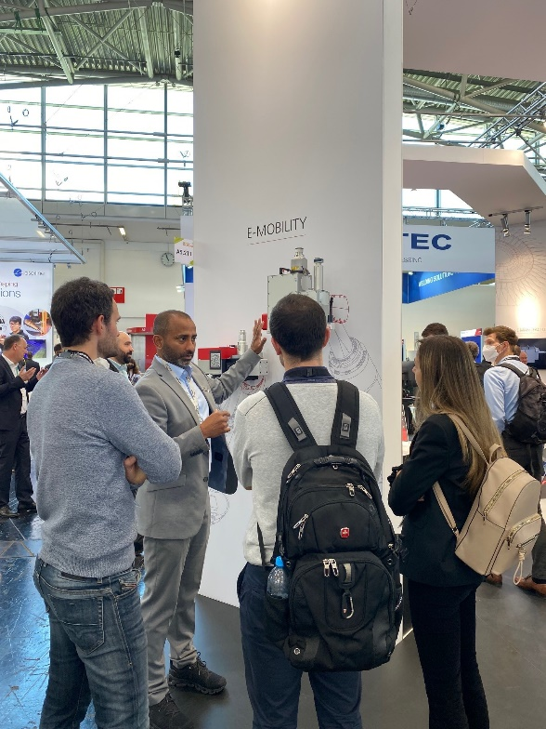

Marketing & Sales Director Harnesh Singh explains to young visitors the advantages of the various welding products in electromobility.
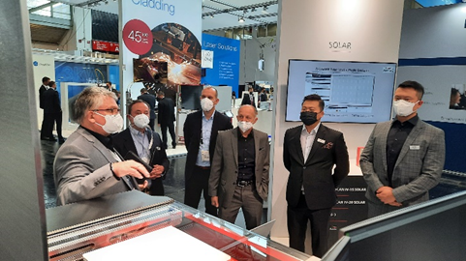
Wolfgang Lehmann, Product Manager RAYLASE shows the new SFC 600, which is unique on the market in terms of saving steps, time and accuracy in process field calibration.

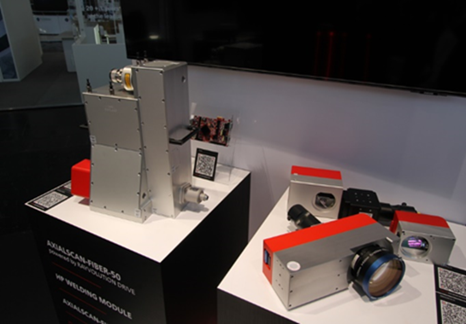
The AXIALSCAN FIBER-50 pre-focusing deflection unit with the latest digital and highly dynamic RAYVOLUTION DRIVE focus axis has been in high demand from machine builders

