LAMILUX at Caravan Salon 2022, Hall 13 Stand F94

Professional material for motorhomes

Under the slogan “SUNSATION® OVER GENERATION”, LAMILUX will be presenting its new products at Caravan Salon 2022 in Düsseldorf: the most UV-resistant GRP face sheet in the world LAMILUX SUNSATION®. LAMILUX fibre-reinforced composites (GRP) not only impress with their UV resistance. LAMILUX also sets new standards in terms of value retention, peace of mind, hail, rust and dent resistance as well as easy repair. The GRP specialist can be found in Hall 13 at Stand F94.
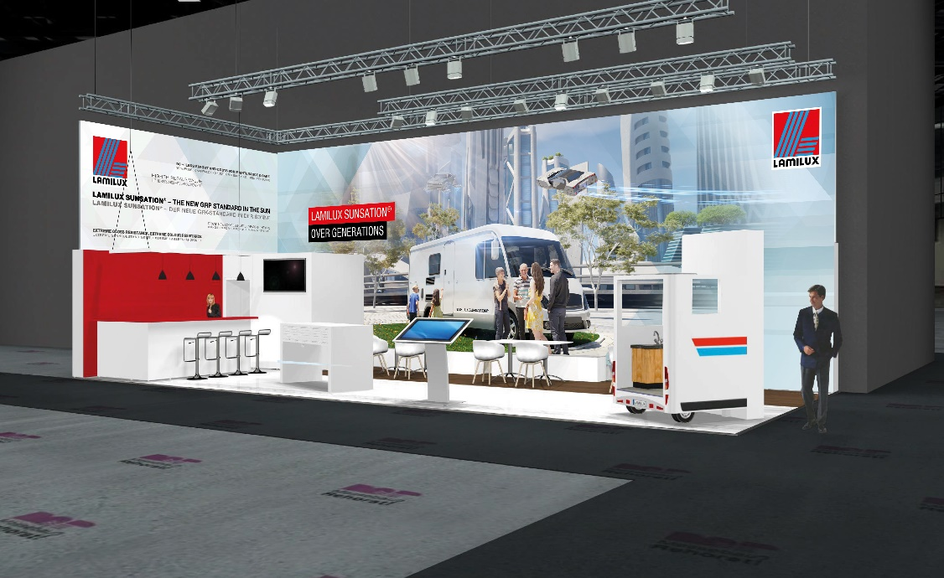
LAMILUX Composites is a German GRP manufacturer and market leader throughout Europe with its high-tech materials. LAMILUX Composites’ fibre-reinforced composites are distinguished by decades of experience in the European and American caravan market and the highest quality standards in Germany. In 2022, the manufacturer will be presenting its composite materials at Caravan Salon in Düsseldorf for the first time.

Tailor-made composites for every type of motorhome
GRP is used as the material of the future for the inner and outer face sheets of side walls, roofs, floor constructions, rear garages and underbodies of all well-known caravan and motorhome manufacturers. LAMILUX Composites offers tailored solutions for every application. When installed in the roof, LAMILUX X-treme impresses as an extremely durable hail protection roof; when it comes to interior design, LAMILUX Composites Floor as the floor material, LAMILUX LAMIGraph as a wall material and LAMILUX LAMIfoamtext for the interior roof meet all of the customer’s design requirements. LAMILUX Anti Slip Style as a visually attractive floor in rear garages, Impact woven roving as stone chip protection in the underbody and the world innovation Sunsation® as the outer side wall complement the manufacturer’s product portfolio, ensuring that motorhomes can easily withstand the challenges of everyday life.

New products: World’s most UV-resistant GRP face sheet
LAMILUX Sunsation® represents the long-awaited revolution in fibre composite plastics and completely redefines the standard for exterior applications. The innovative gelcoat technology features 20 times better UV resistance than the gelcoats currently available on the market, broadens the horizons in terms of image, appearance, care and value and makes investments look like new, even after decades in the sun.

Customer benefit shapes the development
All LAMILUX products are designed to satisfy a number of requirements at the same time. They always offer at least 2-in-1 or even 3-in-1 benefits. This means that LAMILUX GRP, for example, combines a harmonious appearance with robustness and durability, and reduces processing costs and the number of processing steps for customers at the same time. “The added benefits are the hallmark of our products: we analyse the application situations of our customers and produce the ideal products to satisfy their requirements”, says Marketing Consultant Markus Bächer. “In this respect, we consider it our job to keep on developing: to serve the customer, whatever the challenge.”

About Caravan Salon
Caravan Salon is the world’s largest trade fair for camping and caravanning and has made Düsseldorf the international capital of mobile leisure since 1994. Visitors can compare and buy motorhomes, caravans and camper vans in a wide variety of ways, as well as discover vehicle technology, components and attachments or caravanning accessories and much more.

…

Caravan Salon 2022 | LAMILUX

About LAMILUX Composites GmbH
LAMILUX Composites GmbH has been producing fibre-reinforced plastics for around 70 years. The medium-sized company is a leading European producer thanks to its technologically advanced continuous production process, large manufacturing capacities and wide product range. LAMILUX supplies customers around the globe in a wide range of sectors, such as the building industry, the automotive and recreational vehicle sectors, refrigerated store room and cell construction, and many other industrial sectors. With more than 1250 employees, LAMILUX generated a turnover of 335 million euros in 2021. The family-managed company is based in Rehau, Bavaria.

