**GEA, JGC Corporation and Chugai successfully commission advanced pharmaceutical spray dryer for OEB-5 containment**

Duesseldorf (Germany), August 21, 2025 – GEA is supplying Chugai Pharmaceutical in Japan with a cutting-edge pharmaceutical spray dryer designed and built to meet the highest containment standards. The PSD-3 spray dryer was successfully commissioned in the first quarter of 2025 and represents an important milestone in the collaboration between the two companies. Headquartered in Tokyo, Chugai Pharmaceutical is a leading research-based pharmaceutical company focused on innovative medicines. The project was executed in collaboration with the Japanese engineering company JGC Japan Corporation. This PSD-3, the first pharmaceutical spray dryer built by GEA for OEB-5 products, sets new standards for high-containment pharmaceutical spray drying.

**Specially designed for processing highly potent pharmaceutical products classified as OEB-5**

The spray dryer has been specially developed for processing highly potent pharmaceutical products classified as OEB-5 (substances with the highest hazard potential), substances with occupational exposure limits (OELs) in the nanogram/m3 range. This makes it one of the most advanced and safest systems ever built for high-containment spray drying in the pharmaceutical industry. This spray dryer is part of Chugai’s new FJ3 pharmaceutical manufacturing facility for OEB-5 products in Fujieda, designed and built in close collaboration with JGC Corporation.

**A Technological Masterpiece in Spray Drying**

"This pharmaceutical spray dryer is one of the most technically advanced spray drying systems ever built by GEA," says Dr. David Costes, Area Sales Manager at GEA. "Our team’s extensive expertise in spray drying, combined with JGC’s engineering excellence and Chugai’s deep knowledge of high-containment processes, has allowed us to create a truly groundbreaking solution. This system not only meets but exceeds the stringent containment and operational demands of the pharmaceutical industry."

With over 30 years of experience in designing and delivering pharmaceutical spray dryers, GEA is the leading supplier in the field. Dr. Costes continues, "We are incredibly proud of our collaboration with Chugai and JGC, companies with exceptionally high standards. Together, we’ve developed a solution that integrates advanced containment, precise process control and state-of-the-art automation features."

**Innovative Solutions for High-Containment and Control**

The project presented unique challenges due to Chugai’s and JGC’s demanding requirements, especially in terms of containment and process automation. These challenges have pushed GEA to innovate and develop new, customized solutions to achieve the level of containment required for OEB-5 substances. Jesper Hansen, Senior Process Technologist at GEA, adds, “This project has been a great learning experience for us. Working alongside such a detail-oriented and perfection-driven partners like Chugai and JGC pushed us to go beyond conventional limits. Every solution we implemented was tailored to meet their exact needs, and we are proud of the result. This spray dryer is one of the most advanced pharmaceutical closed-cycle spray drying plants in the world and establishes new industry benchmarks for high-containment pharmaceutical spray dryers."

**A collaborative Success with High Containment Expertise**

A member of FJ3 project comments, “We are thrilled to have successfully completed this project and to have the new spray dryer now in full production. It significantly enhances our drying capabilities, offering greater flexibility and efficiency for our operations. The collaboration with GEA and JGC has been very rewarding and has resulted in a truly outstanding piece of equipment and a new production facility for OEB-5 products.” The same FJ3 project member adds, “GEA’s creativity and technical know-how were key to delivering a solution that met all our specific requirements. We are confident that this new spray dryer will play a crucial role in advancing Chugai’s product development and manufacturing capabilities."

**Photos:**

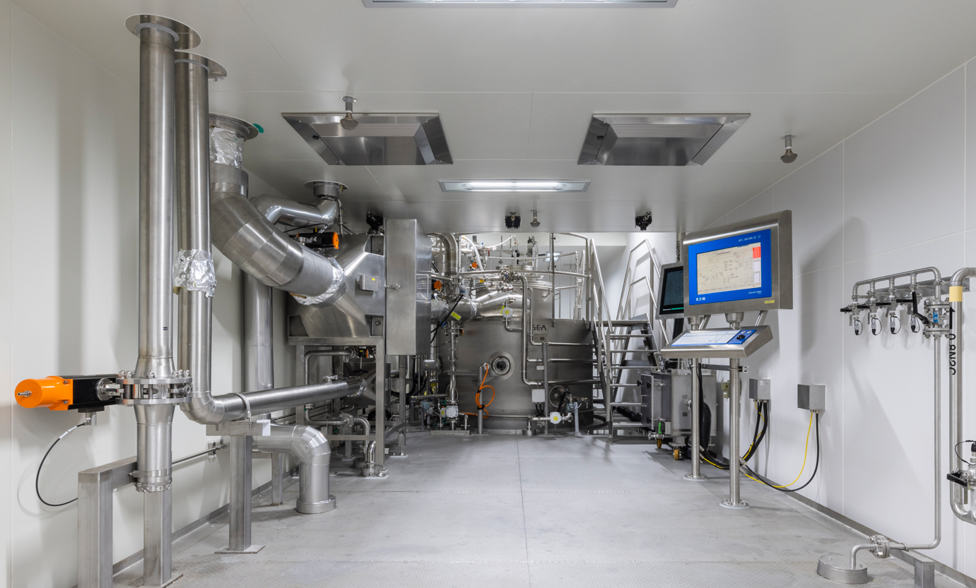

Photo 1: Inlet HEPA filter and top of GEA PSD-3 drying chamber. (Photo: Chugai)

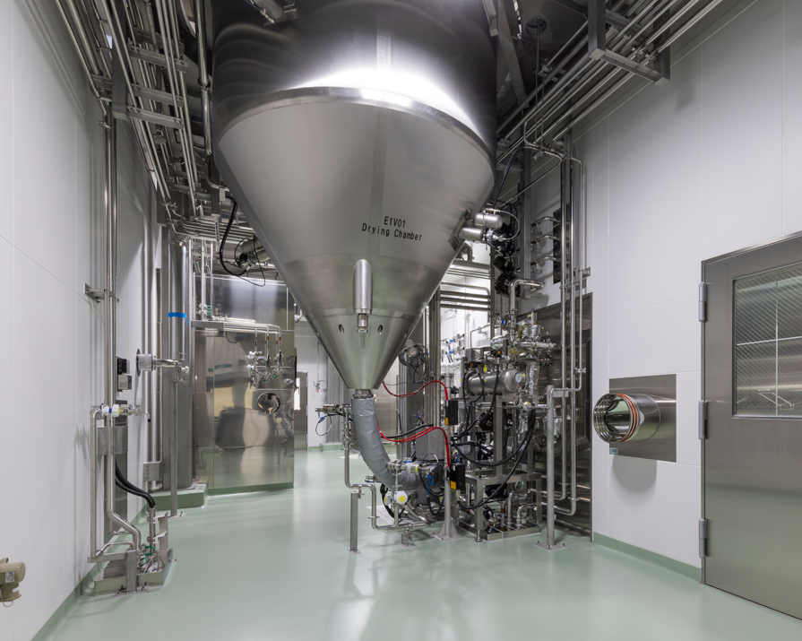

Photo 2: Bottom part of the GEA PSD-3 drying chamber with swing cone. (Photo: Chugai)

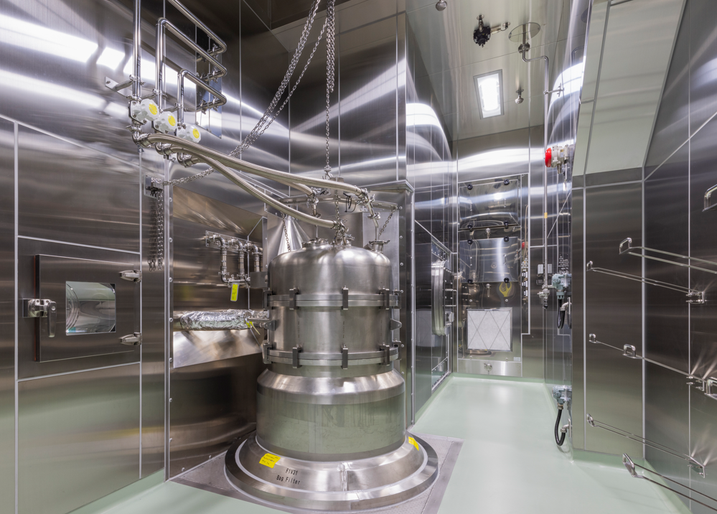

Photo 3: Top of the GEA Wettable Bag Filter. (Photo: Chugai)

**About Chugai Pharmaceutical Co., Ltd.**

Chugai Pharmaceutical Co., Ltd., headquartered in Tokyo, is a research-based pharmaceutical company with world-class drug discovery capabilities, including proprietary antibody engineering technologies. Chugai is committed to creating innovative pharmaceutical products that may satisfy unmet medical needs. Chugai is listed on the Prime Market of the Tokyo Stock Exchange. While maintaining autonomy and management independence, Chugai is an important member of the Roche Group. Additional information is available at[*https://www.chugai-pharm.co.jp/english/*](https://eur02.safelinks.protection.outlook.com/?url=https%3A%2F%2Fwww.chugai-pharm.co.jp%2Fenglish%2F&data=05%7C02%7Cdavid.costes%40gea.com%7C4a2568a710bc409f25d808ddc264707d%7C0e17f90f88a34f93a5d7cc847cff307e%7C0%7C0%7C638880459265993342%7CUnknown%7CTWFpbGZsb3d8eyJFbXB0eU1hcGkiOnRydWUsIlYiOiIwLjAuMDAwMCIsIlAiOiJXaW4zMiIsIkFOIjoiTWFpbCIsIldUIjoyfQ%3D%3D%7C0%7C%7C%7C&sdata=c%2Fv8tEwESMO30WlwuPkjVfEQuHq%2FNQm2vY366QW7E9o%3D&reserved=0)*.*

**About JGC Japan Corporation**  
JGC Japan Corporation, also known as JGC Holdings Corporation, is a world-renowned engineering company based in Japan. Established in 1928, its headquarters are located in Yokohama City, Kanagawa Prefecture. JGC specializes in the design, procurement, and construction (EPC) of facilities such as oil refineries, natural gas processing plants, and LNG plants. In addition to these services, it actively contributes to the life sciences sector. So far, JGC has managed more than 600 EPC projects for pharmaceutical manufacturing facilities and laboratories.

About GEA

GEA is one of the world’s largest suppliers of systems and components to the food, beverage and pharmaceutical industries. The international technology group, founded in 1881, focuses on machinery and plants, as well as advanced process technology, components and comprehensive services. For instance, every second pharma separator for essential healthcare products such as vaccines or novel biopharmaceuticals is produced by GEA. In food, every fourth package of pasta or every third chicken nugget are processed with GEA technology. With more than 18,000 employees, the Group generated revenues of about EUR 5.4 billion in more than 150 countries in the 2024 fiscal year. GEA plants, processes, components and services enhance the efficiency and sustainability of customers’ production. They contribute significantly to the reduction of CO2 emissions, plastic usage and food waste. In doing so, GEA makes a key contribution toward a sustainable future, in line with the company’s purpose: ”Engineering for a better world.”

GEA is listed on the German MDAX, the European STOXX® Europe 600 Index and is also a constituent of the leading sustainability indices DAX 50 ESG, MSCI Global Sustainability and Dow Jones Best-in-Class World.

More information can be found online at gea.com.

If you do not wish to receive any further information from GEA, please send an e-mail to pr@gea.com.

NOTE TO EDITORS

* Further [information](https://www.gea.com/en/company/about-us/index.jsp)about GEA
* To the GEA [Press page](https://www.gea.com/en/company/media/index.jsp)
* To the GEA [Media Center](https://www.gea.com/en/company/media/media-center/index.jsp)
* Background information on current topics can be found at [Features](https://www.gea.com/en/company/media/features/index.jsp)
* Follow GEA on [Ein Bild, das Logo, Symbol, Screenshot, Schrift enthält.

  Automatisch generierte Beschreibung](https://www.linkedin.com/company/geagroup/posts/?feedView=all) [](http://www.youtube.com/user/TheGEAGroup)

**GEA**

Media Relations GEA

Dr. Michael Golek

Peter-Müller-Str. 12, 40468 Düsseldorf

Phone +49 211 91361505

Tel. +491736205746

**michael.golek@gea.com**