PRESS RELEASE
Schwaebisch Hall, July 11, 2019

Great Momentum for New Pharmaceutical and Cosmetics Projects
Looking back – OPTIMA at the FCE Pharma & Cosmetique 2019 Trade Show

The STISO sterility test isolator from Metall+Plastic is eye-catching. Many visitors to the Optima trade show booth were very interested in this essential technology for pharmaceutical quality control. Both the pharmaceutical and the consumer sections also reported that they made overwhelmingly good contacts and received many specific requests during the trade show. The FCE Pharma & Cosmetique trade show took place in Brazil at the end of May.
FCE Pharma & Cosmetique is considered the most important trade show for Brazil and other South American countries. In addition to the multinational pharmaceutical corporations that are also present in South America, the local market is currently particularly focused on “traditional” filling and closing machines for vials. However, demand for the newest trends, like the highly flexible MultiUse Filler, is still developing. The same applies to production isolators or complete turnkey projects, which were mainly in demand from the international corporations at the trade show.
The still new STISO Sterility Test Isolator from Metall+Plastic was at the heart of numerous specific inquiries. Ergonomic aspects are at the heart of the STISO’s design because laboratory staff usually work at this type of isolator for several hours at a time to test the aseptic characteristics of pharmaceutical products. The STISO provides many benefits, including its modular space-saving construction, wireless glove testing devices, and a fast decontamination cycle.
Brazil has one of the world's leading cosmetics industries. These customers’ and prospective buyers’ requirements are based on current state-of-the-art technology with regard to system flexibility, new digital Smart Services from Optima or complete individually designed systems that are requested for everything from turnkey projects to palletized options. Semi-automated or fully automated entry-level solutions such as the OPTIMA FM1 and CM1 Filling and Closing Machines are just as important and have already convinced customers with their high degree of flexibility. All visitors – whether from the pharmaceutical or cosmetics industries, from large or small companies – were impressed by how quickly local service is available.
A trend seen at many trade shows also continued at FCE Pharma & Cosmetique in Brazil: Visitor numbers remained constant or were slightly lower, but the quality of the contacts made remained very high. This means that visitors often already have specific questions when they come to the trade show. Once again, numerous projects were also discussed at FCE Pharma & Cosmetique, and we expect to close on those contracts shortly.

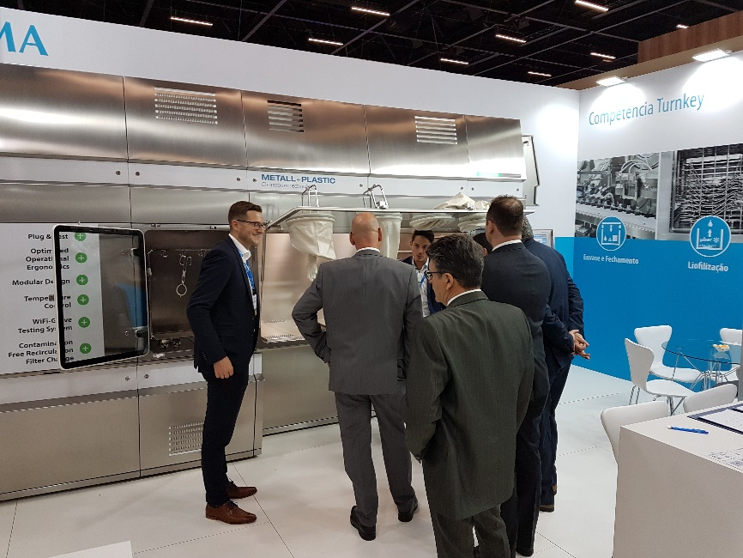
The STISO sterility test isolator from Metall+Plastic won over FCE Pharma & Cosmetique visitors with its ergonomic characteristics and many functional details.

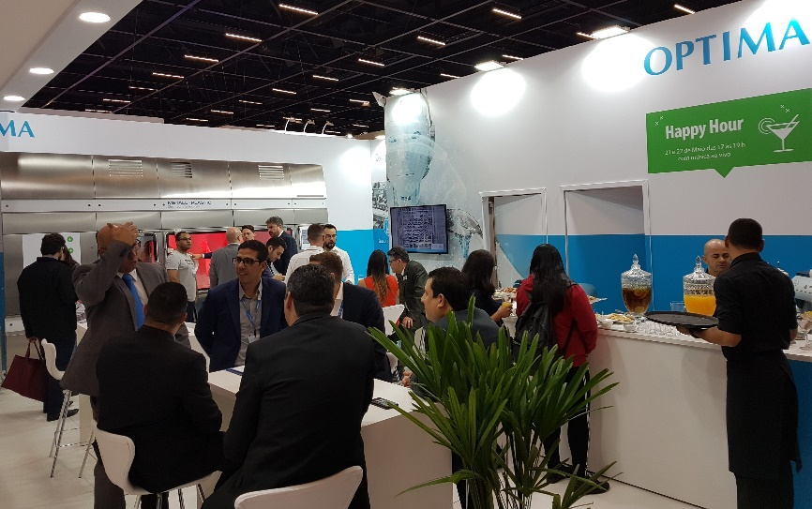
Happy Hour at the Optima FCE Pharma & Cosmetique trade show booth nearly became rush hour – but the atmosphere remained personal and relaxed.

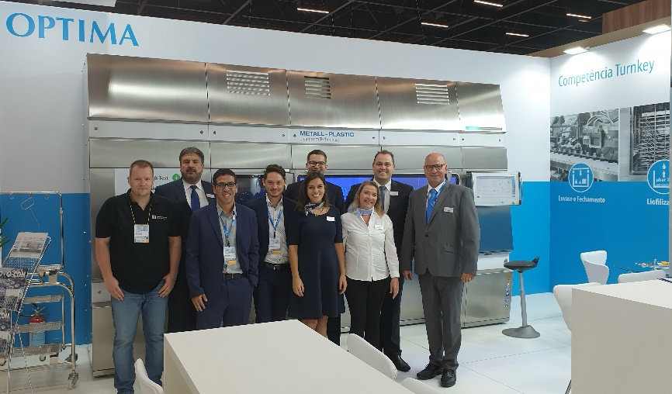
The German-Brazilian Optima trade show team at FCE Pharma & Cosmetique.

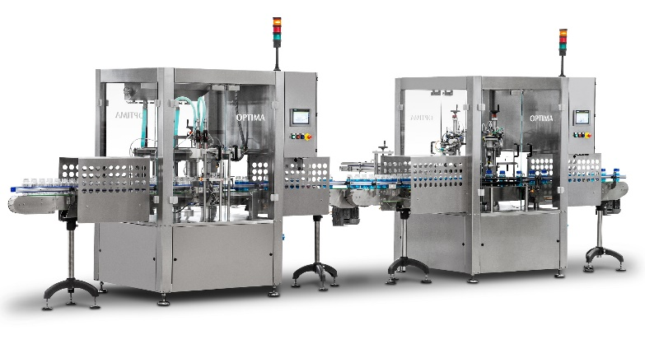
The OPTIMA FM1 and CM1 entry-level solutions for filling and closing can be operated as a stand-alone option or as part of a production line.

Characters (incl. spaces): 2,790

Press contact:
OPTIMA packaging group GmbH
Jan Deininger
Editor
+49 (0)791 / 506-1472
jan.deininger@optima-packaging.com
www.optima-packaging.com
Thank you very much for your publication. We look forward to receiving a specimen copy.

