On  On Kawara  27 August – 6 November 2022  With contributions by Bethan Huws, Tatsuo Miyajima, Barbara Signer, Aleksandra Signer, and Roman Signer  It seems incomprehensible, this time that defines our existence like no other dimension. This homage to On Kawara and Hiroko Kawahara brings together five artists who have created unique works on this subject. In keeping with the flow of time, the artists will engage in a dialogue with works by On Kawara from the collection of the Kunstmuseum St. Gallen.  Curator: Roland Wäspe  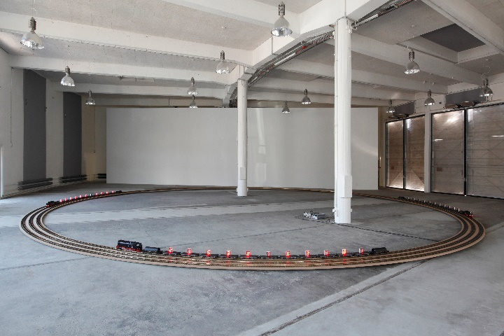  Tatsuo Miyajima, Tree Time Train, 2014,  Installation view Kunstzone (art space) in the Lokremise St.Gallen | Exhibition dates  27 August – 6 November 2022  Kunstzone (art space) in the Lokremise  Press conference  26 August, 11 am  Exhibition opening  26 August 2022  6.30 pm  Opening hours  Mon. – Sat.: 1 pm – 8 pm  Sun.: 11 am – 6 pm
Press contact

Gloria Weiss
Kunstmuseum St. Gallen
Head of Communications
Museumstrasse 32
9000 St. Gallen
T +41 71 242 06 84

Sophie Lichtenstern
Kunstmuseum St. Gallen
Communications
Museumstrasse 32
9000 St. Gallen
T +41 71 242 06 85

kommunikation@kunstmuseumsg.ch
www.kunstmuseumsg.ch
Factsheet
On
On Kawara

Exhibition dates | 27 August – 6 November 2022
Exhibition venue | Kunstzone (art space) in the Lokremise
Press conference | 26 August, 11 am, Kunstzone (art space) in the Lokremise
Exhibition opening | 26 August 2022, 6.30 pm, Kunstzone (art space) in the Lokremise
Curator | Roland Wäspe
Opening hours | Monday – Saturday: 1 pm – 8 pm, Sunday: 11 am – 6 pm
Admission | Single admission, regular price  Combined ticket Kunstzone and Kunstmuseum  Group ticket (from 8 persons)  Members of the Kunstverein St. Gallen | CHF 6.–  CHF 16.–  CHF 14.–  Free
Press contact | Gloria Weiss  T +41 71 242 06 84  Sophie Lichtenstern  T +41 71 242 06 85  kommunikation@kunstmuseumsg.ch
Website | www.kunstmuseumsg.ch

