Award for the highest customer satisfaction

**LAMILUX wins the PLUS X Award**

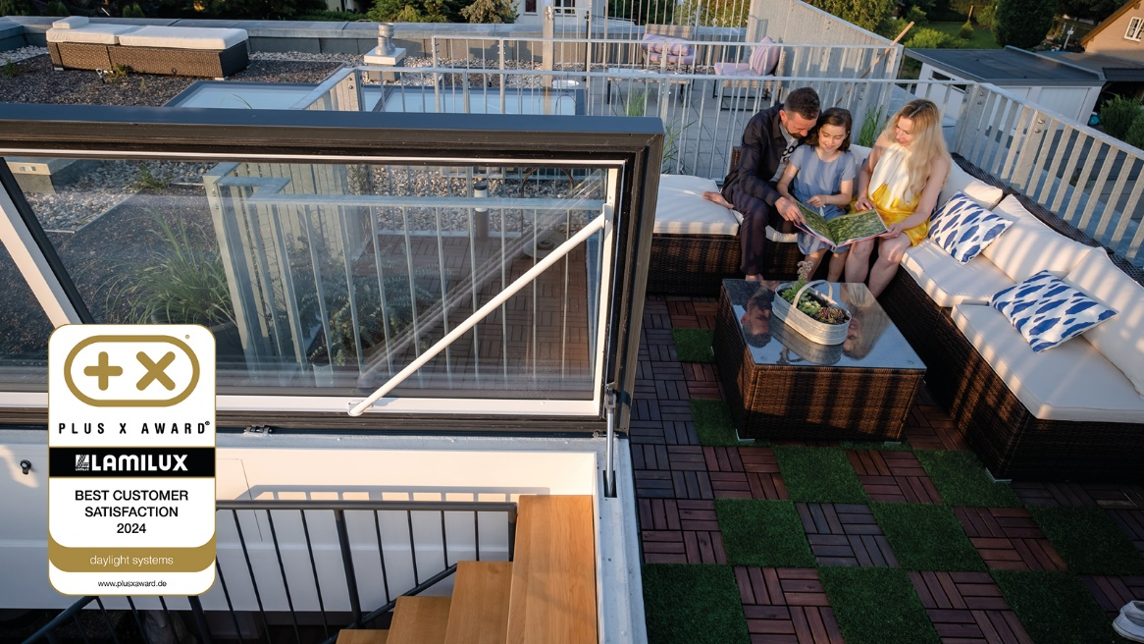**LAMILUX has won the prestigious Plus X Award in the category ‘Germany's Highest Customer Satisfaction 2024’, taking first place. This important award recognises the company's extraordinary commitment and outstanding achievements in increasing customer satisfaction.**

‘How reliable is a brand promise and how satisfied are Germans with their brand after making a purchase?’ - This main question is the focus of the annual consumer survey conducted on behalf of the Plus X Award. Especially in times of digital transformation, when customer advice and after-sales service often falls short of expectations, LAMILUX is setting a strong example. The company was able to impress its customers in every respect and prevail against strong competition.

‘We are delighted with this recognition! It confirms our endeavour to always satisfy and inspire our customers beyond the desired level. We have been following our company philosophy ‘Customised intelligence - serving the customer as a programme’ for many decades. Our corporate philosophy is more than just a motto for us - it is the basis of everything we do,’ emphasises Dr Alexander Strunz, Managing Director of LAMILUX.

Klaus Gollwitzer, Chief Sales and Marketing Officer at LAMILUX, agrees: ‘Our customers are at the centre of everything we do. This award is great proof that our continuous commitment to excellence in all areas relevant to the customer is bearing fruit. I would like to thank the entire LAMILUX team for this, because this award is the day-to-day work of our enthusiastic employees.’

The ‘Highest Customer Satisfaction 2024’ award is a great honour and impressive proof of LAMILUX's excellent work and tireless commitment. The company shows that it is not only able to deliver high-quality products, but also to keep its promises and ensure the highest level of customer service.

**About the Plus X Award**

The PLUS X AWARD is the world's biggest innovation prize for technology, sport and lifestyle. Since 2018, it has honoured companies that have been awarded the highest level of general satisfaction in an unsupported online survey of customers. A total of 11,372 valid votes were analysed in a nationwide survey conducted by the German Institute for Product and Market Research between May and June 2024. Consumers had the opportunity to vote for their favourite brands in 62 different categories.

LAMILUX Heinrich Strunz Group, Rehau

Continuous rooflights, glass roofs or rooflights: the LAMILUX Heinrich Strunz Group is one of the leading manufacturers of skylights in Europe. The skylights ensure efficient use of natural daylight in a wide variety of buildings. In addition, special smoke and heat extraction systems provide safety in case of fire and are therefore essential components of fire protection concepts. LAMILUX is also known for its solutions for object smoke extraction. Furthermore, the medium-sized family business founded in 1909 is one of the world's largest producers of carbon and glass fibre reinforced plastics. These composite materials provide stability, lightweight construction and impact resistance for instance in roof, wall and floor linings in commercial vehicles. LAMILUX strives to be the innovation and performance leader in all areas relevant to its customers. The family-owned company, based in Rehau, Germany, is managed by Johanna and Dr. Alexander Strunz in the fourth generation, currently employs around 1,300 people, and in 2023 generated sales of around 354 million euros.

[www.lamilux.com](http://www.lamilux.com)