PRESS RELEASE
Schwaebisch Hall, February 4, 2019

OPTIMA OSR packaging machine: High speed coupled with flexibility
OPTIMA at Tissue World Milan

With machines like the OSR, Optima is offering what is currently technically feasible in terms of performance and flexibility. The company will also be showcasing its extensive range of the latest machines and digital services at Tissue World Milan.
Optima Nonwovens offers cutting-edge technologies for packaging paper hygiene products. The OPTIMA OSR, which is just one of the machines that visitors can find out more about in Milan, is specifically designed to process kitchen and toilet rolls. The machine can be used to produce single-layer and multi-layer packaging. The OPTIMA OSR covers the entire spectrum, from small to large pack sizes (min. 100 mm x 150 mm x 95 mm up to max. 650 mm x 650 mm x 300 mm). The product is packed in prefabricated plastic bags, including those with user-friendly carrying handles and perforations for easier opening. The performance of the two-lane version can reach up to 150 packs a minute.
At Tissue World, Optima Nonwovens will also be presenting leading packaging solutions for other paper hygiene products such as paper towels, napkins, wet wipes, and cotton pads. Thanks to their modular design, Optima machines can be easily adapted to meet specific customer requirements. They are also characterized by their format flexibility and quick and easy format changes.
In order to achieve fully automated lines, control stations and secondary packaging machines can be integrated into the systems. The issue of “sustainability” is also one of the focal points of the fair – Optima is particularly interested in what paper hygiene product manufacturers want in this regard. Feedback from visitors will be collected at the Optima booth.

Optima at Tissue World Milan (Italy):
March 25 to 27, 2019, Hall 3, booth no. E10
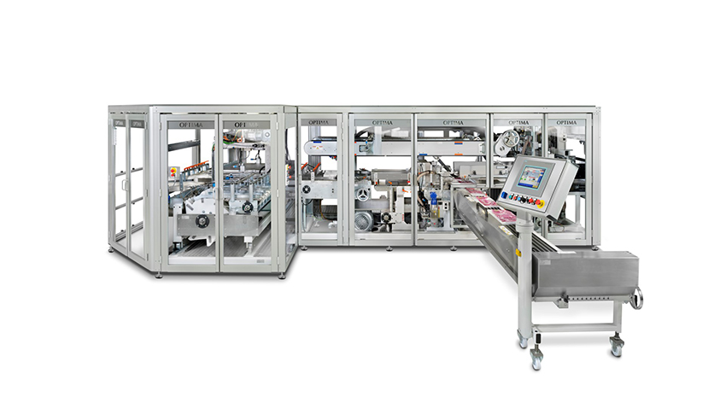

OPTIMA OSR: a fast and particularly format-flexible machine for packaging kitchen and toilet rolls

Characters (incl. spaces): 1,769

Press contact:
OPTIMA packaging group GmbH
Jan Deininger
Editor
+49 (0)791 / 506-1472
jan.deininger@optima-packaging.com
www.optima-packaging.com
Thank you very much for your publication. We look forward to receiving a specimen copy.

