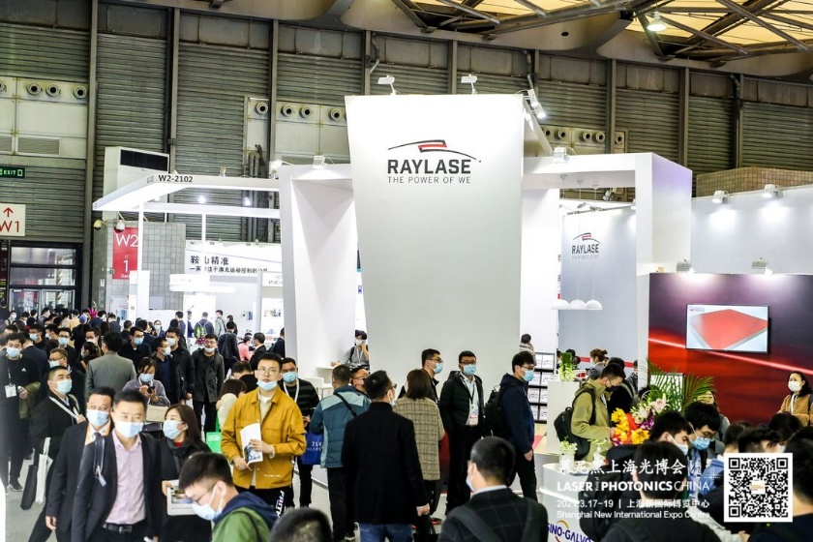
Successful LASER World of PHOTONICS CHINA – the premier global trade fair for the Asian region
In high demand – opto-mechanical scanners from RAYLASE that boost efficiency and productivity in the electromobility and additive manufacturing markets
This year's World of PHOTONICS CHINA trade fair far exceeded all expectations. Despite the preventive measures introduced in the context of the Covid 19 epidemic as well as many security checks, the three-day event had no less than 79,453 trade visitors (predominantly from China) – up a massive 39 percent on last year’s figure. A total of 1,094 exhibitors from 18 countries presented their products on a total floorspace of 63,500 square metres. Highlights included offerings for the electromobility and additive manufacturing markets, in response to the current explosion in demand for batteries and the general rise in requirements for 3D printing. RAYLASE from Upper Bavaria in Germany was also represented, alongside its Chinese subsidiary RAYLASE China. As Leo Liu, Sales Director at RAYLASE China, explains: “Our latest innovative laser deflection units are ideally suited to these markets. That is because they contribute in a sustainable way to improving efficiency and productivity, supported by our high-quality monitoring”.
Foremost among these innovations is the AXIALSCAN-FIBER series with the RAYSPECTOR, which is helping electromobility to continue gaining momentum. For Asian integrators and machine manufacturers in particular, these applications are helping to make battery cell production even more efficient. The focus here is on the complex welding process, e.g., for tab welding and cell binder welding, where the poles of the battery cells are connected by laser beam to enable a good series connection. Another example is laser welding of aluminium components of battery packs. A huge number of individual manufacturing steps are involved to get from cell production to assembled, installable battery packs in electromobility, with each step influencing overall productivity and the output of completed units.
The new RAYSPECTOR is the perfect enhancement for the AXIALSCAN FIBER as an opto-mechanical platform, as it provides the process monitoring that is so critical to ensuring high quality. There are two parallel optical paths for the camera and the welding sensors. A camera with highly dynamic focus tracking is used for production setup and monitoring – for example, to ensure the best possible connection of battery cells to prevent the battery from burning out. Additional welding monitoring systems can also be connected to the second sensor path. In combination, these two products function as a unit – unrivalled in its efficiency – for handling these important process steps in electromobility.
The Bavarian-based company has also added the RAYGUIDE software power-package to its portfolio. Together with the powerful SP-ICE-3 control electronics, it offers a high degree of functionality for solar applications and ideal solutions for the welding process in battery production and fuel cell manufacturing. The software can also be used for many other applications, such as marking, perforating, surface processing and MOTF. In addition, RAYGUIDE optimises laser cutting of electrode foils and current collector lugs in battery production.
However, the company has also positioned itself for a promising future by improving and accelerating the complex production steps in additive manufacturing. Leo Liu elaborates: “In China, there are various applications in additive manufacturing where fixed optics have traditionally been used. The rate of production throughput can be significantly improved with our new scanner technology – such as the AM module Next Gen for fibre-coupled lasers, which is based on pre-focussing deflection units. This module enables the creation of larger fields and larger components, as well as parallel operation of up to four modules over a processing field.
The RAYLASE China subsidiary, with its headquarters in Shenzhen, has been manufacturing its own solutions for the Asia-Pacific market for more than 10 years. These include the analog MINISCAN II series with the analog RL-III and RS-III ranges, which have been in high demand among industry experts. A very attractive price-performance ratio enables competition with Chinese manufacturers. For more challenging applications, the new, digital MINISCAN III offers even greater precision and stability in the laser process.
Summary: Digital opto-mechanical laser deflection units from RAYLASE optimise and enhance many laser processes in electromobility, the solar energy sector and additive manufacturing. They are easily integrated into machine manufacturers’ production lines and allow for easier scaling at higher production speeds and with outstanding precision. The result: Increased output in less time, plus reduced costs.
_________________________________________________________________________________

About RAYLASE

RAYLASE GmbH is a highly innovative, international laser company based in Wessling near Munich. Founded in 1999, the Bavarian company offers high-precision opto-mechanical components, control cards and software for the rapid deflection and modulation of laser beams for laser material processing in industrial manufacturing. With over 130 employees worldwide, the RAYLASE Group stands for innovative technology of the highest quality. Since 2007, the company has a subsidiary and its own production facility in Shenzhen, China, as well as several international representatives in the US, Italy, Japan, Korea, and Taiwan.

The laser deflection units comprise opto-mechanical scanners and digital control electronics with an intuitive software interface. These form the core of industrial laser systems and enable more flexible, economical, and precise processing of a wide variety of materials such as metal, plastic, paper, textiles and many more. Opto-mechanical deflection units also offer excellent image processing for better calibration, simple automation, and exact monitoring of a range of laser processes.

Customers come from the electronic, automotive, photovoltaic, textile and packaging industries. RAYLASE’s current focus markets are electromobility, for example, in battery production, solar wafer production for photovoltaics in the solar industry and additive manufacturing. RAYLASE supports its customers primarily in four core applications: laser cutting, laser welding, laser surface processing and laser powder bed fusion or selective laser sintering for additive manufacturing. In each of these areas, the company drives digital innovations by combining these with established technologies.

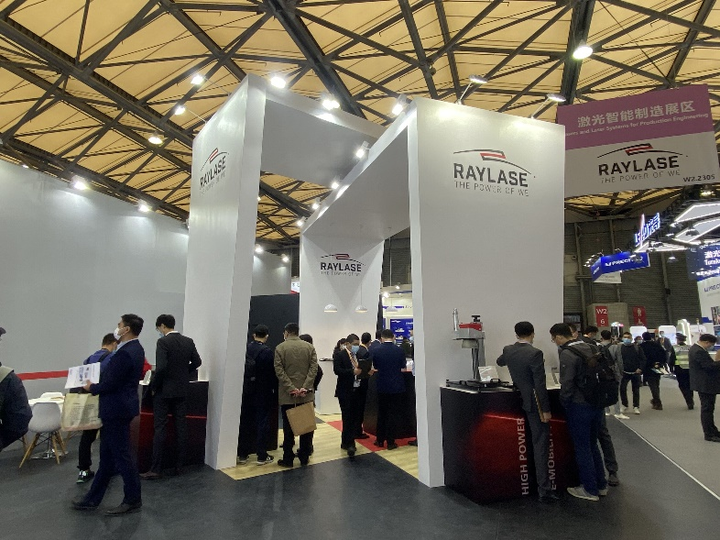
Interested Chinese machine manufactures find out
about the latest applications from RAYLASE GmbH.

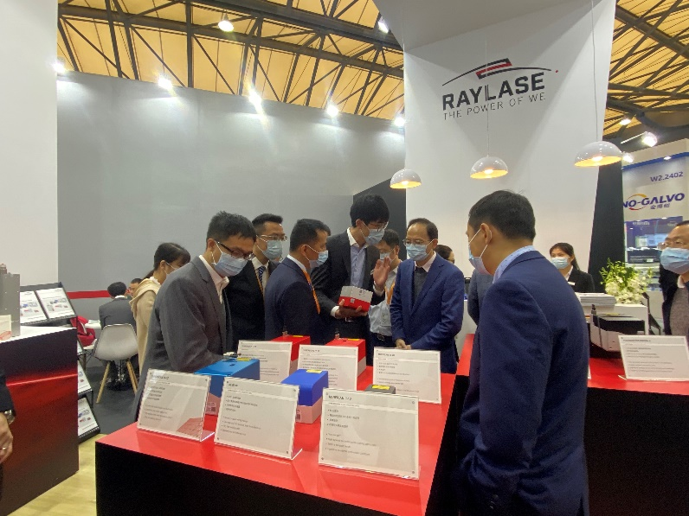
In an intensive exchange, visitors discuss
possible technical solutions at the RAYLASE stand.
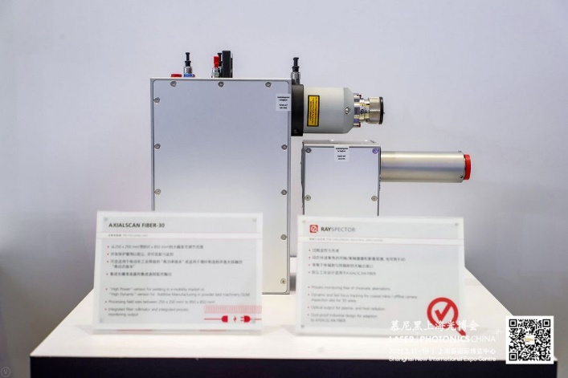
The AXIALSCAN-FIBER with the
RAYSPECTOR monitoring unit connected.

