LAUDA Celebrates Its 70th Anniversary

From Pioneer to Global Market Leader: Temperature Control Specialist Has Been Writing Extraordinary Success Story

Lauda-Königshofen, February 26, 2026 – LAUDA DR. R. WOBSER GMBH & CO. KG celebrates its 70th anniversary on March 1. The global market leader generates around 100 million euros in annual sales with approximately 570 employees across three locations in Germany and twelve foreign subsidiaries. Renowned customers all over the world rely on the precision of LAUDA – from chemistry, pharmaceuticals, and biotech to medical technology, the semiconductor industry, electromobility, and hydrogen technology.

Exactly seven decades ago, Dr. Rudolf Wobser founded the measuring instrument factory LAUDA DR. R. WOBSER KG in Lauda. With innovations such as novel laboratory thermostats in a modular system and refrigeration thermostats with mechanical cooling, the company established itself on the market in its early years. Wobser laid the foundation for success in 1949 with the development and series production of the world’s first thermostat. For the first time, a compact device could reliably heat and cool using liquid circuits. After fleeing the GDR in 1955, he systematically built up the business. Groundbreaking new developments such as industrial systems (1964), measuring instruments (1967), and the world’s first microprocessor thermostat (1982) shaped the company’s further development.

After the death of the company founder in 1977, his sons Dr. Gerhard Wobser and Karlheinz Wobser took over the management. Karlheinz Wobser retired at the end of 2002. Dr. Gunther Wobser was appointed as the new President & CEO and, together with his father Dr. Gerhard Wobser, remained at the helm of the company until 2010, when his father retired after 39 years.

Under the leadership of Dr. Gunther Wobser, the third generation of the family, the company’s international business activities were significantly expanded. In 2005, LAUDA France is founded as the first foreign subsidiary, followed three years later by branches in Latin America, China, and the USA. With acquisitions in Spain (2011) and the USA (2014) as well as further foreign subsidiaries in Great Britain (2012) and Italy (2014), the world market leader continuously expands its international presence. In 2015, the new subsidiary LAUDA Scientific took over the development, sales, and service activities for LAUDA measuring instruments. In 2016, the subsidiaries LAUDA Ibérica Soluciones Técnicas, S.L.U. in Spain and LAUDA América Latina Tecnologia Ltda. in São Paulo, Brazil, were founded. LAUDA expanded its portfolio in 2019 with the acquisition of the long-established company GFL Gesellschaft für Labortechnik mbH. LAUDA Medical GmbH & Co. KG was founded in 2021, followed in 2025 by the subsidiary Degree LAUDA Precision Pvt. Ltd. in Pune, India.

Parallel to its international expansion, LAUDA continuously invests in the expansion of its infrastructure at its headquarters. In 2013, a new logistics center and a new production hall with a total investment volume of around 6.2 million euros are inaugurated in Lauda-Königshofen. In 2014, LAUDA expanded its management team with Dr. Marc Stricker, followed by Dr. Mario Englert in 2017. In 2022, the company underwent another office expansion, investing approximately 1.1 million euros.

The technical range of services extends from compact laboratory thermostats to customer-specific large-scale systems with a cooling capacity of over 400 kilowatts. LAUDA devices and systems operate in a temperature range from -150 to 550 °C with a consistency of up to one thousandth of a degree Celsius – a level of precision that is indispensable in highly demanding applications.

Since 2015, LAUDA has consistently held the title of “world market leader” in the field of constant temperature equipment and systems for precise temperature control. The latest product developments underscore this position: In 2024, LAUDA launched Mobifreeze, the world’s first actively temperature-controlled, mobile ultra low temperature chest freezer. This was followed in 2025 by the market launch of LAUDA Universa – a modular product line with standard Wi-Fi control. In addition, LAUDA received the EcoVadis Silver Medal for sustainability achievements in 2025, as well as the “Best of AI Award” for its own AI platform LAUDA.GPT. The temperature control specialist is planning sales growth of around 15 percent to approximately 115 million euros for 2026.

“Our 70th anniversary fills us all with extraordinary pride,” explains Dr. Gunther Wobser. “Together we improve the world with precise temperatures – this aspiration drives everything we do. In this anniversary year, we want to be even closer to our customers and devote even more attention to them worldwide. Continuous innovation, excellent processes, and further growth will secure our position as the global market leader in the coming decades.”

LAUDA DR. R. WOBSER GMBH & CO. KG is already inviting all interested parties and citizens to an open house on Sunday, September 13, 2026, in Lauda-Königshofen. Details will be announced in good time in the daily press and on the social media channels of LAUDA.


Picture 1: Seven decades of innovation and precision: LAUDA will celebrate its 70th anniversary in 2026 and can look back on an extraordinary success story from pioneer to global market leader. © LAUDA

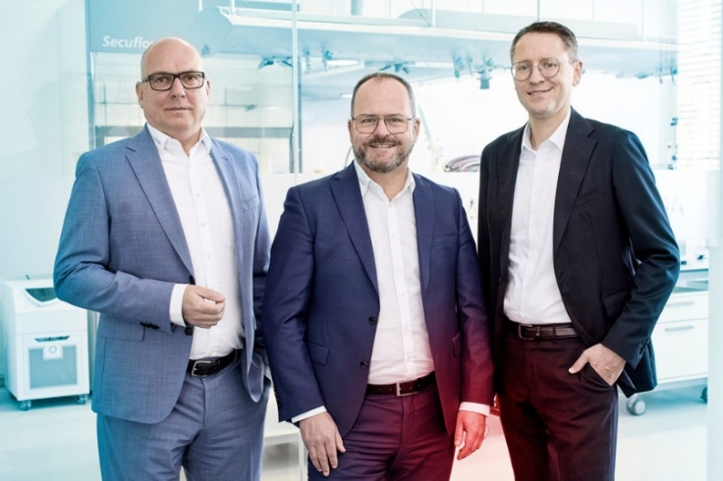
Picture 2: The LAUDA management team: Dr. Marc Stricker, Dr. Gunther Wobser, and Dr. Mario Englert (from left to right) are driving the global market leader forward with innovations such as LAUDA Universa and Mobifreeze and are planning sales growth of 15 percent for 2026. © LAUDA

We are LAUDA – the world leader in precise temperature control. Our constant temperature equipment and systems are at the heart of important applications, contributing to a better future. As a complete one-stop supplier, we guarantee the optimum temperature in research, production and quality control. We are the reliable partner for Aerospace, Electromobility, Hydrogen, Chemistry, Pharmaceuticals/Biotech, Semiconductors and Medtech. We have been inspiring our customers for 70 years with our expert mentoring and innovative solutions – every day anew and all over the world.

In our company, we always go one step further. We support our employees’ development and are constantly developing ourselves: to create a better future together.

Press contact
We are more than happy to make prepared information about our company, the LAUDA Factory Gallery and our projects in the area of innovation promotion, digitalization and idea management available to the press. We look forward to hearing from you – just give us a call!

CHRISTOPH MUHR
Director Corporate Communications
T + 49 (0) 9343 503-349
christoph.muhr@lauda.de

LAUDA DR. R. WOBSER GMBH & CO. KG, Laudaplatz 1, 97922 Lauda-Königshofen, Deutschland/Germany. Limited partnership: Headquarters Lauda-Königshofen, Registration court Mannheim HRA 560069. General partner: LAUDA DR. R. WOBSER Verwaltungs-GmbH, Headquarters Lauda-Königshofen, Registration court Mannheim HRB 560226. Managing Directors: Dr. Gunther Wobser (President & CEO), Dr. Mario Englert (CFO), Dr. Marc Stricker (COO)

