Highest Honor for Fritz Bartelt

LAUDA awards Dr.-Rudolf-Wobser-Medal to Austrian corporate partner

Lauda-Königshofen, January 23, 2025 – LAUDA DR. R. WOBSER GMBH & CO. KG has awarded Fritz Bartelt senior, the former Managing Director of the Austrian distributor Bartelt GmbH, the Dr.-Rudolf-Wobser-Medal. The award recognizes the exceptional and long-standing partnership between the two family-owned companies, which has existed since 1986.

Dr. Gunther Wobser, President & CEO of LAUDA, personally presented the award at the company headquarters in Graz in the presence of his son and current Managing Director, Fritz Bartelt junior. In his laudatory speech, he emphasized the special collaboration: “The partnership between LAUDA and Bartelt is a prime example of successful cooperation. From the 1980s until his retirement from operational business in 2002, Fritz Bartelt contributed significantly to our growth with his commitment and impetus. His innovative ideas, particularly regarding marketing and internationalization, were groundbreaking for my father and me.”

The partnership between LAUDA and Bartelt GmbH began in 1986 at the analytica trade fair and has since contributed significantly to the success of the global market leader LAUDA. Bartelt, a third-generation company with headquarters in Graz and branches in Vienna, Innsbruck and a partner company in Budapest, generates an annual turnover of around 20 million Euros with around 70 employees. Bartelt GmbH has already received three awards from LAUDA as an outstanding sales partner and offers the complete product range from laboratory equipment to process thermostats requiring intensive consultation.

Now in its third generation under the leadership of Fritz Bartelt, the continued success of the partnership is clearly reflected in the sales figures of recent years. The turnover of more than one million Euros in 2022 was the high point so far. In 2024 the positive trend continued with a total turnover of around 900,000 Euros.

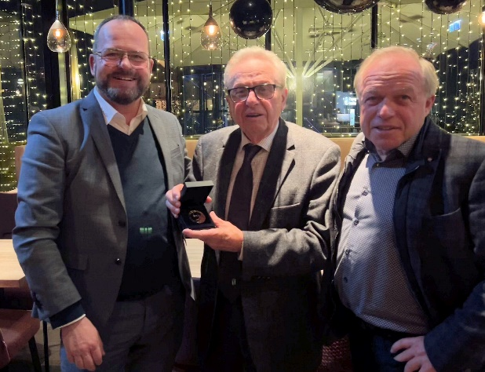
Picture: President & CEO, Dr. Gunther Wobser (left), presents the prestigious Dr.-Rudolf-Wobser-Medal to Fritz Bartelt senior (center). Fritz Bartelt junior, who continues the successful family tradition as the current Managing Director, is delighted with his father. © LAUDA

We are LAUDA – the world leader in precise temperature control. Our constant temperature equipment and systems are at the heart of important applications, contributing to a better future. As a complete one-stop supplier, we guarantee the optimum temperature in research, production and quality control. We are the reliable partner for electromobility, hydrogen, chemicals, pharmaceuticals/biotech, semiconductors and medical technology. We have been inspiring our customers for almost 70 years with our expert mentoring and innovative solutions – every day anew and all over the world.

In our company, we always go one step further. We support our employees’ development and are constantly developing ourselves: to create a better future together.

Press contact
We are more than happy to make prepared information about our company, the LAUDA Factory Gallery and our projects in the area of innovation promotion, digitalization and idea management available to the press. We look forward to hearing from you – just give us a call!

CHRISTOPH MUHR
Director Corporate Communications
T + 49 (0) 9343 503-349
christoph.muhr@lauda.de

LAUDA DR. R. WOBSER GMBH & CO. KG, Laudaplatz 1, 97922 Lauda-Königshofen, Deutschland/Germany. Limited partnership: Headquarters Lauda-Königshofen, Registration court Mannheim HRA 560069. General partner: LAUDA DR. R. WOBSER Verwaltungs-GmbH, Headquarters Lauda-Königshofen, Registration court Mannheim HRB 560226. Managing Directors: Dr. Gunther Wobser (President & CEO), Dr. Mario Englert (CFO), Dr. Marc Stricker (COO)

