Press release
Schwaebisch Hall, April 12, 2017

Four young OPTIMA talents develop prototype
For the first time, the company is sponsoring the „Smart Green Island Makeathon“ in Gran Canaria

167 students from 39 international universities met at Infecar exhibition center in Gran Canaria from February 23 – 26, 2018.
Together, the participants developed prototypes in fields such as digitalization, industry 4.0, smart home and green energy.
For the first time, Optima supported the international workshop as a sponsor. Four young talents represented the company on location and developed a camera-based detection system for a screw sorter which had been designed in a previous workshop.

Dr. Georg Pfeifer, Managing Director of OPTIMA nonwovens, personally presented the company to international students. In a “speed dating” event, the students had the opportunity to gather information about the Schwaebisch Hall based special purpose machinery manufacturer and to do some networking. Pfeifer was impressed by the professionalism with which the work processes as well as the presentations of the results had been conducted. He called the Makeathon a “success” and a perfect training camp for future challenges in a multicultural work environment. Networking between the participants and the companies represented is the key to working together successfully in the future, says Pfeifer.

It was the second time for the four young technology enthusiasts to participate in a Makeathon. In Munich the team develeoped a screw sorter. The Makeathon in Gran Canaria took place for the third times and was organized by ITQ GmbH and its Spanish subsidiary. Several renowned companies as well as the Spanish municipal administration support the event as sponsors. These provide the student experts with topical assignments for which they then develop prototypes.

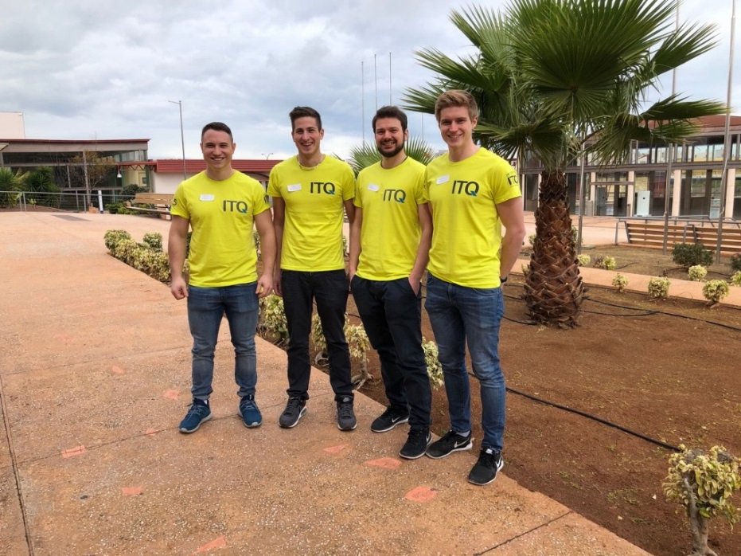
The Optima participants. From left to right: Jonas Kiene, Jonas Lober, Martin Däuber, Markus Röger

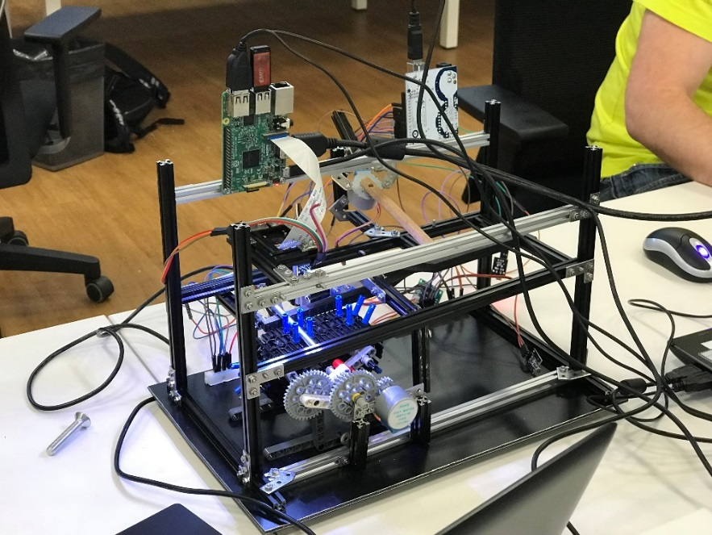
The camera system developed in Gran Canaria detects which type of screw is transported in a screw sorter, where the screws are then sorted in a subsequent step.

Dr. Georg Pfeifer, Managing Director of OPTIMA nonwovens, presented the company to international students.

Characters (incl. spaces): 1,805

Contact:
OPTIMA packaging group GmbH
Sabine Gauger
Marketing Group Leader
sabine.gauger@optima-packaging.com
www.optima-packaging.com
Thank you very much for your publication. We look forward to receiving a specimen copy.

