GEA unveils methanol Fuel2Engine system at SMM in Hamburg

Düsseldorf (Germany), September 1, 2026 – GEA is presenting the new GEA methanol Fuel2Engine System at SMM 2026, the world’s leading maritime trade fair in Hamburg (September 1–4). With this solution, GEA has combined the GEA methanol Booster Unit with the GEA methanol Valve Train to create a comprehensive Fuel2Engine System. This technology thus covers key steps in the fuel supply process, from methanol processing to engine injection.

Designed for new-build and retrofit projects
The GEA methanol Fuel2Engine System is intended for use in newbuilds as well as retrofit projects. GEA can supply the two main components—the GEA methanol Booster Unit and the GEA methanol Valve Train—as an integrated system solution or as individual components tailored to specific projects. For shipyards and shipping companies, this coordinated approach can streamline the coordination of individual scope of supply items and facilitates the integration into diverse ship designs, reducing the overall engineering and project management effort. At the same time, GEA’s global presence – with production sites in Europe and Asia, as well as international marine service hubs – supports operations throughout the entire lifecycle.

GEA pilot project with the John T. Essberger shipping company
A pilot project with the German shipping company John T. Essberger, which has been operating in the maritime industry for more than 100 years, is intended to prepare for the technical implementation of the system under real-world conditions. As part of the project, GEA will supply both the methanol Booster Unit and the methanol Valve Train as one coordinated fuel handling solution for a new generation of methanol-ready chemical tankers. Completion of GEA’s scope of supply is planned for fall 2026. Fuel flexibility is a core element of John T. Essberger's fleet strategy. In line with this approach, the company is preparing its newbuilding vessels for future methanol operation. This ensures that the vessels can be adapted efficiently as fuel availability, regulatory frameworks, and market conditions evolve. The approach reflects a forward-looking, risk-conscious strategy focused on practical and scalable decarbonization pathways without committing exclusively to a single fuel.

GEA methanol Booster Unit: conditioning and control from a single source
The GEA methanol Booster Unit brings methanol to the pressure and temperature parameters required for engine injection. It is designed for continuous operation under maritime conditions and supports a stable fuel supply. The development focused on methanol-compatible materials, safety technology, and control and monitoring technology. The solution builds on more than 25 years of experience with booster units and over 130 years of expertise in marine fuel handling.

GEA methanol Valve Train: precise fuel Control and advanced safety functions for reliable engine performance
The GEA methanol Valve Train serves as the dedicated safety and control interface between the methanol Booster Unit and the engine. It ensures a precise methanol supply tailored to the engine's requirements while meeting the highest safety standards for maritime applications. It serves as the interface between fuel conditioning and the engine while also enabling direct nitrogen purging of both the engine and the Methanol Booster Unit. The component was developed in collaboration with Everllence and approved by the market leading marine engine manufacturer. The GEA methanol Valve Train is designed for two-stroke and four-stroke engines of all variants from Everllence and complies with the standards of the certification classification society Det Norske Veritas (DNV).

On track with methanol
The international shipping industry is under enormous pressure to transform. Stricter emissions regulations, increasing requirements for CO₂ reduction, and new tools such as the Carbon Intensity Indicator (CII) are forcing shipping companies and charterers to realign their propulsion and fuel strategies. Methanol is gaining significant ground in international shipping, though it still accounts for only a small market share compared to the fleet conventionally powered by heavy fuel oil and LNG. The classification and certification society Det Norske Veritas (DNV) currently lists more than 450 methanol-capable ships in service or on order. This means that the share of the global merchant fleet remains well below one percent, while the vast majority of ships continue to be powered by fossil marine fuels such as diesel, marine gas oil, or heavy fuel oil. The increasing number of new orders for methanol-capable ships—such as container ships, tankers, bulk carriers, and car carriers—shows that the technology is becoming established in large parts of the market.
Several factors point to methanol’s success. The fuel can be stored and transported in liquid form at ambient temperature, keeping infrastructure and handling requirements comparatively manageable compared to other alternative fuels. Furthermore, methanol has the potential to significantly support the decarbonization of shipping, especially as green methanol from renewable sources becomes more widely available in the future.

The real challenge lies in the fuel system
However, simply opting for methanol does not complete the transformation. The safe and reliable handling of the fuel requires highly sophisticated systems for fuel preparation, pressure regulation, and injection. “With the GEA methanol Fuel2Engine System, we offer a tailored solution for a key challenge in methanol shipping: the safe and reliable fuel supply from the treatment system to the injection system,” says Vipin Joy, Product Manager Marine from GEA.

GEA at SMM 2026 in Hamburg
SMM 2026 will take place in Hamburg from September 1 to 4, 2026. GEA will present its maritime solutions in Hall A3, Booth 316. In addition to the GEA methanol Fuel2Engine System, the company will showcase other technologies for alternative fuels, fuel and lubricating oil treatment, water treatment, compression technology, and digital marine systems.

SMM 2026
- Date: September 1–4, 2026
- Location: Hamburg, Germany
- GEA booth: Hall A3, booth 316

Photos:

Photo 1:
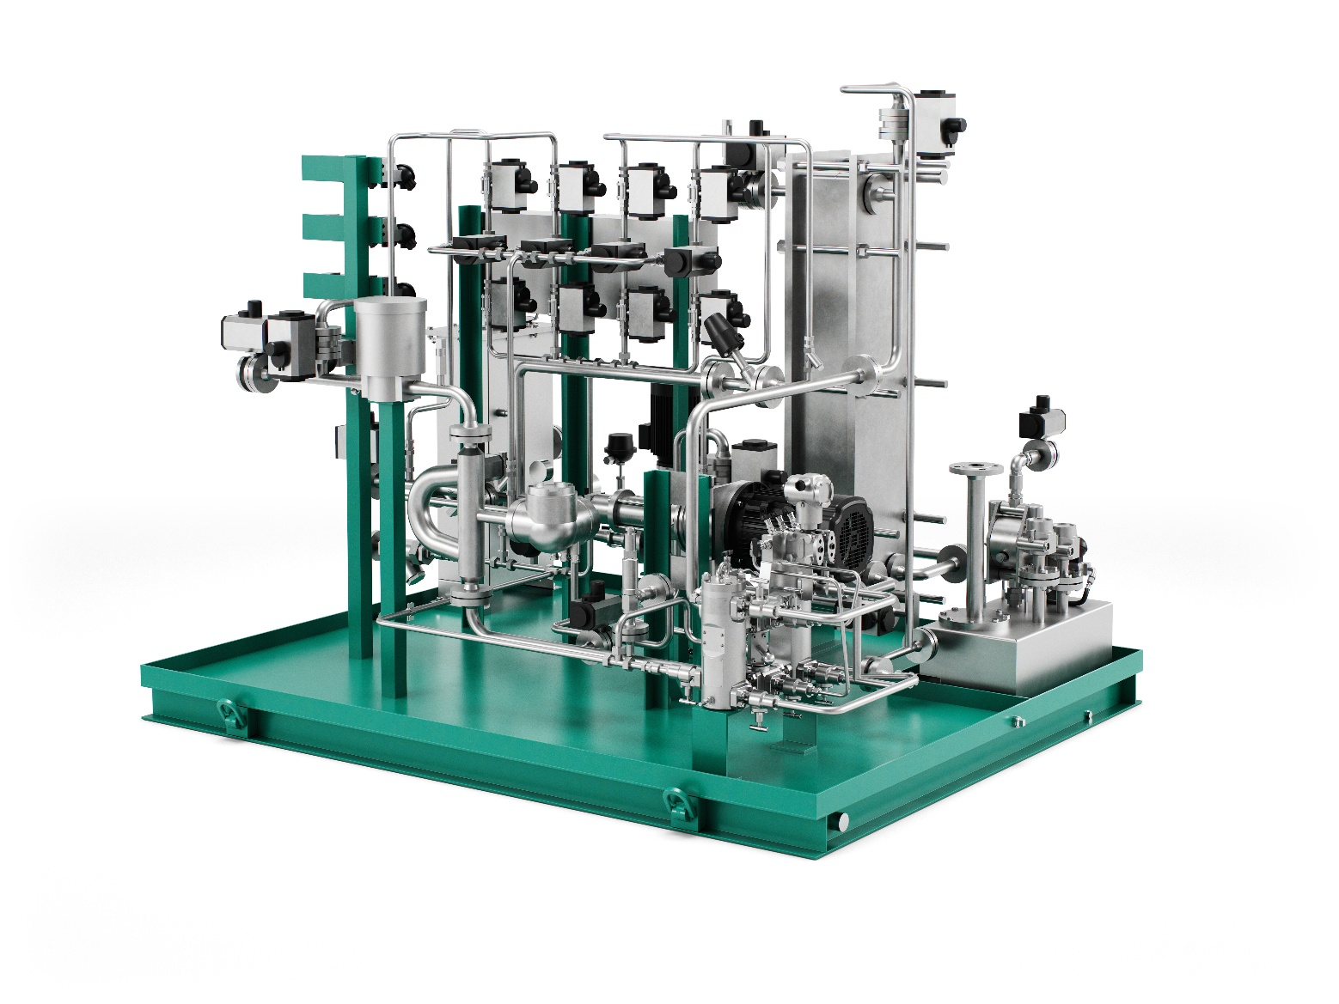
Photo 1, caption: GEA methanol Booster Unit: Conditions and pressurizes methanol to the precise pressure and temperature required for engine injection. (Photo: GEA)

Photo 2:
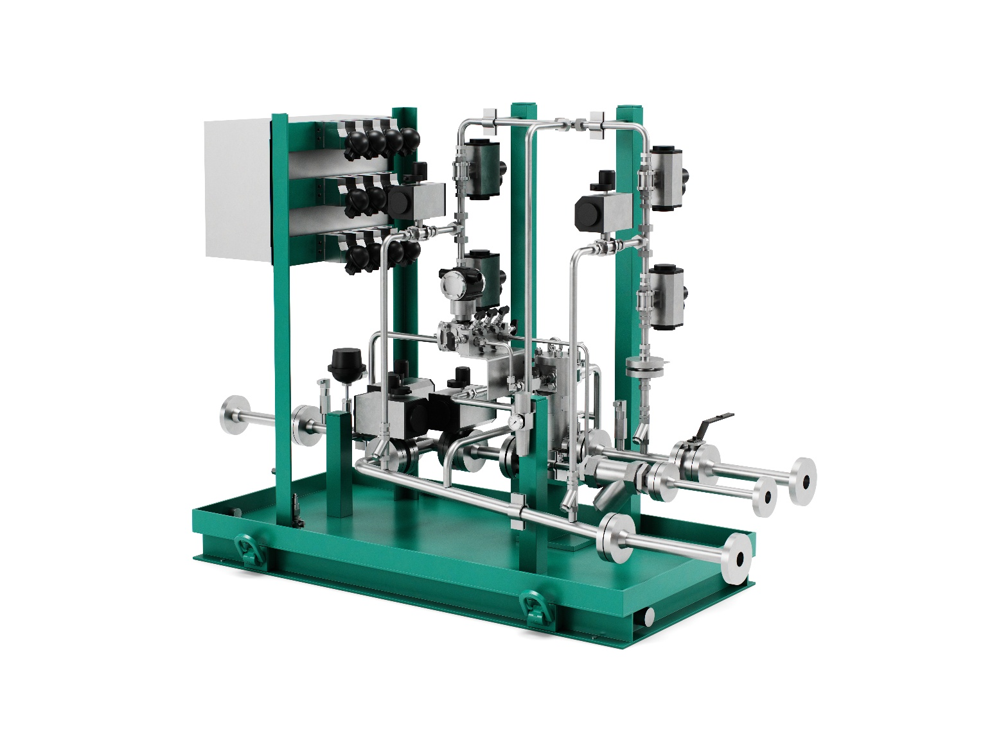

Photo 2, caption: GEA methanol Valve Train: Precisely controls and meters methanol at the interface between fuel conditioning and engine injection. (Photo: GEA)

NOTES TO EDITORS
- Further information about GEA
- To the GEA Media Library
- Features on current topics
- Overview press events
- Follow GEA on  

About GEA
GEA is one of the world’s largest suppliers of systems and components to the food, beverage and pharmaceutical industries. The international technology group, founded in 1881, focuses on machinery and plants, as well as advanced process technology, components and comprehensive services. For instance, every second pharma separator for essential healthcare products such as vaccines or novel biopharmaceuticals is produced by GEA. In food, every fourth package of pasta or every third chicken nugget are processed with GEA technology.

With more than 18,000 employees, the group generated revenues of about EUR 5.5 billion in more than 150 countries in fiscal year 2025. GEA plants, processes, components and services enhance the efficiency and sustainability of customers’ production. They contribute significantly to the reduction of CO2 emissions, plastic usage and food waste. In doing so, GEA makes a key contribution toward a sustainable future, in line with the company’s purpose: “Engineering for a better world.”

GEA is listed on the DAX, the STOXX® Europe 600 Index and is also a constituent of the leading sustainability indices DAX 50 ESG, MSCI Global Sustainability and Dow Jones Best-in-Class World.

More information can be found online at gea.com.
not want to receive any further information from GEA, please send an e-mail to pr@gea.com.

Media Relations
GEA Group Aktiengesellschaft
Dr. Michael Golek
Ulmenstraße 99, 40476 Düsseldorf, Germany
Phone +49 211 9136-1505
michael.golek@gea.com

