ATIÉNA R. KILFA  WONDER LUST  February 8–July 6, 2025  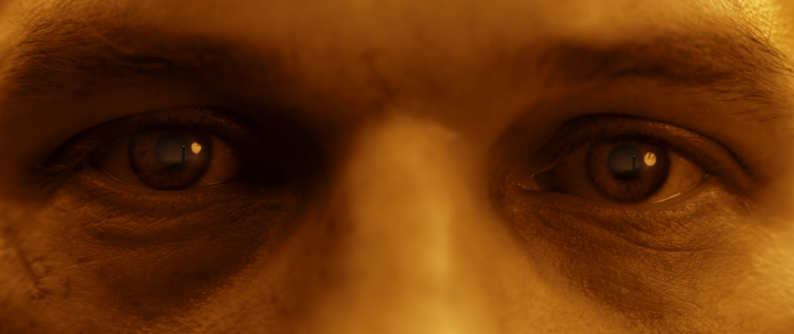  Aiténa R. Kilfa, Landfall at Sunrise; Video Still, 2025  K​​unstmuseum St. Gallen proudly presents Wonder Lust, the first solo exhibition in Switzerland by the French-born, Berlin-based artist Atiéna R. Kilfa (b. 1990). The installation revolves around a new video commission for Kunstmuseum St. Gallen’s industrial exhibition venue, the LOK. Constructed between 1903 and 1911, this pioneering former railway building recalls the peak of Eastern Switzerland’s textile industry. It is from within this icon of a grand past that Kilfa’s new work reflects on the romanticization of imperialist conventions.  Projected against a wall that follows the Lokremise’s rotational design, the video Landfall stages a panoramic view over what appears to be a vast landscape at sunrise or sunset, as perceived through the eyes of an enigmatic men in a nondescript uniform, a “Rückenfigur.” This trope, which consists of a figure, seen from the back, contemplating an evocative and often dramatic landscape, recurs throughout the history of painting and cinema alike. In subverting the figure’s object of contemplation, replacing a distant land with a mere maquette, Kilfa’s work stages a form of playacting that both exposes and deflates the pomposity of this heroic set-up.  Two additional works are part of Wonder Lust: both of which further break down the production of “wonder” as a prop. The print Landfall at Sunrise is a still, derived from an unused cut of the video, in which we see, in a large close-up, the reflection of the landscape in the figure’s eyes, bringing yet another point of view to bear on the figure’s relation to the landscape. A “Wind Machine” is exhibited as well, a foley instrument that spins against fabric to create the illusion of the sound of wind, originally used in the orchestral compositions of romantic operas such as Wagner’s Flying Dutchman and later on in film.  The practice of Atiéna R. Kilfa homes in on cinematic archetypes and the intricate ways in which images are constructed in film – an apparatus which she unravels. Through video, photography, sculpture and installation, her work reflects on various traditions and technical mechanisms of production and post-production, inviting us to consider how images bear witness to time and to the ideologies whose histories we continue to inhabit.  Atiéna R. Kilfa’s works have been featured in group exhibitions at Galerina, London, UK (2025); Museion, Bolzano, IT (2024); Neue Alte Brücke, Frankfurt, DE (2024); Heidi, Berlin, DE (2024); Den Frie, Copenhagen (2023); 032c, Berlin, DE (2023); Expo Chicago, Chicago, US (2022); Yaby, Madrid, SP (2021); Elvira, Frankfurt, DE (2021); and Galleria Zero, Milan, IT (2021). She has had solo exhibitions at Den Frie, Copenhagen (2024); Cabinet, London, UK (2023); Camden Art Centre, London, UK (2023); KW Institute for Contemporary Art, Berlin, DE (2022); Liste Art Fair, Basel (2021); and Cell Project Space, London, UK (2020). Kilfa completed her studies at the Städelschule in Frankfurt in 2022 and was awarded the Ars Viva Prize in 2024.  Melanie Bühler, Senior Curator at the Kunstmuseum St. Gallen, on  Atiéna R. Kilfa:  “Atiéna R. Kilfa's artistic work stands out for its astute analysis of longstanding motifs from visual culture. The newly commissioned video work Landfall dissects the Rückenfigur (“figure from the back”), a motif perhaps best known from German Romantic painting and still used today in film, television, and advertising as a symbol for a specific kind of heroism, one that transports itself through nostalgia, pathos and conquest. Kilfa consciously plays with immersion and illusion, as well as the interruption or rupture of these effects, to reveal the ideological underpinning of enduring, and highly affective, visual tropes as she carefully stages their fall.”  The exhibition is additionally supported by the Dr. Georg und Josi Guggenheim-Stiftung. | Exhibition dates  February 8 –July 6, 2025  LOK by Kunstmuseum St. Gallen  Press Conference  February 7, 2025  11:00 a.m., Lokremise  Exhibition Opening  February 7, 2025  6:30 p.m., Lokremise  Opening Hours  Mon – Sat: 1:00 p.m. – 8:00 p.m.  Sun: 11:00 a.m. – 6:00 p.m.
Press Contact

Nadine Sakotic
Head of Communications
Kunstmuseum St. Gallen
Museumstrasse 32
9000 St.Gallen
T +41 71 242 06 84

kommunikation@kunstmuseumsg.ch
kunstmuseumsg.ch

Factsheet

ATIÉNA R. KILFA
WONDER LUST

Exhibition Dates | February 8 –July 6, 2025
Adress | LOK by Kunstmuseum St.Gallen, Grünbergstrasse 7, 9000 St. Gallen
Press Conference | February 7, 2025, 11:00 a.m. with director Gianni Jetzer, senior curator Melanie Bühler, and Atiéna R. Kilfa
Exhibition Opening | February 7, 2025, 6:30 p.m.
Curator | Melanie Bühler
Opening Hours | Mon – Sat: 1:00 p.m. – 8:00 p.m.  Sun: 11:00 a.m. – 6:00 p.m.
Press Contact | Nadine Sakotic  T +41 71 242 06 84  kommunikation@kunstmuseumsg.ch
Website | kunstmuseumsg.ch
Press | kunstmuseumsg.ch/en/press

