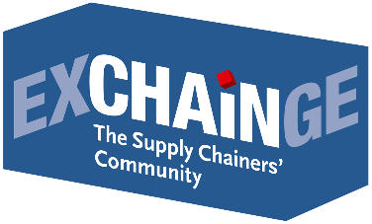
Press Release

Apply now for the Supply Chain Awards!

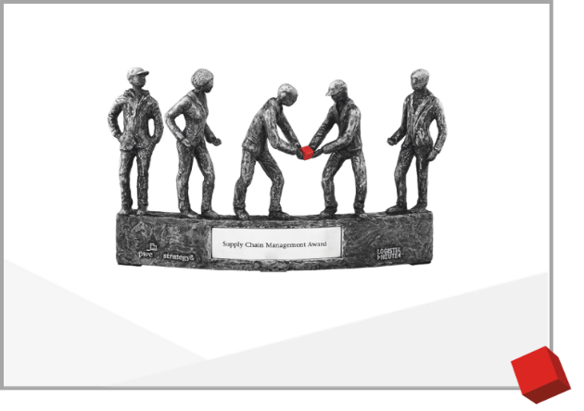
Munich, May 9, 2019 - The competition for the coveted Supply Chain Awards 2019 has started. The trade magazine LOGISTIK HEUTE and Strategy& together with PwC are once again looking for outstanding supply chain solutions.

About the awards
For the 14th time, the Supply Chain Management Award recognizes companies with outstanding value chains - companies that have optimized their supply chain in a consistent or extraordinary way and whose concepts are groundbreaking for other companies as well.

The Smart Solution Award, which was awarded for the very first time in 2018, honors particularly innovative concepts that are still in an early stage of implementation. With this prize, solutions are honored that have the potential to fundamentally change traditional value chains in the future.

“The winners of the Supply Chain Management Awards benefit from the considerable attention it receives in professional circles. In addition, numerous positive effects result – internally, in relationships with customers and suppliers, and also as employers. In general, all applicants receive valuable feedback for the further development of their own supply chain from the application process. Although there is ultimately only one winner, all applicants benefit from the competition,” explains Dr. Petra Seebauer (Managing Director, EUROEXPO; Publisher, LOGISTIK HEUTE).

Harald Geimer (Partner at PwC Management Consulting): “The solutions of the Supply Chain Award winners of the previous years were very varied. However, all of these award-winning solutions have one thing in common: they have all helped to significantly improve competitiveness and have been a game-changing example also for other companies.”

About the application process
Applications are open to corporations from all industries. We also welcome partnership applications from companies linked by a first-class network or from companies that have developed exemplary cross-company supply chain solutions. Companies from Germany and other European countries can participate.

The most convincing candidates are invited to present their concepts live to the audience and the jury at EXCHAiNGE in Frankfurt am Main on November 26, 2019. Based on the available information and their impressions, the independent jury of high-caliber experts consisting of representatives from industry, science, consulting and professional media selects the award winners.

The award ceremony will be held during the EXCHAiNGE Award Night in Frankfurt on November 27, 2019.

Last year's International Supply Chain Summit EXCHAiNGE gave many new impulses and there are already exciting ideas for 2019 to bring together participants from different sectors. This year's agenda includes "Sustainable supply chains: First & last mile solutions", "Culture & Mindsets for digital transformation", "Block chain versus real solutions? Plain text in the buzzword jungle", "Start-ups, Corporates or Customers: How and where are trend-setting innovations created" and supply chain simulations.

Cut-off date
All applications completed and submitted by July 15, 2019, will be included in the selection process.

Further information on the Supply Chain Awards 2019 and the application process:
https://www.exchainge.de/en/award/

Reigning Award Winners
Last year, the digital solution of CEMEX Deutschland for an integrated Purchase-to-Pay (P2P) process received the Supply Chain Management Award. InstaFreight was awarded with the Smart Solution Award for the outstanding implementation of a supply chain solution, which brings the entire customer interaction – from order to delivery up to payment – onto one platform.
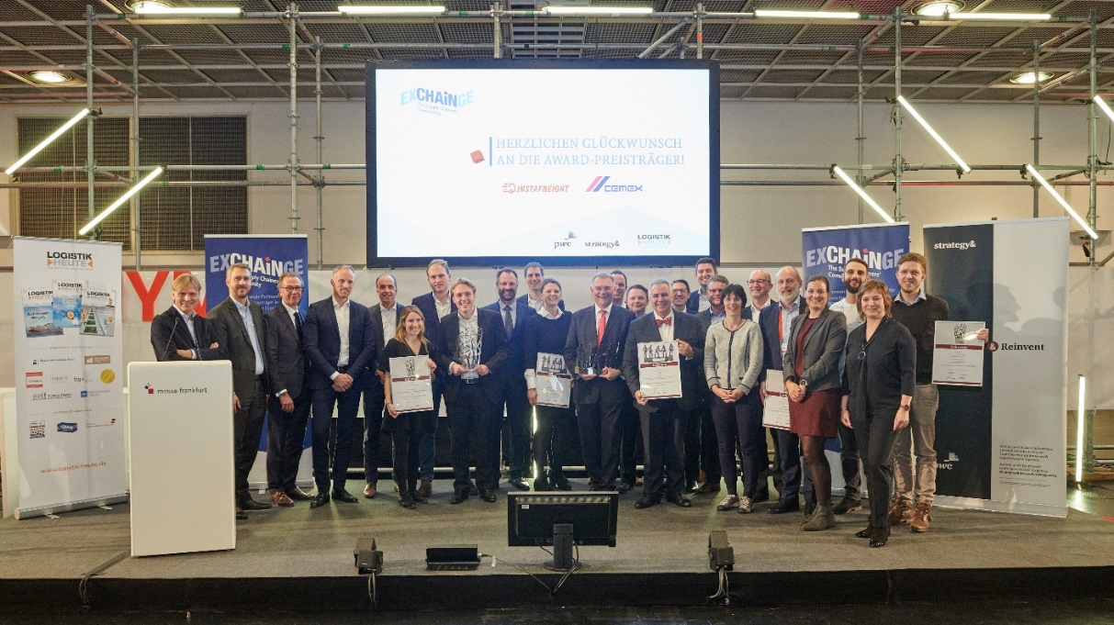

Caption: Last year’s proud winners CEMEX and InstaFreight are joined by finalists BASF, Bossard, Schaeffler, and Synfioo/SAP and members of the jury at the ceremony to present the Supply Chain Awards 2018.
Photo credit: EUROEXPO Messe- und Kongress-GmbH
SAVE THE DATE
EXCHAiNGE—the Supply Chainers’ Community 2019 | November 26–27, 2019
Learn more: www.exchainge.de/en

About EXCHAiNGE
The “Supply Chainers’ Community” brings together movers and shakers from the worlds of SCM, finance, logistics, and purchasing. Representatives from businesses of all sizes - from startups to large enterprises - meet to talk about new ways of thinking, business models and networking in the context of digital transformation.
EXCHAiNGE provides a roadmap for navigating New Work & Digital Business with key issues such as disruption, sustainability, culture and mindsets, big data, and blockchain. Finalists competing for the Supply Chain Awards offer profound insights into pre-eminent examples of best practice. The participants receive valuable suggestions for the repositioning of their companies. The aim is to generate decisive competitive advantages as a driver of innovation.
As an established networking platform - in its seventh edition in 2019 - EXCHAiNGE stands for the personal exchange of important experience reports, illuminating roundtables on future strategic approaches for companies and the ongoing active involvement of participants. The event is organized by EUROEXPO Messe- und Kongress-GmbH in Munich.

About EUROEXPO Messe- und Kongress-GmbH
EUROEXPO Messe- und Kongress-GmbH was founded in 1996. Today, EUROEXPO organizes LogiMAT - the annual international trade show for intralogistics solutions and process management - as well as LogiMAT China and TradeWorld, the professional platform for trade processes.
EUROEXPO also organizes “EXCHAiNGE - the Supply Chainers’ Community.” The international business conference, now in its seventh year, targets leaders from the areas of SCM, finance, logistics, and purchasing at startups, small and medium-sized businesses, and large enterprises. EUROEXPO is also a service provider offering B2C and B2B event management services, such as the organization and implementation of the LOGISTIK HEUTE series.
For more information, please visit www.euroexpo.de.

More images can be found here.

For more information, please contact:
Hendrikje Rother
Marketing/Press
EUROEXPO Messe- und Kongress-GmbH
Phone: +49 89 323 91 240
hendrikje.rother@euroexpo.de
www.exchainge.de/en

(Characters with spaces: 6,178)

EUROEXPO blog postings may be reprinted free of charge. Texts and images can be found at the EXCHAiNGE blog page under www.exchainge.de.
Please send a copy of any republication by email to hendrikje.rother@euroexpo.de or by postal mail to EUROEXPO Messe- und Kongress-GmbH | Presse- und Öffentlichkeitsarbeit | Joseph-Dollinger-Bogen 7 | 80807 München.

