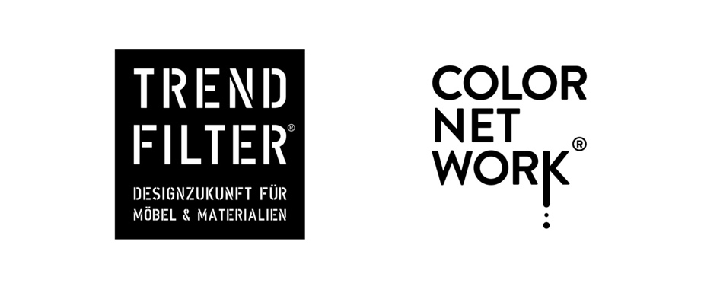

Bünde, 20 August 2025

+++++++++ EMBARGO UNTIL 2 SEPTEMBER 2025 +++++++++

Press Release

Sustained Color No. 9 “taste south!” – a touch of the Mediterranean

The Mediterranean in a colour: star designer Antonio Rodriguez from Milan has created a new colour world that brings a warm, authentic touch to product and interior design. The ninth Sustained Color from the COLORNETWORK® is called “taste south!” – an ochre-toned natural earth colour, inspired by Southern Europe, and particularly the Mediterranean region. The shade evokes images of endless sandy beaches, ancient city walls, a Spanish finca or an Italian villa.

Ochre: one of the world’s oldest pigments
Ochre has played a key role in Mediterranean architecture for centuries, as it is derived from one of nature’s oldest pigments. Found worldwide in varying nuances, it stands for connectedness with nature, warmth and originality.
Sunlight: a positive effect on spaces and people
“taste south!” reflects warm sunlight in a soft and flattering way, which has a proven positive effect on interior spaces. “Sustained Color No. 9 creates a happy, cheerful and optimistic atmosphere and can help stimulate creativity in working and active environments,” explains COLORNETWORK® founder and curator Katrin de Louw.
The base colour yellow is considered the colour of summer and is associated with positive emotions such as joy and energy. “taste south!” therefore fills spaces with the intensity of a midsummer’s day. Like a concentrate storing centuries of sunlight, this colour brings calm, relaxation and stress relief.
Antonio Rodriguez: a designer with an international signature
Designer Antonio Rodriguez, who developed “taste south!”, was born in Spain in 1963. After studying in Valencia and Milan, he moved to Milan in the 1990s, worked at the Taipei Design Centre, and was a lecturer at the European Institute of Design (IED) from 2000 to 2005. He has collaborated with brands such as Hitachi, Mattel and Toshiba, and in 1999 joined forces with the Matteo Thun studio. Antonio Rodriguez and Matteo Thun have been creating successful projects together for over twenty years.
Fragrance Story: the scent of “taste south!”
Psychologist, sociologist and fragrance creator Dr Joachim Mensing developed a unique fragrance story for “taste south!”. It takes the viewer on an olfactory journey to the golden-yellow, sun-drenched fruits of the Mediterranean – such as apricots, dates, mirabelles, quinces, and citrus fruits like lemons and oranges. The aromas are complex and distinctive. An example is the golden Bahri date, one of the oldest fruits in the world, which grows in the southern and eastern Mediterranean. Its fruity-sweet yet nuanced aroma, with notes of buttery caramel, honey and vanilla, pairs perfectly with the colour “taste south!”.
Room fragrance: 100% Natural Essential Oils
For the 2025 Küchen- und Möbelmeile, COLORNETWORK® is presenting its fragrance story as a real-life room scent for the first time – in a high-quality 500 ml diffuser. This marks an important milestone: for the first time, the olfactory interpretation of a Sustained Color is consistently translated into a fragrance, making the emotional power of colour a multi-sensory experience.
“We are convinced that natural aromas can have particularly positive effects on the human body and well-being,” says Katrin de Louw, initiator of the COLORNETWORK®. That is why only 100 per cent natural aroma oils are used – with no compromises on quality, origin or effect.
The fragrance “taste south!” brings the Mediterranean garden indoors: a finely balanced composition of citrus fruits, maritime pine and herbs such as rosemary and sage creates a holistic sensory experience. The fragrance is developed and produced in Germany – with great care, short transport routes and strict quality control. It will soon be available at www.colornetwork.org.
Autumn trade fairs: “taste south!” on show at multiple locations
This autumn, COLORNETWORK® and Sustained Color No. 9 “taste south!” will be presented at several locations across East Westphalia. During Küchenmeile 2025, the Sustained Colors will be featured at Ballerina Küchen, Blanco, and at area30, among others at Caesarstone. The FURNITURE FUTURE FORUM (registration required) also remains a regular point of contact for those interested in the network.
area30: presentation and panel discussion
As part of area30, Katrin de Louw will present the TRENDREPORT 2026 for kitchen professionals on Sunday, 21 September 2025 at 4:00 p.m. This offers insights into current colour and material concepts that allow kitchen studios to stand out, and highlights trends in kitchen form and function.
On Monday, 22 September 2025 at 4:00 p.m., Katrin de Louw will also moderate a 40-minute panel discussion with renowned industry experts. Under the title “COLORNETWORK®: Added value and confidence in the purchasing decision”, the discussion will explore how the network’s colour and material concepts can offer tangible benefits to both retailers and consumers.

About COLORNETWORK®
With Sustained Color No. 9, COLORNETWORK® is offering important inspiration for the interior world this autumn. The network stands for sustainable development of colours and materials and provides manufacturers, retailers and craftspeople with reliable foundations for timeless design concepts.

