PRESS RELEASE
Schwäbisch Hall, 09/20/2019

Solutions for aseptic processes and new forms of administration
OPTIMA innovations at the P-Mec in Frankfurt

At P-Mec, the experts from Optima Pharma and Optima Life Science will be presenting new technologies and an extensive range of services associated with the processing of active pharmaceutical ingredients. Optima Pharma is a turnkey manufacturer providing innovations in aseptic filling and sealing, including freeze-drying and isolator technology. The award-winning DECOpulse bio-decontamination system from the Optima company Metall+Plastic will be presented live, using an "isosquare". The sterility test isolator STISO from Metall+Plastic brings together numerous advantages. It will be on display on site. Optima Life Science will provide information on the recently enhanced OPTIMA TDC machine platform for the development and introduction of oral dispersible films and transdermal patches.
Isolator technology is increasingly being used for the bio-decontamination of filling and sealing processes. The DECOpulse system from Metall+Plastic provides new time savings in the decontamination cycle and reduces the use of H₂O₂. Metall+Plastic can demonstrate this graphically using an isosquare model that will be on show at P-Mec. The Biotech Innovation Award 2019 has been awarded to the DECOpulse system.
Sterility tests are an important cornerstone of aseptic processing. This is where the STISO sterility test isolator from Metall+Plastic is the benchmark product. It offers extremely short decontamination cycle times, and together with the low-maintenance H₂O₂ flash evaporation, ensures exceptionally high machine availability. In operational terms, the ergonomic concept and its numerous details, such as the wireless glove test that can be carried out via the HMI, are particularly impressive. STISO has a modular construction and can be flexibly adapted to meet specific customer requirements. Two versions are available, for aseptic or aseptic high-potency applications.
Take the shuttle to two Optima locations
The increased use of new biopharmaceutical drugs has resulted in a continuing increase in sterile processing requirements. At P-Mec, the experts from Optima Pharma will be providing information about the OPTIMA MultiUse Filler. This type of machine is particularly suitable for efficiently and safely processing small to medium-sized batches and, where required, high potency drugs. Vials, pre-filled syringes and cartridges are processed without format parts using the flexible machine platform and robot technology. The MultiUse systems have already been designed for the use of isolators and for connecting freeze drying systems.
For pharmaceutical applications, turnkey solutions are very popular. At P-Mec, Optima Pharma will be providing information on projects involving the filling and sealing of biopharmaceutical drugs, isolator technology and freeze-drying. The company takes key responsibility for these projects, from designing all of the systems to site management and site acceptance tests (SATs).
Optima Pharma is offering a special service, with a shuttle transfer from the exhibition stand to the Mornshausen site specializing in manufacturing pharmaceutical freeze-drying systems, and to the Schwäbisch Hall site, where both filling and capping systems and turnkey systems are produced.
New solutions for active pharmaceutical ingredients in film and patch form
Oral dispersible films (ODF) and transdermal patch systems (TDS) contain active pharmaceutical ingredients. At P-Mec, Optima Life Science will be demonstrating how these can be efficiently manufactured, assembled and packaged. The OPTIMA TDC 125 allows the company to offer a particularly flexible machine type for entering this market segment – a scalable machine that can be used on a laboratory scale in product development as well as in the ensuing production cycle. A new feature of this machine is the optional extendable range of converting functions. Furthermore, production capacity can now be ramped up to 200 products per minute and double-sided printed material can be produced. If required, the OPTIMA TDC can also be used purely as a packaging machine with a semi-automatic product feed.
With the COMEDCO alliance, Optima Life Science offers a development and technology partnership for customers that will help them bring TDS and ODF products to market quickly and in a targeted manner. This is significant because TDS and ODF products require a certain amount of development work before they are ready for the market. The COMEDCO alliance is contributing its many years of experience to the consulting process. For example, this includes selecting suitable film carrier materials through to specific application systems. COMEDCO also offers a combined machine system that can cover all of the production steps, right through to packaging. At P-Mec, those who are interested can get all the information they need.
Optima Pharma and Optima Life Science (with COMEDCO) from November 5 to 7, 2019 at P-Mec (Frankfurt am Main)

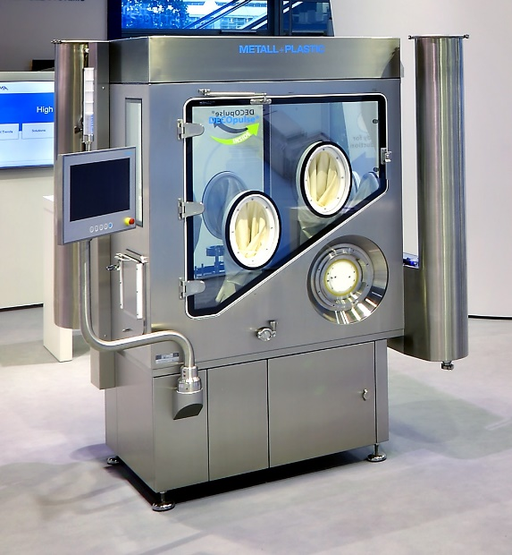
Metall+Plastic will be demonstrating the functionality and benefits of the innovative DECOpulse isolator technology for bio-decontamination using an "isosquare".

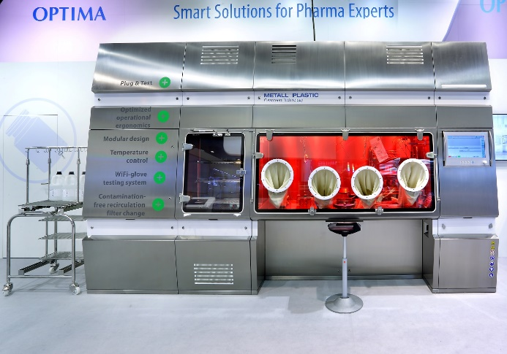
The STISO sterility test isolator from Metall+Plastic offers a wide range of benefits, from fast bio-decontamination times to a consistently ergonomic design.

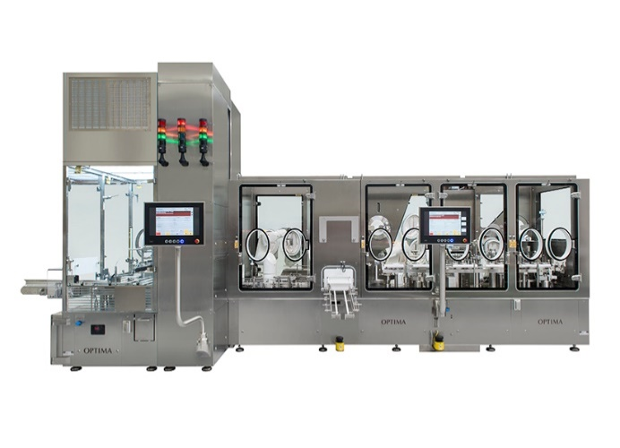
Optima Pharma's MultiUser Filler is perfectly suited to small batches, such as complex, highly potent drugs. Pre-filled syringes, cartridges and vials are processed without format parts.

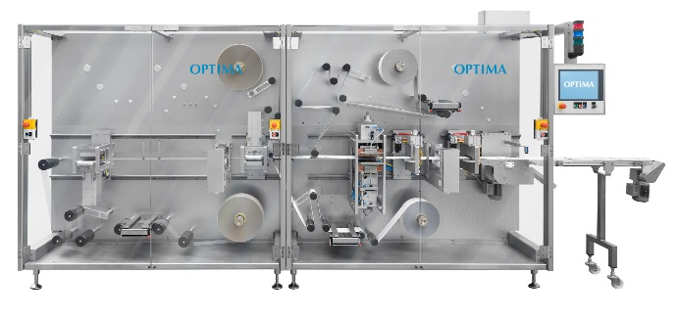
The OPTIMA TDC modular machine platform provides the ideal gateway to the development and production of oral dispersible films and transdermal patches. The converting functions can now be upgraded as required.

Characters (including spaces): 5,042

Press contact:
OPTIMA packaging group GmbH
Jan Deininger
Editor
+49 (0)791 / 506-1472
jan.deininger@optima-packaging.com
www.optima-packaging.com
Thank you for publishing this information. We would be pleased to receive a file copy.

