LAMILUX produces high-tech composites for the bus industry

Robust, lightweight and attractive in all applications

The German company LAMILUX Composites offers highly developed, tried-and-tested high-tech materials made from fibre-reinforced plastics in a continuous production process. These materials are used both internally and externally in buses. The very light yet extremely sturdy material forms the outer face sheets of roofs and side walls. Further product variants in the interior allow walls to be clad and floors to be coated.

X-treme sturdy outer wall
LAMILUX High Strength X-treme is specially developed for extreme commercial vehicle applications subject to very high mechanical loads. Thanks to its resistance to hail storms, UV light radiation and the effects of the weather, the material is eminently suitable as side wall elements. LAMILUX X-treme is frequently used as a single segment in the bus outer wall. The advantage: Quick replacement and easy installation are possible in the event of damage. Among other things, this reduces downtime for fleet operators.
UV and weather resistance combined in the roof
LAMILUX Woven Roving 48% Gelcoat is particularly well-suited for use on bus roofs, as it offers outstanding UV and weathering stability thanks to its sealing with a gelcoat layer. Although the woven roving structure has been reduced to improve the look, the mechanical strength is increased by the woven roving reinforcement. This results in less linear expansion on the roof surface. LAMILUX Woven Roving X-treme can also be used as an alternative. This reduces the weight even further and, thanks to its bending radius, makes it possible to dispense with the use of expensive profiles.

Visually attractive and functional interior
The fibre-reinforced plastic LAMILUX Graph enables users to create aesthetically appealing wall panelling. Besides extensive scope for design due to a wide choice in decoration, this composite also impresses with its outstanding mechanical properties, which make it easy to process. Such qualities include its flexural and tensile strength and extremely low surface abrasion. A key, positive product feature is its high-grade glaze. Unlike decorative plywood products, LAMILUX Graph does not soak up any water it comes into contact with. As a result, condensation build-up doesn't affect the material and its appearance in any way.

Another classic in the interior: LAMIfoamtex. The innovative composite material has a three-layer structure and can not only be designed individually according to customer specifications and product requirements, but also offers great savings potential for the vehicle manufacturer. LAMIfoamtex is considerably lighter, more environmentally friendly and more sustainable than the conventional solutions that the customer himself has to laboriously cover with fabrics. The high-quality soft-touch surfaces guarantee maximum function, while achieving high design standards.

Floor solutions: Long-lasting, durable and abrasion-resistant
LAMILUX Anti Slip is an extremely strong, lightweight construction element and the tried-and-tested anti-slip protection for floors in the luggage compartment of buses. The abrasion-resistant surface ensures maximum protection against slipping of luggage and suitcases.

Over time, moisture, heat and dirt also affect buses and, in particular, the conventionally installed flooring laminates. The Composite Floor by LAMILUX is the smart solution to such problems in buses. Here, the PVC top layer is incorporated directly into the composite and is permanently bonded with the carrier material. The direct bond between the PVC and the fibre-reinforced carrier material by LAMILUX also eliminates the need for the additional layer of glue, which also reduces weight and streamlines production.

…

www.lamilux.com

About LAMILUX Composites GmbH
LAMILUX Composites GmbH has been producing fibre-reinforced plastics for around 70 years. The medium-sized company is the leading European producer thanks to its technologically advanced continuous production process, large manufacturing capacities and wide product range. LAMILUX supplies customers around the globe in a wide range of sectors, such as the building industry, the automotive and recreational vehicle sectors, refrigerated store room and cell construction, and many other industrial sectors. LAMILUX strives to be the innovation and performance leader in all areas relevant to its customers. Headquartered in Rehau, Germany, the family-owned company is managed by Johanna and Dr. Alexander Strunz in the fourth generation, currently employs around 1,300 people, and in 2022 generated sales of around 392 million euros.

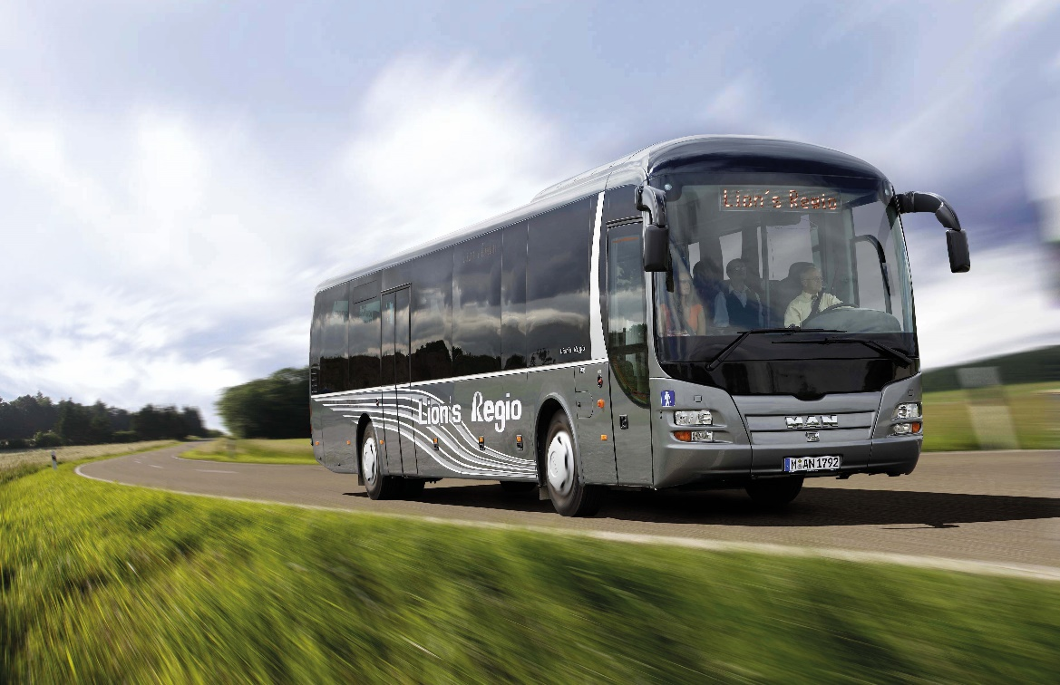
PICTURE CAPTION: LAMILUX manufactures fibre-reinforced plastics for use in all areas of a bus – whether roof, outer walls, interior cladding or floor.

