Tipps für mehr Harmonie im Haushalt

Gerechtigkeit und Ordnung

Pressekontakt
Moritz Dittmar
Pressereferent
Alfred Kärcher SE & Co. KG
Alfred-Kärcher-Str. 28-40
71364 Winnenden
T +49 71 95 14-3919
moritz.dittmar@de.kaercher.com
Winnenden, im Juni 2021 – Ein Fingerschnips und die Duschwand ist von Kalk befreit, ein Augenzwinkern und die Krümel unter dem Esstisch sind verschwunden – wäre der Hausputz wie von Zauberhand erledigt, herrschte in deutschen Haushalten wesentlich mehr Harmonie. Doch die Realität sieht anders aus: Laut einer Studie im Auftrag von Kärcher gibt es bei 60 Prozent derjenigen, die in einem Mehrpersonenhaushalt leben, Streit ums Saubermachen. Die Gründe dafür sind vielfältig: So empfinden die Befragten etwa die Verteilung der Aufgaben als unfair oder es herrscht Uneinigkeit über die Gründlichkeit und Häufigkeit des Putzens. Kärcher und die Hauswirtschaftsmeisterin Urte Paaßen haben Tipps, wie das Putzen mit Partner und Familie schneller und mit mehr Freude von der Hand geht.
Die richtige Kommunikation
Grundsätzlich sollte Toleranz auch beim Hausputz im Vordergrund stehen, denn wie die Studie zeigt, hat nicht jeder das gleiche Ordnungs- und Sauberkeitsempfinden. „Es ist immer wichtig, Kompromisse einzugehen, damit sich alle im Haushalt wohlfühlen. Das bedeutet ebenfalls, dass Probleme direkt angesprochen werden sollten, bevor sie sich aufstauen. Ein subtiler Hinweis wie ‚Die Küche müsste auch mal wieder gewischt werden.‘ ist dabei nicht unbedingt der richtige Weg“, sagt Urte Paaßen. Eine gute Möglichkeit, Unzufriedenheit zu vermeiden, ist ein Gespräch über Pflichten, die einem Mitbewohner weniger ausmachen als dem anderen – so findet vielleicht schon jeder seine bevorzugten Tätigkeiten. Putzaufgaben, die niemandem leichtfallen, sollten abgewechselt werden.
Zusammen macht’s mehr Spaß
Um Streitigkeiten über die angemessene Häufigkeit des Putzens zu vermeiden, können Mitbewohner einen Tag in der Woche zur gemeinsamen Putzzeit erklären. Werden immer am Samstagvormittag zusammen Lappen und Besen geschwungen, am besten zu guter Musik, gibt das gegenseitige Motivation und mehr Spaß an der Arbeit. Und wenn der Haushalt im Teamwork erledigt ist, kann man ein gemeinsames Belohnungsritual genießen: Ein Stück Kuchen in der blitzeblanken Küche zum Beispiel, oder ein gemütlicher Nachmittag auf dem Sofa im staubfreien Wohnzimmer.
Technik statt Trouble
Die Wahl der richtigen Reinigungsutensilien und die korrekte Vorgehensweise beim Saubermachen können den Haussegen ebenfalls in Schieflage bringen. Für beide Streitpunkte kann die richtige Technik die Lösung sein: Der Hartbodenreiniger FC 7 Cordless von Kärcher beispielsweise beseitigt trockenen und feuchten Alltagsschmutz in einem Arbeitsgang. Auf Staubsaugen vor dem Bodenwischen kann verzichtet werden, das spart Zeit und schont die Nerven. Mit der richtigen Unterstützung fallen die anstehenden Aufgaben leichter und Streitigkeiten werden von vorneherein vermieden.

Zu Urte Paaßen: Die 54-Jährige hat nach dem Biologiestudium zur Hauswirtschaft gefunden. Heute ist sie als Hauswirtschaftsmeisterin tätig. Die Vielseitigkeit und das umfangreiche Wissen, das man zur Berufsausübung benötigt, faszinieren sie. Seit der abgeschlossenen Meisterprüfung gibt sie ihr Wissen mit viel Enthusiasmus an die Auszubildenden weiter. Im Jahr 2010 startete sie die Internetplattform „Wissen rund um die Hauswirtschaft“ (www.hauswirtschaft.info). Hier wird hauswirtschaftliches Wissen anschaulich dargestellt. Ein großer Bereich ist der Reinigung und Pflege von Räumen gewidmet.

Eine Word-Datei und druckfähige Bilder zu dieser Presseinformation liegen für Sie in unserem Newsroom https://www.kaercher.com/presse zum Download bereit.

Urte Paaßen – Hauswirtschaftsmeisterin

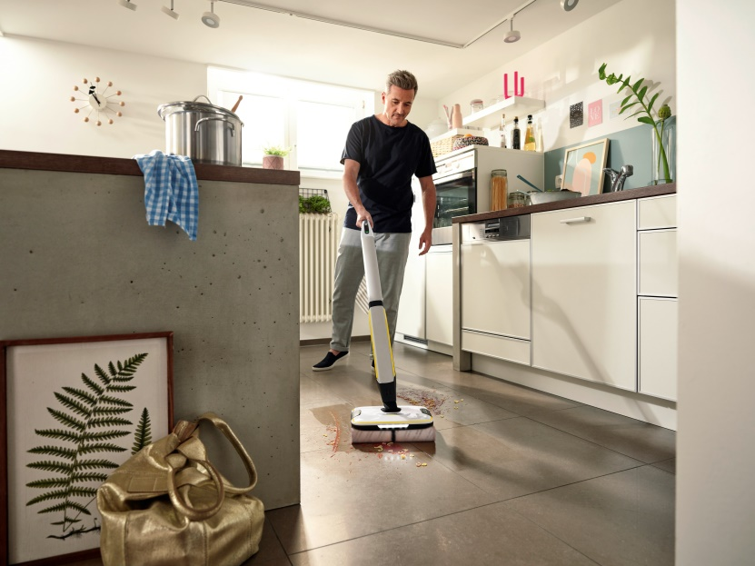
Eine gute Aufgabenverteilung und die passenden technischen Helfer sorgen für Harmonie im Haushalt.

In der richtigen Stimmung kann Putzen sogar Spaß machen und mit ein paar Tipps lassen sich Streitigkeiten leicht vermeiden.

