Kärcher auf dem Landwirtschaftlichen Hauptfest 2018: Freifläche N, Stand 24

Leistungsfähige Neuheiten zum 100. Geburtstag

Pressekontakt
Alexander Becker
Pressereferent
Alfred Kärcher GmbH & Co. KG
Alfred-Kärcher-Str. 28-40
71364 Winnenden
T +49 71 95 14-4256
alexander.becker@de.kaercher.com
Winnenden, im August 2018 – Kärcher präsentiert auf dem Landwirtschaftlichen Hauptfest 2018 zahlreiche Reinigungs- und Pflegelösungen für den Agrarbereich. Die 100. Auflage der größten Fachmesse für Land-, Forst- und Ernährungswirtschaft in Süddeutschland findet vom 29. September bis zum 7. Oktober 2018 auf dem Cannstatter Wasen in Stuttgart statt.
Auf dem Kärcher-Stand wird die Neuauflage der Aktion für Mitglieder in den Bauern- und Winzerverbänden präsentiert. Im Fokus stehen Angebote für Hochdruckreiniger, Nass-/Trockensauger und Reinigungsmittel, die auf die Bedürfnisse in der Landwirtschaft abgestimmt sind.
Dazu gehört der HDS 11/18-4 S Classic. Der mobile Heißwasser-Hochdruckreiniger arbeitet in der eco!efficiency-Stufe besonders wirtschaftlich. Für den komfortablen Einsatz ist das Gerät mit der EASY!Force-Hochdruckpistole ausgestattet. Das wesentliche Merkmal des ergonomischen Zubehörs ist der Abzug, der mit dem Handballen in den Griff geschoben wird. Dadurch erübrigt sich nach dem Auslösen praktisch jegliche Haltearbeit: Der Rückstoß des Wasserstrahls drückt den Abzug von selbst in die Hand.
Auch der NT 40/1 Ap Agri hält den Anforderungen der Landwirtschaft stand. Der vielseitig einsetzbare Nass-/Trockensauger ist auch für die Aufnahme von feinem Staub geeignet: Sein Filter lässt sich auf Knopfdruck reinigen, so dass die volle Saugkraft sofort wieder zur Verfügung steht.

Eine Word-Datei und druckfähige Bilder zu dieser Presseinformation liegen für Sie in unserem Newsroom https://www.kaercher.com/presse zum Download bereit.

Kaercher_Vorschau_LWH_2018.docx

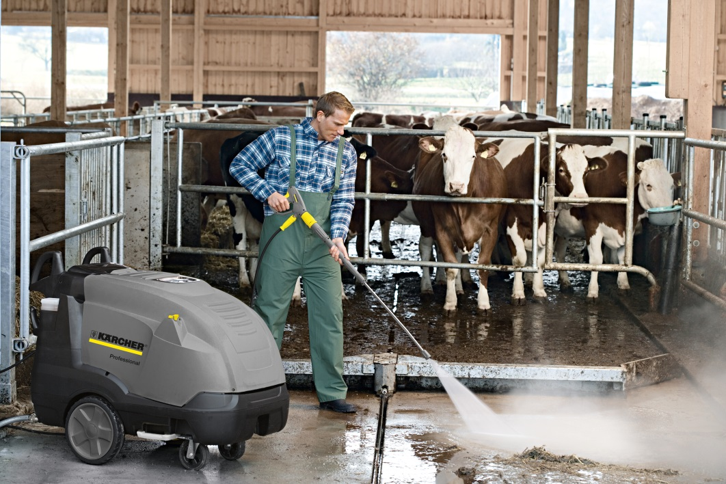
Der Heißwasser-Hochdruckreiniger HDS 11/18-4 S Classic ist für die Anforderungen im landwirtschaftlichen Einsatz konzipiert.

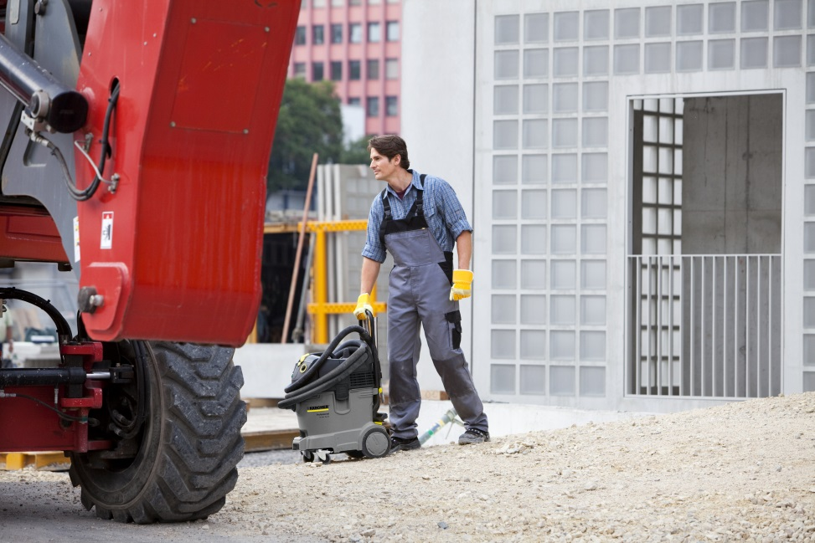
Der NT 40/1 Ap Agri ist im landwirtschaftlichen Umfeld vielfältig einsetzbar und nimmt trockenen und nassen Schmutz zuverlässig auf.

