GEA NOx Separator: For cleaner shipping with pioneering fuel technology

Duesseldorf, December 11, 2025 – On the occasion of Marintec China (2–5 December 2025), GEA was showcasing its latest technologies for low-emission ship design. At the center is the GEA NOx Separator, a key technology for reducing nitrogen oxide (NOx) emissions in EGR and iCER systems. As the leading maritime innovation, the trade fair provided the ideal platform to highlight the importance of cleaner fuel technologies and GEA’s role in advancing sustainable shipping worldwide.

Innovative Technology for Clean Emissions

With the increasing adoption of dual-fuel engines and stricter IMO Tier III regulations, the efficient treatment of wash water from EGR/iCER systems has become a critical requirement for modern newbuild projects. The GEA NOx Separator is engineered to meet these requirements with exceptional reliability and efficiency. It helps shipowners and engine builders reduce emissions, protect machinery, and maintain consistent separation performance even under challenging operating conditions.
With cutting-edge technologies such as the GEA NOx Separator – an advanced solution that significantly reduces nitrogen oxide emissions through exhaust gas recirculation – and intelligent control systems that optimize wash water treatment, we are empowering the shipping industry to accelerate its shift toward low-emission operations,” said Li Bin, Senior Director Sales Separator, GEA China. “By uniting our decades of separation expertise with next-generation wash water treatment solutions, we help our customers meet the toughest environmental standards while delivering the reliability and performance they depend on,” Li Bin added.

Methanol Dual-Fuel: Next-Generation Propulsion Technology

Methanol dual-fuel propulsion is gaining worldwide traction as it can reduce greenhouse gas emissions by up to 65% compared to conventional fuel engines. While the maritime sector currently contributes less than 3% to global GHG emissions, its relative share is expected to rise as other industries decarbonize. Alternative fuels like methanol are therefore a key enabler for more sustainable shipping operations.
GEA Supports Everllence and X-Press Feeders

A current example of this technological development is the use of the GEA NOx Separator in several methanol dual-fuel projects.
GEA is supplying six GEA NOx Separator for wash water treatment in Everllence engines of type 5S50ME-C9.6-LGIM+EcoEGR Tier III – China’s first methanol dual-fuel main engine of this kind. These engines will power 1,250-TEU container ships currently under construction at Huangpu Wenchong Shipbuilding for Singapore-based feeder shipping company X-Press Feeders. The first units have already successfully entered commissioning.

"The delivery of the GEA NOx Separators for China’s first methanol dual-fuel main engine project is a milestone," said Li Bin. "This project demonstrates how our technology helps customers worldwide meet the most demanding environmental standards."

A greener course for the blue seas

GEA supports the massive efforts of shipping companies and ship owners to protect the environment and the maritime ecosystem with technological solutions for green ship design. The machine and plant manufacturer presents a comprehensive portfolio with its "Marine System Solutions." Significantly stricter laws and regulations, as well as initiatives and impetus from the shipping industry, are setting the course for climate-friendly shipping, or green shipping. The aim of GEA's collaboration with its customers and partners is to reduce the CO₂ footprint in maritime transport even further, while at the same time increasing the efficiency of marine equipment and machinery in ships. When it comes to technological solutions for green ship design, for example, the construction or retrofitting of climate-friendly ships, GEA is a global leader with its expertise in environmental protection, performance, and profitability.

Photos:

Photo 1:

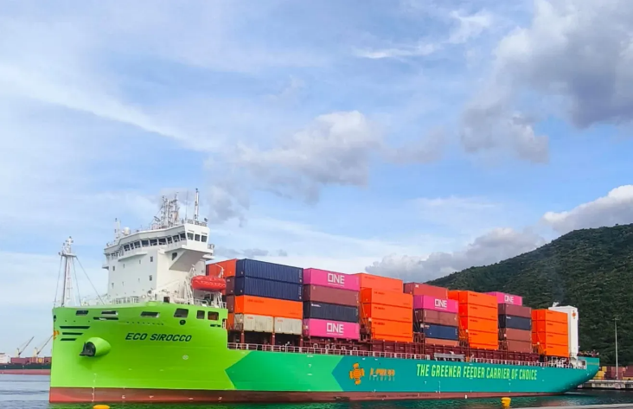

Photo 1, caption: The M.V. Eco Sirocco is equipped with a GEA NOx Separator. (Photo: MarineTraffic.com)
Photo 2:

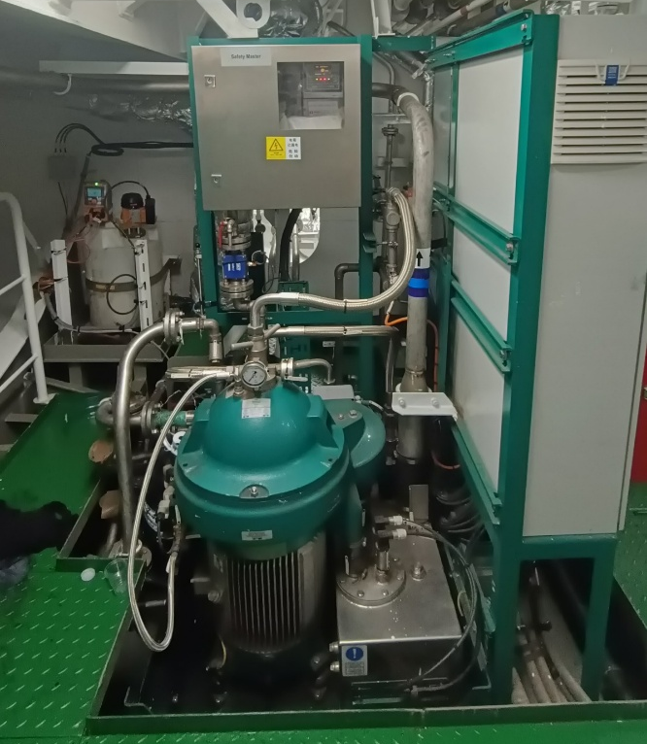
Photo 2, caption: The GEA NOx Separator on board the M.V. Eco Sirocco. (Photo: GEA)

X-Press Feeders: Leading provider of feeder solutions
X-Press Feeders was founded in 1972 and has since grown to become the world's largest independent feeder service provider. Our mission is to "provide the best feeder solutions and be the feeder service provider of choice." We position ourselves as "The Global Common Carrier" and strive to offer the most reliable and cost-effective service solutions to meet our customers' feeder requirements. With a fleet of more than 100 vessels, X-Press Feeders offers a wide range of ships for our services. With a nominal capacity of 700 TEU to 7,000 TEU, X-Press Feeders is able to offer both shuttle services and longer relay services around the major transshipment hubs, thus serving all types of freight requirements.

About GEA
GEA is one of the world’s largest suppliers of systems and components to the food, beverage and pharmaceutical industries. The international technology group, founded in 1881, focuses on machinery and plants, as well as advanced process technology, components and comprehensive services. For instance, every second pharma separator for essential healthcare products such as vaccines or novel biopharmaceuticals is produced by GEA. In food, every fourth package of pasta or every third chicken nugget are processed with GEA technology. With more than 18,000 employees, the group generated revenues of about EUR 5.5 billion in more than 150 countries in the 2024 fiscal year. GEA plants, processes, components and services enhance the efficiency and sustainability of customers’ production. They contribute significantly to the reduction of CO2 emissions, plastic usage and food waste. In doing so, GEA makes a key contribution toward a sustainable future, in line with the company’s purpose: ”Engineering for a better world.”

GEA is listed on the DAX, the STOXX® Europe 600 Index and is also a constituent of the leading sustainability indices DAX 50 ESG, MSCI Global Sustainability and Dow Jones Best-in-Class World.

More information can be found online at gea.com.
If you do not want to receive any further information from GEA, please send an e-mail to pr@gea.com.

NOTE TO EDITORS

- Further information about GEA
- To the GEA Press page
- To the GEA Media Center
- Background information on current topics can be found at Features
- Follow GEA on  

GEA
Media Relations GEA
Dr. Michael Golek
Ulmenstraße 99, 40478 Düsseldorf
Phone +49 211 91361505
Tel. +491736205746
michael.golek@gea.com

