PRESS RELEASE
Schwaebisch Hall, August 13, 2018

OPTIMA employees move into office spaces at the new logistics center
Building to be completed as planned

Copious glazed windows, overlooking green spaces to the west and the warehouse to the east. This describes the striking appearance of the new Optima logistics center, of around 6,000 square meters in size. Employees from the Materials Management division, together with the Purchasing, Logistics and Quality Assurance departments, moved into the new premises as planned at the beginning of July 2018. The building sets whole new standards in terms of environmental standards, the IT concept and working conditions.
Once the staff members have moved into the office building on the Solpark industrial park in Schwaebisch Hall, the automatic small parts warehouse will also be put into operation, which will be able to accommodate 45,000 articles. The logistics center will be fully operational at the beginning of 2019. Warehousing processes are managed and controlled using the latest and most up-to-date warehouse management software available on the market: SAP Extended Warehouse Management.
Light, bright design and comfortable noise levels
The new building also offers many advantages for the company's employees. The logistics center is integrated into the expansive landscape of the Hohenlohe plane with adjacent airfield and view of the Einkorn mountain local to Schwaebisch Hall. The glazing on both sides of the office building creates a bright working environment with a view of what's going on in the logistics hall on the east side and the large expanses of green on the west side. For interruption-free working and comfortable noise levels, a building physicist was specially commissioned to install sound-absorbing elements.
Pleasant temperatures throughout the year are ensured in the spacious office building by a modern heating and cooling ceiling. In the warehouse, this is achieved via concrete core activation which cools and heats the floor, similar to an underfloor heating system. State-of-the-art workstations with attractive plant and water features, write-on walls, communal areas that look like lounges, catering areas, a creativity room and a rooftop terrace offer plenty of space and comfort for employees. Well-equipped communal spaces and a relaxation room complete the concept of the workplace as a “living space”.
District heating supplies the building with energy
The building conforms to the "Effizienzhaus 55" standard, meaning it meets particularly high environmental standards. It is connected to the district heating network of the city of Schwaebisch Hall.
The reasons for the new building are manifold: an acute lack of space due to the growth of Optima, storage technology that was no longer up-to-date, as well as Optima's subsidiary companies seeking more space to expand their successful product business. This was followed in 2011 by initial considerations regarding a reorientation of Optima's materials management systems. After unifying the purchasing, logistics and quality assurance departments under the umbrella company of OPTIMA materials management GmbH, a shared building was the next logical step.
Further construction measures are currently being planned. At present, office and production space for Optima Pharma is being built on the Solpark industrial park in Schwaebisch Hall.

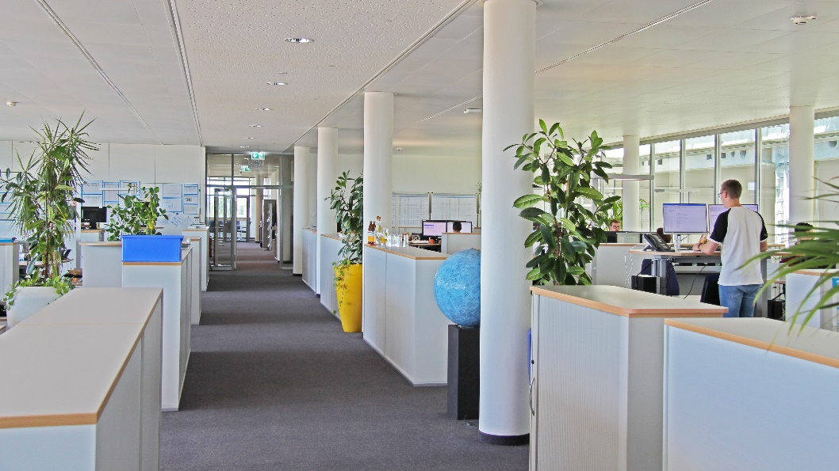
Glazing on both sides of the building ensures plenty of light in the office spaces.

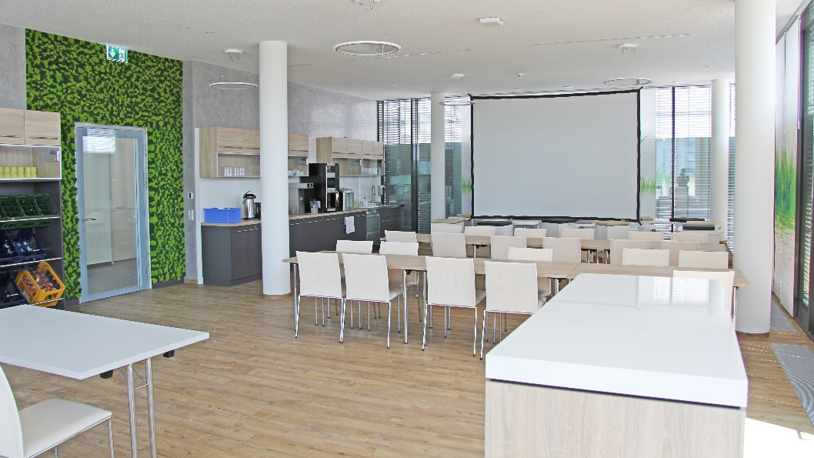
Catering areas are just as much a part of the spatial concept as plant and water features, write-on walls, communal areas that look like lounges, a creativity room and a roof terrace.

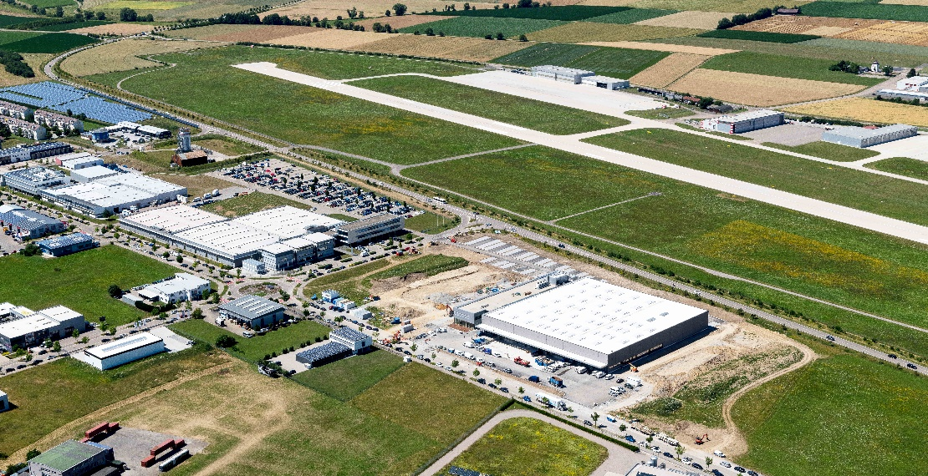

Bird's eye view of the new building. The proximity to Optima's other business units means short distances and thus more efficient processes for the company.

Characters (incl. spaces): 3,335

Contact:
OPTIMA packaging group GmbH
Jan Deininger
Editor
+49 (0)791 / 506-1472
jan.deininger@optima-packaging.com
www.optima-packaging.com
Thank you very much for your publication. We look forward to receiving a specimen copy.

