EEW and GEA launch strategic partnership for CO₂ capture

Duesseldorf (Germany), May 19, 2025 – EEW Energy from Waste (EEW) and machine and plant manufacturer GEA have agreed a strategic partnership for CO₂ capture. The aim of the collaboration is to test innovative processes for capturing and utilizing CO₂ under real-life conditions and to further develop them for industrial-scale application.

As a first step, EEW has acquired a mobile test plant from GEA. The plant will be used at various EEW locations from summer 2025, initially in Delfzijl in the Netherlands. The plant will provide practical insights into the efficiency, scalability and integration of CO₂ capture into existing thermal waste recycling processes.

"Together, we are focusing on state-of-the-art technologies for CO₂ capture in order to pave the way for large-scale implementation," says Dr. Joachim Manns, Chief Operating Officer (COO) of the EEW Group. "The test plant acquired as part of the cooperation is a decisive step towards increasing energy efficiency, relieving the burden on plants and increasing the technological maturity of carbon capture solutions. In this way, we are creating the basis for consistently implementing our decarbonization strategy."

Dr. Felix Ortloff, Senior Director Carbon Capture Solutions at GEA: “With the new test plant and the technology used, we are supporting EEW in its decarbonization goal and on the path to achieving it. CO₂ capture plays a central role in this.”

EEW calls for political framework: "Politicians must now deliver"

While EEW is investing in technology and partnerships, the reliable regulatory framework in Germany is still lacking. Although CO₂ capture is technologically viable, large-scale projects remain impossible without legal clarity on the transportation, storage, use and remuneration of CO₂."We are in the starting blocks. But we need clear rules to get started," emphasizes Dr. Manns. "The new federal government must deliver now: We need a regulatory framework that enables economically viable investment in the construction and operation of CO₂ capture, a CO₂ pipeline network, planning security for investments and start-up funding to reduce risk for the first pioneering projects." Thermal waste utilization can make a significant contribution to carbon management - especially because more than half of EEW emissions are of biogenic origin. If this CO₂ is captured and stored, negative emissions are produced that are essential for achieving national climate targets.

Carbon capture solutions from GEA

With carbon capture, GEA offers complete solutions ranging from gas purification and heat extraction as well as downstream CO₂ separation to liquefaction, which significantly reduce CO₂ emissions (end-to-end solutions). There are options for decoupling thermal energy that make it possible, for example, to produce electricity yourself in order to reduce your own consumption and thus further reduce your carbon footprint. It also makes sense to use the decoupled thermal energy in the carbon capture process to make the process more efficient. Carbon capture solutions also offer the possibility of converting CO₂ emissions into valuable products such as raw alcohols, especially methanol, or other precursors for the chemical industry (CCU, Carbon Capture Utilization). There is also the possibility of storing captured CO₂ (CCS, Carbon Capture Storage). A combination of storage and conversion into valuable primary products for the plastics and pharmaceutical industries is also possible (CCUS, Carbon Capture Utilization and Storage). GEA offers a high degree of modularization in the carbon capture sector with standardized plant capacities that can be adapted to the industry-specific requirements of different emitters.

Photos:

Photo 1:

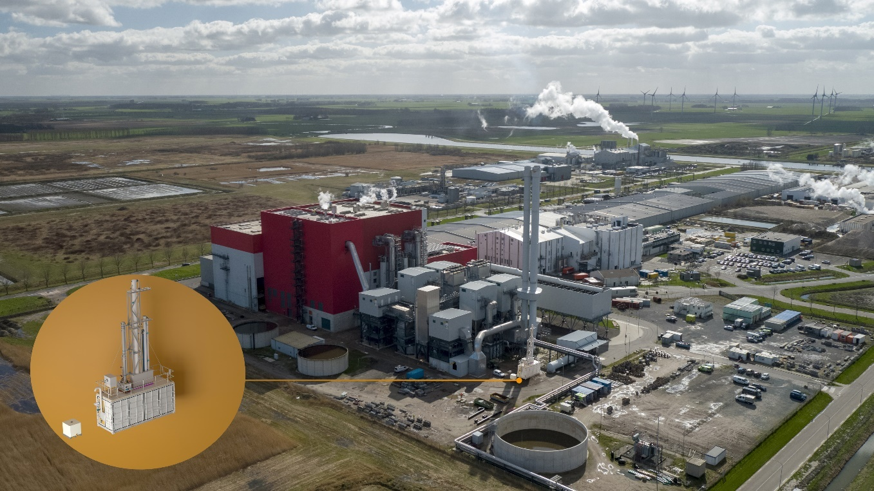

Photo 1, caption: EEW plans to use the mobile test plant in Delfzijl in the Netherlands first. From there, it will then begin its journey to selected EEW Group sites and provide valuable insights into the integration of CO₂ capture technologies into the operation of thermal waste recycling plants. (Photo/graphic: EEW)

Photo 2:

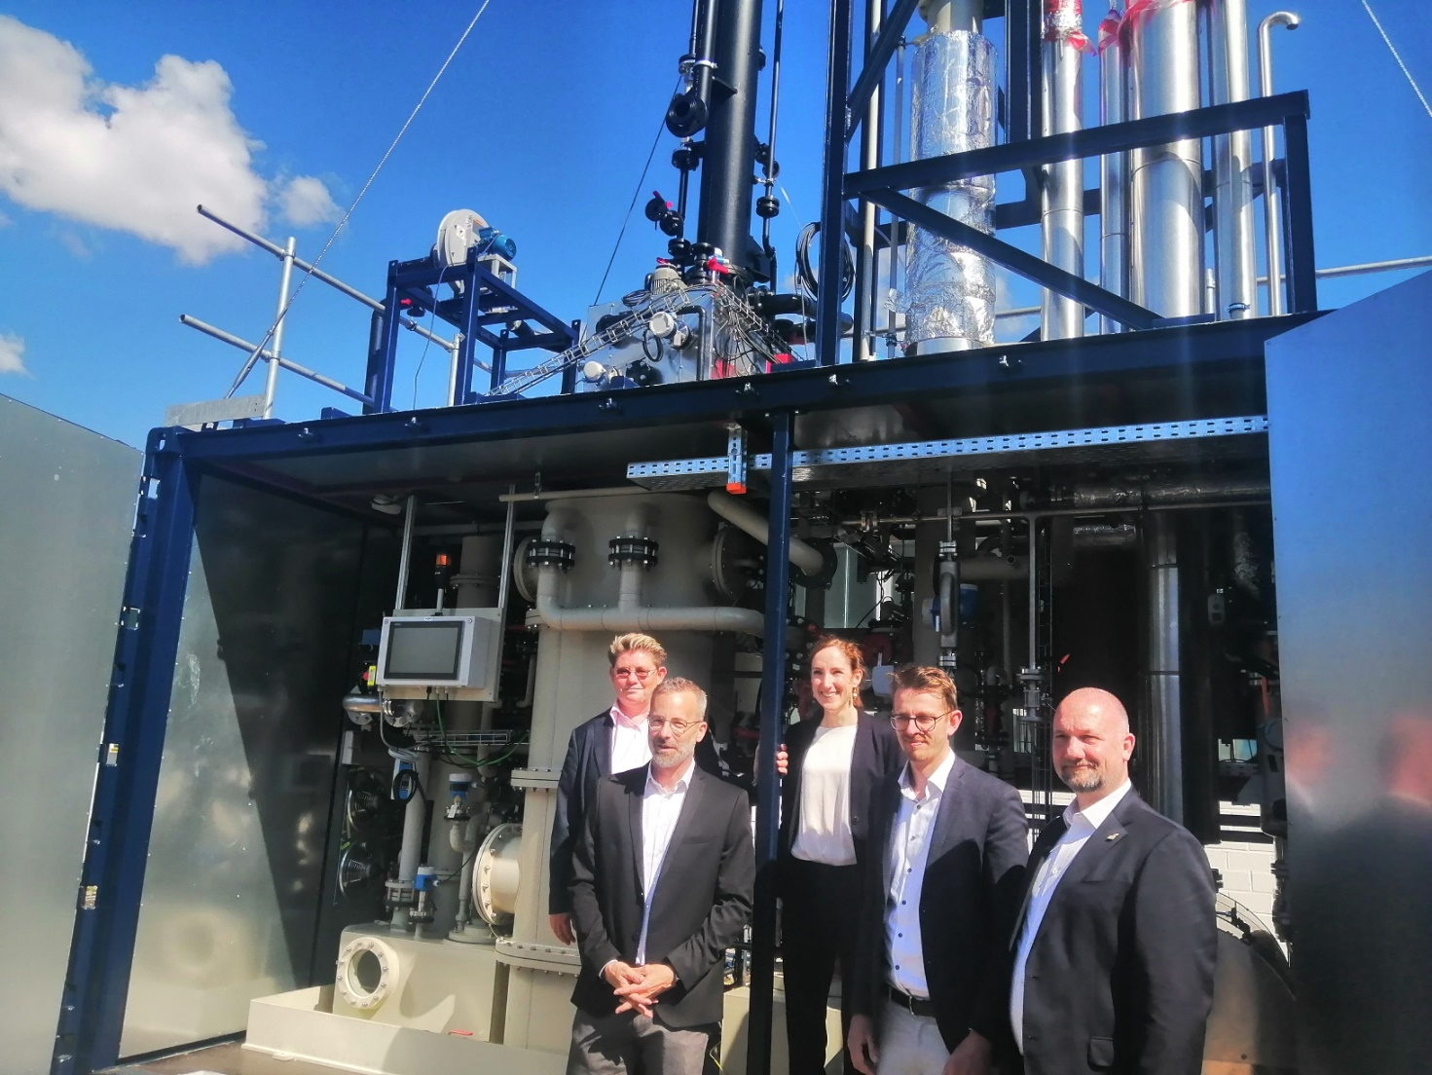

Photo 2, caption: EEW Energy from Waste (EEW) and machinery and plant manufacturer GEA have agreed on a strategic partnership for CO₂ capture. (Photo: Michael Golek/EEW)

Foto 3:

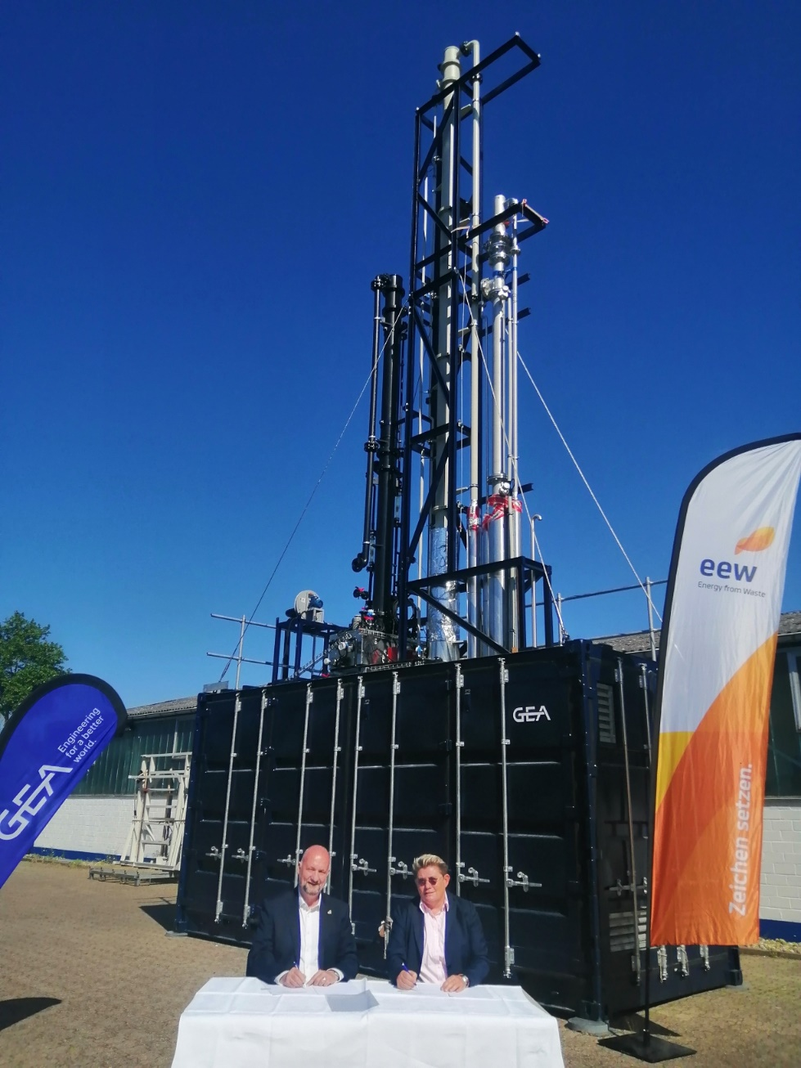

Photo 3, caption: Dr. Joachim Manns, Chief Operating Officer (COO) of the EEW Group (left), and Kristina Böe, GEA Senior Vice President Powder & Thermal Separation, agreed on a strategic partnership. (Photo: Michael Golek/GEA)

EEW
Energy from Waste GmbH (EEW) is a leading company in the circular economy that not only treats waste but uses it as a valuable resource for energy and raw materials. At our 17 sites in Europe, we thermally utilise around 5 million tonnes of waste annually, generating enough electricity to supply 700,000 households. In this way, we make a major contribution to climate protection and resource conservation. With more than 1,400 employees, we work hard to efficiently utilise the energy contained in waste, reduce waste volumes and lower CO₂ emissions. Our sustainability strategy aims to make our operations climate-neutral by 2030 and climate-positive by 2045 CO₂ capture at our plants will play a key role in this.

About GEA
GEA is one of the world’s largest suppliers of systems and components to the food, beverage and pharmaceutical industries. The international technology group, founded in 1881, focuses on machinery and plants, as well as advanced process technology, components and comprehensive services. For instance, every second pharma separator for essential healthcare products such as vaccines or novel biopharmaceuticals is produced by GEA. In food, every fourth package of pasta or every third chicken nugget are processed with GEA technology. With more than 18,000 employees, the Group generated revenues of about EUR 5.4 billion in more than 150 countries in the 2024 fiscal year. GEA plants, processes, components and services enhance the efficiency and sustainability of customers’ production. They contribute significantly to the reduction of CO2 emissions, plastic usage and food waste. In doing so, GEA makes a key contribution toward a sustainable future, in line with the company’s purpose: ”Engineering for a better world.”

GEA is listed on the German MDAX, the European STOXX® Europe 600 Index and is also a constituent of the leading sustainability indices DAX 50 ESG, MSCI Global Sustainability and Dow Jones Best-in-Class World.

More information can be found online at gea.com.
If you do not wish to receive any further information from GEA, please send an e-mail to pr@gea.com.

NOTE TO EDITORS

- Further information about GEA
- To the GEA Press page
- To the GEA Media Center
- Background information on current topics can be found at Features
- Follow GEA on  

GEA
Media Relations GEA
Dr. Michael Golek
Peter-Müller-Str. 12, 40468 Düsseldorf
Phone +49 211 91361505
Tel. +491736205746
michael.golek@gea.com

