Thi My Lien Nguyen  Shaping Fluidity  Starting from September 7, 2024  Installation with Pop-up Café at the Kunstmuseum St.Gallen  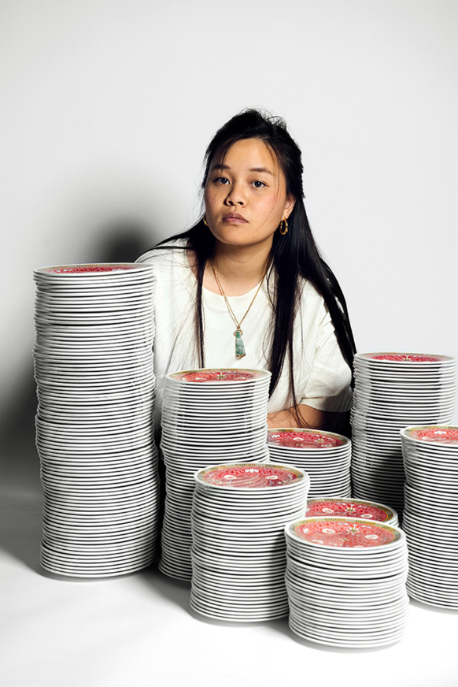  Thi My Lien Nguyen, My Heritage. A Self-Portrait, 2022  In her work, Swiss-Vietnamese artist Thi My Lien Nguyen (b. 1995, St.Gallen) explores the concepts of home and belonging, as well as the experience of foreignness. She is particularly interested in post-migrant realities, traditions, rituals, folklore, and customs from various cultural spheres. Through inclusive and participatory projects, Nguyen creates integrative spaces. In the context of her activations, she emphasizes the importance of food culture, its customs, rituals, and ceremonies within the social fabric of a community. Her photographic series address the Vietnamese-Swiss identity and the diverse, sometimes parallel, living environments in Switzerland.  With the Shaping Fluidity project, Thi My Lien Nguyen is creating a unique space at the Kunstmuseum St.Gallen that merges photography with culinary experiences. Beginning on September 7, 2024, Nguyen will present an installation that will be complemented by a variety of educational offerings. An integrated pop-up café will serve as a meeting place for exchange and dialogue, while also offering insights into the rich diasporic culture.  The exhibition features various photographic works that extend her artistic practice, addressing themes such as belonging, invisibility and visibility, and the relationship between food and identity. Special attention is given to the significance of Vietnamese culture in Switzerland. The aim is to create a space for encounters and intercultural exchange, where cultural diversity is celebrated through food in a participatory manner.  Thi My Lien Nguyen (b. 1995, St.Gallen) completed her Bachelor's degree in Visual Communication at the Lucerne School of Art and Design (HSLU). She has exhibited her works in solo shows at Coalmine - Raum für Fotografie in Winterthur (2022) and in the ‘Seitenwagen’ at Kunst(Zeug)Haus Rapperswil (2018), as well as in group exhibitions, including at the Athens Photo Festival at the Benaki Museum in Athens (2024), at Werkschau Zürich at Museum Haus Konstruktiv in Zurich (2023), at Plat(t)form at Fotomuseum Winterthur (2022), at Heimspiel 2021 at Kunsthaus Glarus (2021), at Vincom Centre for Contemporary Art in Hanoi, Vietnam (2021), at Angkor Photo Festival in Siem Reap, Cambodia (2019), and at Heimspiel 2018 at Kunsthalle St.Gallen (2018). In 2024, she will be in London on a studio grant from Landis & Gyr.  This exhibition is generously supported by the Cultural Foundation of the Canton of Thurgau, Susanne and Martin Knechtli-Kradolfer Foundation and Senn Resources AG, St.Gallen. | Exhibition Dates  Starting from September 7, 2024  Kunstmuseum St. Gallen  Exhibition Opening  September 7, 2024  6 p.m.  Opening Hours  Tue – Sun: 10:00 a.m. – 5:00 p.m.  Thu: 10:00 a.m. – 8:00 p.m.
Press Contact

Nadine Sakotic
Head of Communications
Museumstrasse 32
9000 St. Gallen
T +41 71 242 06 84

kommunikation@kunstmuseumsg.ch
kunstmuseumsg.ch

Factsheet

Exhibition Dates | Starting from September 7, 2024
Exhibition Venue | Kunstmuseum St. Gallen
Exhibition Opening | September 7, 2024, 6 p.m.
Curator | Nadia Veronese
Opening Hours | Tue – Sun: 10:00 a.m. – 5:00 p.m.  Thu: 10:00 a.m. – 8:00 p.m.
Press Contact | Nadine Sakotic  T +41 71 242 06 84  kommunikation@kunstmuseumsg.ch
Website | kunstmuseumsg.ch
Press Photos | kunstmuseumsg.ch/presse

