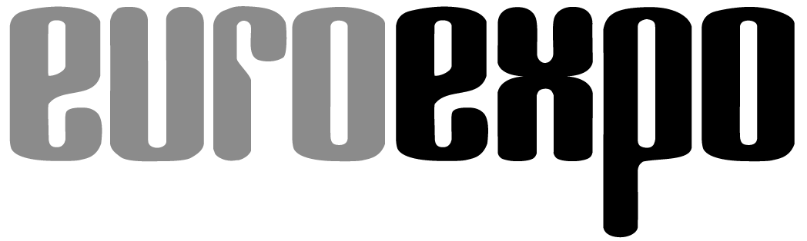
Messe- und Kongress-GmbH
Joseph-Dollinger-Bogen 7
D - 80807 München
Tel.: +49 (0)89 32391-259
Fax: +49 (0)89 32391-246
www.euroexpo.de
www.logimat-messe.de
www.tradeworld.de

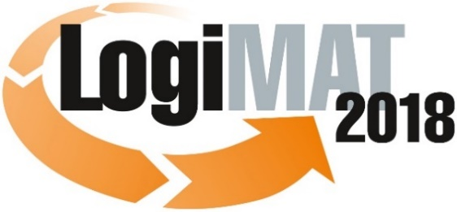

16th International Trade Fair for Intralogistics
Solutions and Process Management
13 to 15 March 2018, Messe Stuttgart

Part of LogiMAT:
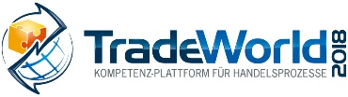

Munich, 13.03.2018

Press Release

LogiMAT 2018 in Stuttgart
LogiMAT 2018 – First-hand intralogistics

The exhibits at the 16th LogiMAT showcase all the latest developments and trends in the sector. Set out here for the trade audience from industry and trade is a roadmap for forward-looking investment in leveraging further potential in intralogistics.

On 117,000 square metres of exhibition space, over 1,560 exhibitors from 38 countries will be putting on a presentation at the 16th LogiMAT of the full spectrum of solutions for intralogistics and modern process management. Under the motto of “First-hand intralogistics: Digital – Connected – Innovative” this event highlights the overarching theme affecting all segments in the sector of how to integrate modern technologies and materials in future-capable solutions that meet the challenges of Industry 4.0, Logistics 4.0, the Internet of Things and the digitalisation that comes with this integration. As such, with their exhibits the exhibitors also reflect the current trends in product development in the respective supplier segments.

For example, at the stands of the developers of logistics software systems in Hall 8 and in the new Hall 10 at the Stuttgart exhibition centre, the trade visitors can review augmented reality (AR) applications and apps and IT platforms for Cloud computing. Cloud solutions with which the functions can be configured to suit individual requirements offer small and medium-sized companies in particular a practical route into process optimisation, collecting and digitalising data – and promise the developers new and lucrative business models. In parallel with this integrated concepts are presented that not only control individual warehouses and manage transports, but also bring integration, transparency and coordinated control options into the entire supply chain. They depict upstream and downstream processes, support order tracking, fleet and transport management and standard processing in air and sea freight, and also integrate partners into the supply chain. As regards future perspectives the exhibits of the software companies at the 16th LogiMAT also feature the programming of adaptive, self-learning systems, the expansion of services and the integration of artificial intelligence (AI).

In the response to new development trends and technologies, for example as part of the Internet of Things (IoT), there is an intersection between software and AutoID. In Halls 4 and 6 the ident segment is presenting diverse enabling technologies for Industry 4.0 that ensure safe and secure processes in logistics and production. The corresponding products range from optical readable media (ORM), including labels, label-printing systems and data-capture devices for the encoded information via RF identification and navigation systems, to 3D scanning and real-time localisation solutions (RTLS) with IoT chips.

On the basis of software and auto ID components, in-company materials flow is being increasingly automated. The spectrum of solutions ranges from driverless transport systems and vehicles to entire solutions for automated warehouse systems for small and medium-sized businesses. This development trend is being reflected at LogiMAT 2018 on the one hand by the exhibitors in the section on materials handling and storage technology in Halls 1, 3, 5 and 7 and on the other by the manufacturers of ground conveyors in Halls 7, 9 and 10.

In materials handling and storage technology the growing demands on process quality and integration are promoting the expansion of automation in intralogistics processes. They operate as a driver of developments that focus on modularity and the themes of sequencing and efficiency in order-picking processes. The development trends are seen in compact, modular device and plant concepts of the exhibitors with which the components for a continuous materials handling concept can be combined according to individual requirements. With regard to efficiency and the shortage of skilled personnel, robots are increasingly being used.

The combination of robotics and driverless transport systems, for example in the shape of mobile picking robots, will in the foreseeable future change the man-to-goods order-picking strategy through automated ground conveyors and processes such as autonomous intelligent systems. Almost all the plant builders, many new entrants and of course the ground-conveyor manufacturers are presenting at LogiMAT 2018 the latest developments from this area. In addition the international exhibitors in the ground conveying segments are showcasing their latest innovations in electric vehicles. In Halls 9 and 10 the automation of processes and vehicle movements is also increasingly dominating the trends – and the innovations in the exhibits on display. The spectrum covered by these new developments – often these are also world premieres – ranges from new devices and series in all e-device classes to driver-assistance systems for intelligent integration and more efficiency and safety through to new, cost-saving energy concepts and alternative drives, first and foremost lithium-ion technology.

As well as the trends of digitalisation, integration and automation, another key driver of new developments in intralogistics is e-commerce. LogiMAT recognised the strategic importance of this area early on and included it in its spectrum, with TradeWorld. As a competence platform for trading processes TradeWorld is now an established part of the world´s biggest trade fair for intralogistics. As well as the solutions on show that many LogiMAT exhibitors in plant building, software and ident technology offer in their solutions portfolios, TradeWorld in Hall 6 also showcases a wide range of products and solutions that are specifically targeted to the needs of trade logistics and omnichannel. The spectrum covered and the current demands on trade logistics are explored as themes in the TradeWorld lecture block in the trade forums of the accompanying programme. These themes encompass, for example, aftersales, e-commerce concepts, Retail 4.0, fulfilment, returns handling and shop systems as well as payment systems.

LogiMAT, the 16th International Trade Fair for Intralogistics Solutions and Process Management – as seen by the above-mentioned examples – is again underlining its reputation as a trend barometer, information and presentation platform for innovations from and for all areas of intralogistics. The trade audience from industry and trade benefit from a full overview of all the latest products and solutions and of stable trends and developments. As such this event supports that trade audience as it makes investment decisions for optimising their businesses to meet current and future challenges. It brings the suppliers of these innovations together with the users. In short: first-hand intralogistics.

Organiser:
EUROEXPO Messe-und Kongress-GmbH
Joseph-Dollinger-Bogen 7; 80807 München, Tel.: +49(89)32391-259;
Fax: +49(0)89 32391-246

Further information: www.logimat-messe.de

Munich, 13.03.2018 Reproduction free of charge. Copies of publication to: EUROEXPO Messe- und Kongress-GmbH, Presse- und Öffentlichkeitsarbeit, 80912 Munich, Germany.

About LogiMAT

The next LogiMAT, 16th International Trade Fair for Intralogistics Solutions and Process Management, takes place at Messe Stuttgart, directly adjacent to the airport, from 13 to 15 March, 2018. This event is now regarded as the world´s largest specialist trade fair for intralogistics. It presents a comprehensive overview of the market, featuring everything of importance to the intralogistics sector from procurement to production and delivery. Here, early in the year, international exhibitors present innovative technologies, products, systems and solutions for rationalisation, process optimisation and cost-reduction in in-company logistics processes.
TradeWorld – a part of LogiMAT – is a competence platform for trading processes; it showcases products and solutions for e-commerce and omnichannel. Located in the middle of the halls, this event features an exhibition section and also each day different lecture blocks on a wide range of themes.

