Start von 23 dualen Studenten

Kärcher bildet uneingeschränkt weiter aus

Pressekontakt
Anouk von Hochmeister
Pressereferentin
Alfred Kärcher SE & Co. KG
Alfred-Kärcher-Str. 28-40
71364 Winnenden
T +49 71 95 14-2168
F +49 71 95 14-2193
anouk.vonhochmeister@de.kaercher.com
Winnenden, 25. September 2020 – Kärcher begrüßt diese Woche 23 junge neue Kolleginnen und Kollegen, die ein duales Studium beginnen. In den kommenden drei Jahren werden sie den Praxisteil ihres jeweiligen Studiengangs bei Kärcher absolvieren, das für den Bachelor-Abschluss notwendige Theoriewissen an der Dualen Hochschule Baden-Württemberg (DHBW) erarbeiten. Die traditionellen Einführungstage in das Familienunternehmen finden unter Einhaltung aller Corona-Regeln auch in diesem Jahr auf dem Werksgelände statt, um den Einstieg so persönlich wie möglich zu gestalten. Alle dualen Studenten und Auszubildende haben in diesem September wie geplant begonnen – und auch 2021 wird Kärcher im vollen Umfang ausbilden.
Kärcher und die DHBW kooperieren seit mehr als 30 Jahren. Im 12-Wochen-Rhythmus wird zwischen akademischem Wissen und praktischer Erfahrung gewechselt. Die Studierenden profitieren von einer individuellen Betreuung und erhalten von Kärcher eine Ausbildungsvergütung sowie Unterstützung während einer Praxis- oder Theoriephase im Ausland. Erfolgreiche Studienabsolventen erhalten ein unbefristetes Arbeitsangebot.
Offene Stellen für einen Ausbildungsstart im Herbst 2021 unter: https://www.kaercher.com/de/inside-kaercher/karriere/schueler.html
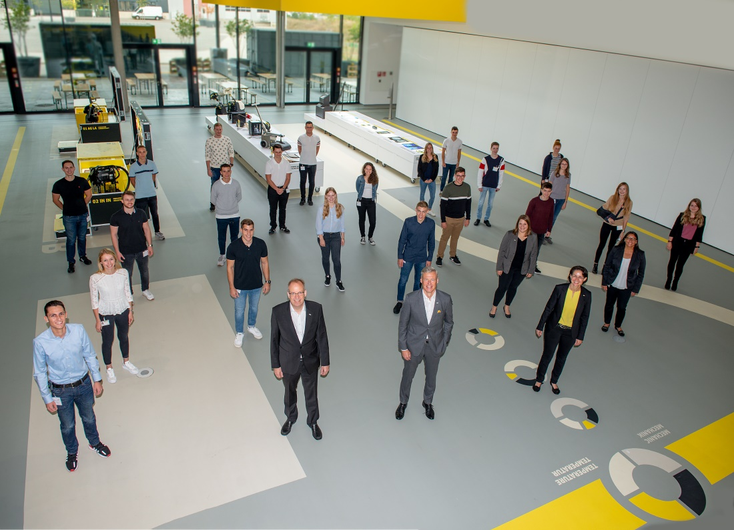
Hartmut Jenner, Vorsitzender des Vorstands von Kärcher, mit den neuen DH-Studenten und ihren Ausbildern.

