PRESS RELEASE
Schwaebisch Hall, July 16, 2019

OPTIMA awarded for cutting-edge human resources management
Allianz Industrie 4.0 honors company at award ceremony in Stuttgart

The OPTIMA packaging group GmbH, based in Schwaebisch Hall, Germany, was the first human resources department recognized by Allianz Industrie 4.0 Baden-Wuerttemberg for pioneering human resources management in the age of digitalization. At an award ceremony on July 15, Director Human Resources Sebastian Henke accepted the award on behalf of the company. In the competition "100 Locations for Industry 4.0", the alliance honored small and mid-sized companies which make the most out of the potential of Industry 4.0 with outstanding ideas.
Digital solutions that demonstrate the added value of digital networking – this is what Allianz Industrie 4.0 was looking for in the competition "100 Locations for Industry 4.0". The alliance is a network initiated and promoted by the Baden-Wuerttemberg Department of Commerce, with its coordinating body located with the Baden-Wuerttemberg state association of the VDMA (German Mechanical Engineering Industry Association). Innovations that were sought also included outstanding organizational processes such as those introduced by the OPTIMA packaging group GmbH as part of an extensive digitalization strategy.
Digital solutions are firmly established in many of the company's departments
The special purpose machine manufacturer from Schwaebisch Hall, Germany, uses the potentials of digitalization in many areas – including human resources. The company has now been awarded for that. The Industry 4.0 solution, titled "Human Resources as an Accelerator of Transformation", incorporates several complementary human resources tools and initiatives that support employees and managers – from personnel planning to human resources development. "With these measures, we successfully support our employees in the future of work," said Sebastian Henke, Director Human Resources of the OPTIMA packaging group GmbH. "The human resources tools are oriented toward target groups and applications, and focus on the needs of individual employees," Henke continued.
OPTIMA proactively integrates employees and management into the subject of digitalization
Among other things, this includes active internal communication on the topic of the future of work in internal media, the introduction of active sourcing and the Packaging Valley e.V. Virtual Reality Center in university marketing and vocational training. Management actively informs the company about future requirements connected with digitalization. Industry 4.0 and necessary qualification measures are an important topic in performance reviews.
The human resources development program at Optima prepares employees for the future. It includes numerous training offerings on digital subjects and agile work. At the moment, the company is about to conclude a collective bargaining agreement that comprehensively regulates mobile work and gives employees more flexibility. In addition, the works council and the Human Resources department are closely exchanging views on the goals and requirements of Work 4.0.
Market relevance and level of innovation are crucial
A successful application for the competition depends on the market relevance and the solution's level of innovation. The competition is oriented toward companies from Baden-Wuerttemberg, primarily those that are small or mid-sized. A jury of experts from Allianz Industrie 4.0 judges the applications received. It is composed of representatives from business, science, chambers of industry and commerce, unions and politics. Award-winners include well-known companies such as SAP, Bosch, Siemens, Wuerth, Kaercher and ebm-papst.

About OPTIMA

OPTIMA packaging group GmbH with headquarters in Schwaebisch Hall, Germany, teams with its subsidiaries to design and build packaging equipment for pharmaceutical, consumer, nonwoven and life science products – from single standard machines to complete complex turnkey systems. Whether custom solutions or modular standard units, functions are consistently tailored to the specific needs of the customers and their industries. Optima is the worldwide leader in packaging technologies for many fields. Founded in 1922, the family owned and operated business is in its third generation and employs a workforce of 2,400 at its five sites in Germany and 14 locations abroad. An export share of more than 85 % is indicative of the company’s international standing
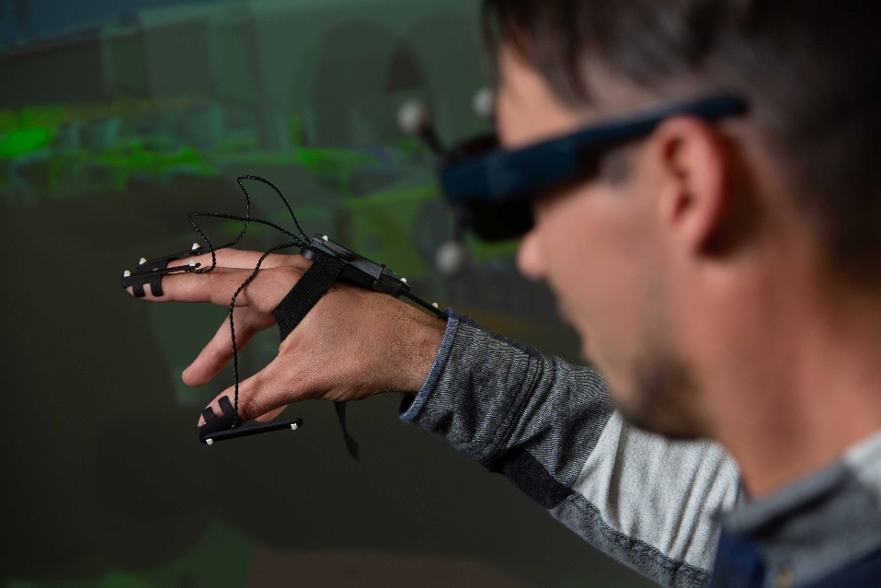
Virtual reality is not only used for the planning of filling and packaging systems at Optima. Trainees and students are also familiarized with the new technology at an early stage. The mechanical engineering company has now been awarded for measures such as these.

Employees and management at Optima are equally involved with digitalization. In performance reviews, management and employees look together for qualification measures to prepare the employees for the digital transformation.

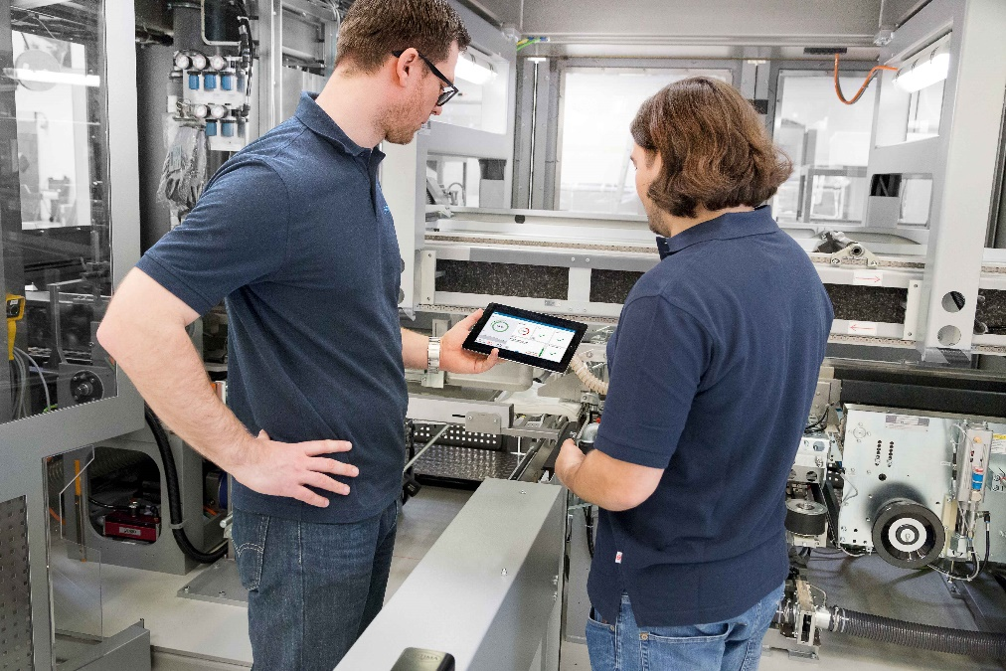
The personnel development program at the Optima Group offers employees the opportunity to proactively find training offers dealing with digitalization.

Characters (incl. spaces): 3,706

Press contact:
OPTIMA packaging group GmbH
Jan Deininger
Editor
+49 (0)791 / 506-1472
jan.deininger@optima-packaging.com
www.optima-packaging.com
Thank you very much for your publication. We look forward to receiving a specimen copy.

