PRESS RELEASE
Schwaebisch Hall, August 01, 2023

2022/2023 Annual Report

Growing sustainably
OPTIMA is strengthening its claim as technology leader and strategic innovation partner
Right in the heart of a fast developing and changing packaging industry, the OPTIMA packaging group GmbH has positioned itself even more strongly as a strategic innovation partner, developing innovative and sustainable filling, packaging and production systems for challenging products in a variety of sectors worldwide. With a clear focus on quality, safety, efficiency and customer satisfaction, the company achieved a consolidated turnover of over 550 million euro in business year 2022. The group currently employs over 3.000 workers around the world.
Optima can look back on another successful business year. "After the challenging pandemic years, we are delighted that we have returned to a successful path and achieved a good overall result in 2022", says Hans Buehler, CEO of the Optima Group. Optima has retained the flexibility of a family company and combined it with the performance strength of a group. That is why the company now has over 7.000 distinguished customers, from start-ups to large company groups. Thanks to the consistent focus as a strategic innovation partner, Optima received three large orders in the past year, which only a few machine and plant builders could have fulfilled. The company is currently producing eight challenging lines in the food industry for a US customer. The demand for complex turnkey lines in the pharmaceutical industry remains extremely high all over the world. Optima has also won two large orders from international global players in pharmaceuticals. The company offers its customers comprehensive turnkey expertise from a single source, which ultimately results from the consistent focus as a system supplier.
Optima generates the majority of the revenue abroad, with exports accounting for over 85 percent. More than 3.000 people are employed worldwide at 20 locations. Over 2.500 in Germany and over 2.000 of these in Schwaebisch Hall. With more than 170 trainees and students, the company focuses heavily on supporting the workforce of the future. Training young talents is a key component of the mission "We care for people". Well-trained personnel is always difficult to find, particularly when there is a shortage of specialist workers. That is why Optima is focusing on continuity and sustainability here too. Trainees benefit from the experience and specialist knowledge of experienced colleagues and develop their own skills. This knowledge transfer is important for companies to ensure that they can adapt to current developments and remain innovative. Trainees contribute to a stable team and help to ease the generational change within the company. "Thanks to the encouraging business conditions, we can offer our apprentices and students a good future. Our employees around the world have secure, exciting jobs and we are constantly on the lookout for skilled professionals worldwide to enable us to continue to expand," says Buehler. Around 200 positions are currently vacant.
OPTIMA is showing a clear approach with its new mission statement
To provide orientation for the many new employees, Optima used the anniversary year 2022 as an opportunity to update its mission statement. "We care for people" defines a clear mission, vision, principles and values. With its technologies and solutions, Optima makes a valuable contribution to improving health and safety and creating a better quality of life. The vision is to be the best partner for filling, packaging and production systems for challenging products. Optima has also committed to the values that characterize the daily cooperation within the team: reliability, partnership, commitment, focus on solutions and a human approach.
Innovative and sustainable concepts
Following a pandemic-induced break, Optima was once again represented at the leading trade fairs in the packaging industry in 2023. It started in the middle of April with INDEX in Geneva. In addition to a flexible high-performance cartoner, Optima presented digital solutions to support machine operators in their daily work.
Technologies, tailored services for safe and efficient production and a clear focus on sustainable packaging solutions have built the focus at Interpack at the beginning of May. One example for the innovative strength of Optima is the new OPTIMA Moduline Smart filling and closing machine for cosmetics, which was presented for the first time at Interpack and attracted lots of interest. The new, particularly flexible and modular OPTIMA FillCell has what it takes to make a lasting impact on the market. The system can fill cell and gene therapeutics with maximum product yield. This includes viral vectors in particular. The costly medicines are seen as a beacon of hope in the fight against previously incurable diseases.
Holistic cooperation with new technologies
and sustainable design
In Düsseldorf, Optima also showed how more sustainable packaging solutions can be achieved with new technologies and close cooperation across the entire value chain. The "Trific" sustainable travel kit is a proof for this, which was developed in cooperation with the companies Holmen Iggesund, Yangi® and FutureLab & Partners. The end result is a circular packaging solution that eliminates material waste. Additionally, it combines three elements of modern travel cases: renewable materials, low-energy manufacturing and user convenience. With the help of its exhibits, Optima demonstrated how to calculate, reduce and possibly compensate for a product carbon footprint and how it is making its own contributions to reducing material, energy and media consumption in the development and utilization phases of machines. In 2022, Optima was awarded the EcoVadis silver medal. The company is also systematically working on further emission reduction goals using the approach of the Science Based Targets Initiative (SBTi).
Enthusiasm for fuel cell technologies
at the highest level
The fuel cells field, which Optima has successfully entered into, also caused quite a stir. "The country needs people like this", said Baden-Wuerttembergs Minister-President Winfried Kretschmann during this year's visit to the Hanover trade show. Optima was represented on the shared booth Baden-Wuerttemberg "The Länd" together with many other companies from the region. The innovations from Optima attracted political interest at the highest level. In addition to Minister-President Kretschmann, Dr. Nicole Hoffmeister-Kraut, Minister of Economics, Labor and Tourism in Baden-Wuerttemberg, also visited the company and was impressed by the solutions for a sustainable future.
With the production plants for fuel cells, Optima is making a significant contribution to creating a hydrogen-based industry. To increase the production capacity of fuel cells, the Group has now developed the corresponding machine solutions. As a result, the required production steps – cutting, joining and stacking the individual layers – have been automated. Optima is currently developing a test converter specifically for developing and testing innovative production processes. The company is receiving considerable subsidies from the state of Baden-Wuerttemberg for this work under the "Zukunftsprogramm Wasserstoff BW" (future program hydrogen BW) initiative.
Involvement in the region: Quick rescue in an emergency, bee sponsorships and sports kits for young players
At the start of 2023, the Optima Group supported the non-profit organization "Region der Lebensretter" (region of lifesavers) with a donation of 2.000 euros. The Schwaebisch Hall region joined the initiative to enable even faster aid in an emergency via an app. The goal is to enable medically trained people to reach patients faster than the emergency services in an emergency. The children in Schwaebisch Hall nurseries are delighted with the donation of two mini lift trucks. 20 employees at Optima are looking after bee colonies on the Optima company site this year and thus helping to preserve biodiversity.
An "athletic" ceremony took place on July 23, 2022 at the Optima Sportpark. Almost 700 players and coaches from regional youth teams came with high spirits to Schwaebisch Hall. At a Schwaebisch Hall Unicorns soccer match, the brand new kits were ceremoniously handed over. They were all winners of the big Optima jersey deal. To mark the 100-year anniversary, Optima raffled off 100 complete jersey sets to youth teams from all sporting disciplines from the Schwaebisch Hall and Hohenlohe areas.

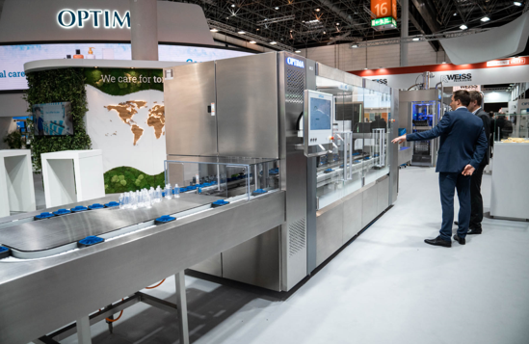
The OPTIMA Moduline Smart, an innovative filling and closing machine for cosmetics, was among the highlights at the Optima booth at Interpack 2023. The flexible system impresses with minimal footprint, quick delivery times and a visually appealing design. (Source: Optima)

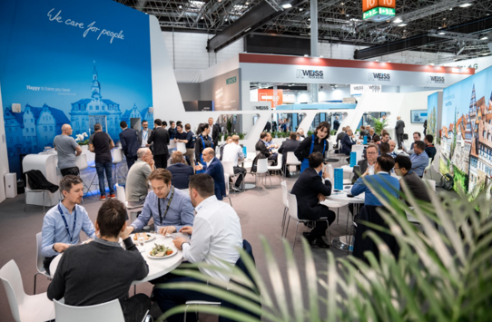Visitors and Optima employees alike were delighted to have the opportunity to discuss upcoming packaging projects in person once again. (Source: Optima)

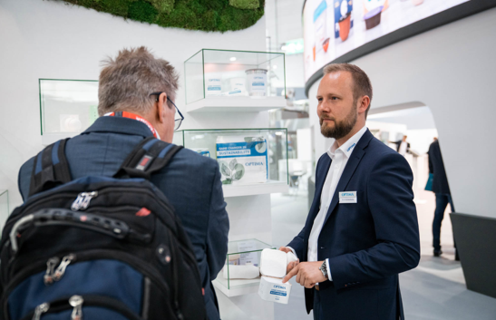
The sustainability field attracted large visitor numbers. In addition to a sustainable travel kit, an environmentally-friendly can portfolio was presented. (Source: Optima)

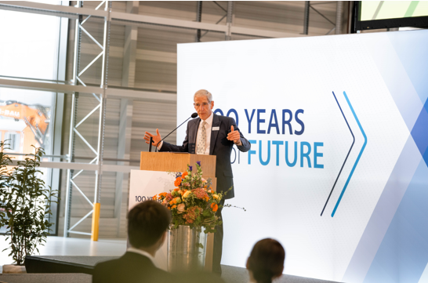
A particular highlight for Optima and CEO Hans Bühler was the 100-year anniversary celebration on May 5, 2022 with Baden-Wuerttemberg’s Minister-President Winfried Kretschmann. (Source: Optima)

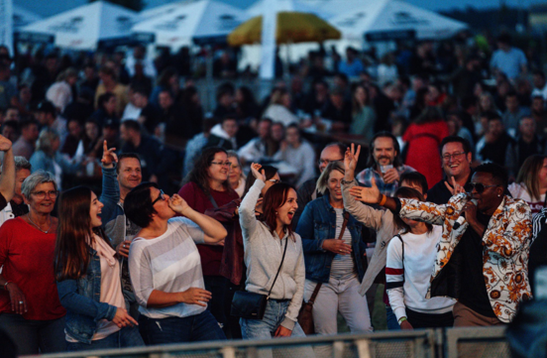
As part of the festivities to mark the anniversary, Optima organized a family day with an open-air concert for employees and their families in July 2022. (Source: Optima)

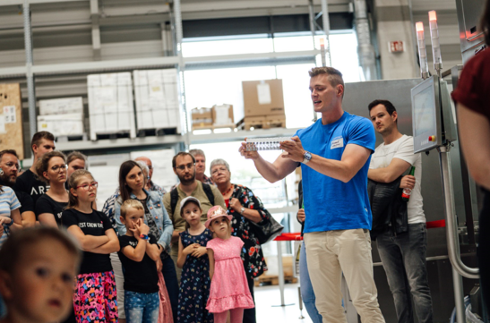
The smallest members of the Optima family were also well catered for. From an insight into the technologies of the machine builder, through to sports presentations and bouncy castles. (Source: Optima)

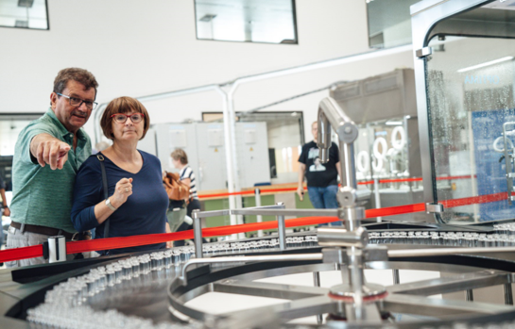
Employees showing loved ones what they do every day. That's the concept behind the Optima family day. (Source: Optima)

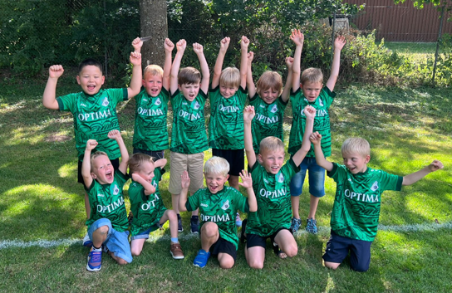
Optima raffled off 100 brand new jersey sets to sports teams in the Schwaebisch Hall and Hohenlohe regions to mark the 100-year anniversary. The donations were well received, as we can see. (Source: Optima)

Characters (including spaces): 8,451

Press contact:
OPTIMA packaging group GmbH
Jens Betsch
Group Leader Marketing
+49 (0)791 / 506-1478
pr-group@optima-packaging.com
www.optima-packaging.com

About OPTIMA
Optima supports companies worldwide with flexible and customer-specific filling and packaging machines for pharmaceuticals, consumer goods, paper hygiene and medical devices markets. As a provider of solutions and systems, Optima accompanies these companies from the product idea through to successful production and throughout the entire machine life cycle. Over 3,000 experts around the globe contribute to Optima's success. 20 locations in Germany and abroad ensure the worldwide availability of services.
Thank you very much for your publication. We look forward to receiving a digital specimen copy.

