PRESS RELEASE
Schwaebisch Hall, November 10, 2020

Expertise in paper and tissue
SENNING joins the OPTIMA group

Since October 2020, Senning GmbH has joined the Optima Group based in Schwaebisch Hall. The Bremen-based company specializes in the production and packaging of paper and tissue products.
Senning was formerly known as Christian Senning Verpackungsmaschinen GmbH & Co. KG, and in future it will be operating under the name Senning GmbH. "The production and packaging technology for paper tissues and napkins developed by Senning constitutes an ideal addition to our product portfolio," says Hans Buehler, the Managing Director/CEO of the Optima Group.

Optima has already successfully implemented machine projects for the paper and tissue sector. Through integration and associated synergy effects, Optima is strengthening its market position for turnkey solutions. Senning's new, revised organizational structure makes it well prepared to meet the demands and questions of its customers.

An experienced company with a worldwide presence

The medium-sized family business was founded by Christian Senning in Bremen in 1949, where it is still based to this day. Annette Bengs is the third generation of the family to head up the company as its Managing Director. Senning has over 70 years of experience in the construction of production and packaging machines for the paper and tissue industry, and has agents worldwide, making it a preferred partner for complex mechanical engineering projects. The company sells over 85 percent of its equipment to foreign countries.

In collaboration with its new colleagues, Optima offers integrated packaging systems from a single source. "We are excited about the company expansion, and look forward to working on joint projects," says Buehler.

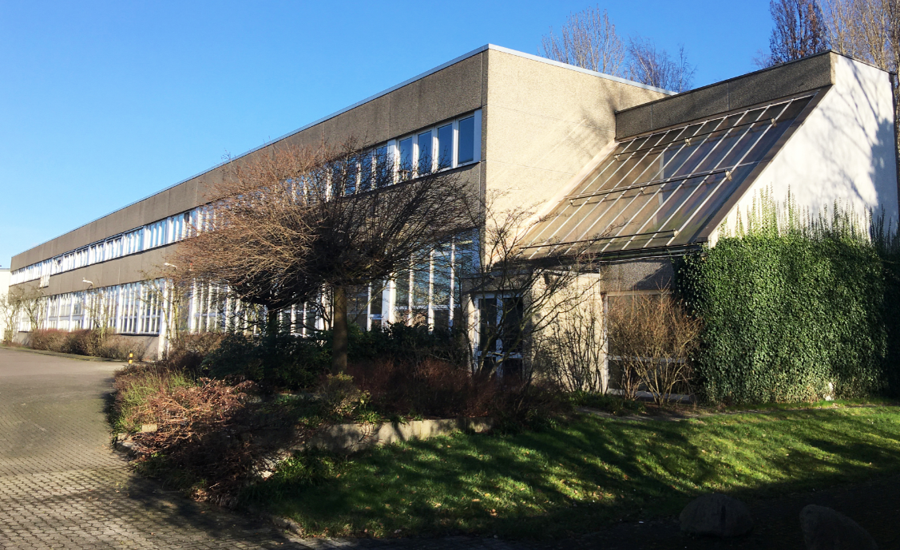
Bremen-based Senning belongs to the Optima Group since October 2020. (Source: Optima)

Characters (incl. spaces): 1,734

Press contact:
OPTIMA packaging group GmbH
Jan Deininger
Group Communications Manager
+49 (0)791 / 506-1472
jan.deininger@optima-packaging.com
www.optima-packaging.com

About OPTIMA
Optima supports companies worldwide with flexible and customer-specific filling and packaging machines for pharmaceuticals, consumer goods, paper hygiene and medical devices markets. As a provider of solutions and systems, Optima accompanies these companies from the product idea through to successful production and throughout the entire machine life cycle. 2,450 experts around the globe contribute to Optima's success. 19 locations in Germany and abroad ensure the worldwide availability of services.

Thank you very much for your publication. We look forward to receiving a specimen copy.

