## LAUDA supports young scientists at the University of Würzburg

### Commitment to ‘Deutschlandstipendium’ underlines social responsibility

Lauda-Königshofen, February 12, 2025 – LAUDA DR. R. WOBSER GMBH & CO. KG is supporting the ‘Deutschlandstipendium’ (German public-private scholarship) program of the Julius-Maximilian-University Würzburg (JMU) for the second time. At the scholarship award ceremony in the historic Toscana Hall of the Würzburg Residence, the students were honored for their outstanding academic achievements and social commitment.

The ‘Deutschlandstipendium’ opens up educational opportunities for high-achieving students of all nationalities, regardless of their social background. In addition to particular success at school and university, the selection criteria also include social commitment and a willingness to take on responsibility. The monthly grant of 300 euros is funded in equal parts by private sponsors such as LAUDA and the Federal Ministry of Education and Research.

“As the global market leader in the field of precise temperature control, LAUDA is aware of its social responsibility,” emphasizes Dr. Gunther Wobser, President & CEO of LAUDA. “It is particularly important to us to reward highly talented students for their outstanding studies and social commitment. The ‘Deutschlandstipendium’ scholarship enables them to concentrate fully on their studies.”

Julius-Maximilian-University Würzburg, where 14 Nobel Prize winners have already taught, has been supporting young talents with the ‘Deutschlandstipendium’ since 2011. In the 2023/24 funding year, 45 students were supported – and the trend is rising. Nationwide, around 30,000 students benefit from the support of more than 9,000 private donors. For the current academic year 2024/25, LAUDA was able to support three outstanding female students as one of the scholarship donors: Dr. Wobser personally congratulated the scholarship holders Vera Schuhmann, Kira Diemer and Eva Viktoria Münzel on their outstanding academic successes during the scholarship award ceremony.

“As a family business, we have been working towards a better future with technical innovations for almost 70 years,” explains Dr. Wobser. “Supporting the ‘Deutschlandstipendium’ is part of the ongoing commitment of LAUDA to progress and innovation in science. We will continue to support talented students from the University of Würzburg in the coming years and invite them to join our company.”

The festive setting for the award ceremony included performances by a string quartet and words of welcome from Prof. Dr. Doris Fischer, Vice President for Internationalization and Alumni at JMU, and other representatives from business and society.

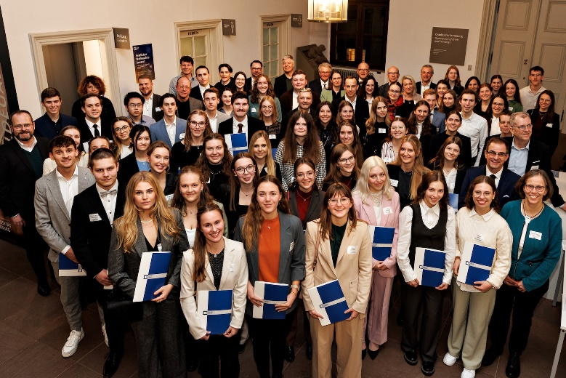

**Picture 1:** Group photo of the sponsors with all scholarship holders of the ‘Deutschlandstipendium’ 2024/2025 of Julius-Maximilian-University Würzburg. © Andreas Grasser

**Ein Bild, das Kleidung, Person, Lächeln, Menschliches Gesicht enthält.
**

**Picture 2:** Dr. Gunther Wobser, President & CEO of LAUDA (2nd from left), with the scholarship holders (from left to right) Vera Schuhmann, Kira Diemer and Eva Viktoria Münzel at the award ceremony for the German scholarships in the Würzburg Residence. © Andreas Grasser

**We are LAUDA** –the world leader in precise temperature control. Our constant temperature equipment and systems are at the heart of important applications, contributing to a better future. As a complete one-stop supplier, we guarantee the optimum temperature in research, production and quality control. We are the reliable partner for electromobility, hydrogen, chemicals, pharmaceuticals/biotech, semiconductors and medical technology. We have been inspiring our customers for almost 70 years with our expert mentoring and innovative solutions – every day anew and all over the world.

In our company, we always go one step further. We support our employees’ development and are constantly developing ourselves: to create a better future together.

**Press contact**

We are more than happy to make prepared information about our company, the LAUDA Factory Gallery and our projects in the area of innovation promotion, digitalization and idea management available to the press. We look forward to hearing from you – just give us a call!

CHRISTOPH MUHR

Director Corporate Communications

T + 49 (0) 9343 503-349

[christoph.muhr@lauda.de](mailto:christoph.muhr@lauda.de)

LAUDA DR. R. WOBSER GMBH & CO. KG, Laudaplatz 1, 97922 Lauda-Königshofen, Deutschland/Germany. Limited partnership: Headquarters Lauda-Königshofen, Registration court Mannheim HRA 560069. General partner: LAUDA DR. R. WOBSER Verwaltungs-GmbH, Headquarters Lauda-Königshofen, Registration court Mannheim HRB 560226. Managing Directors: Dr. Gunther Wobser (President & CEO), Dr. Mario Englert (CFO), Dr. Marc Stricker (COO)