GEA AWP optimizes the ValveCalc sizing software

Düsseldorf, October 13, 2026 – GEA AWP is expanding and optimizing its sizing software for industrial refrigeration and heating applications. The new ValveCalc P&ID planning module integrated into ValveCalc now shows how generators, vessels, valves, and other piping components are connected within an industrial facility, the performance they deliver individually and collectively, and their impact on the overall system. Linking the visual representation with integrated calculations adds significant value to piping and instrumentation diagrams (P&IDs). During the design phase, these diagrams now provide a substantially improved data foundation for developing, engineering, and modifying all the processes they depict visually.
No more separate programs
Until now, plant schematics and technical sizing have often been created in separate programs: the schematic is drawn in a CAD application, while piping and components are sized in parallel in ValveCalc. As a result, changes must be tracked in two working environments. ValveCalc P&ID brings both steps together. Pipes, valves, and loads carry their technical data directly in the schematic; changes to the sizing are immediately visible in the drawing.

From the building model to the calculated system
The workflow begins by placing components such as compressors, valves, heat exchangers, and other components via drag and drop and connecting them with piping. The required technical data is stored for the line type, pipe material, refrigerant, and loads. Based on this information, ValveCalc performs the sizing and displays the bill of materials and part numbers at the touch of a button. For better visualization and clarity, ValveCalc P&ID makes it possible to group components in their designated rooms and display everything on standardized drawings of the rooms in a building.

Drawing editor and component library in a single interface
The drawing, properties, and results are available in a single window. The drawing editor is launched directly from ValveCalc using a dedicated tile. The component library includes valves, actuators, compressors, evaporators, separators, air coolers, and connection types, among other items. It comes with a symbol library based on DIN EN 1861 (121 symbols) and a refrigeration P&ID library (57 symbols); sizing supports ammonia, CO₂, and HFC systems.
In addition to the AWP components already integrated, users can create missing components themselves in the component editor. Custom designs can be created with a symbol, connections, and the characteristic values required for calculation, then saved and shared with the team as a library file. This allows the software to represent both standardized components and project-specific solutions.

Automatic flow path detection and immediate calculation
ValveCalc reads the drawn system as a network. From the components, pipes, and transfer points, the module identifies the refrigerant flow path; suction, hot-gas, liquid, and wet-return lines are distinguished and color-coded. After the capacities at the loads and the operating parameters are entered (refrigerant, evaporating and condensing temperatures, superheat, and circulation ratio for pumped circulation), the software automatically calculates mass flow, pressure drop, and velocity in each pipe section.
Simple and fast calculation
For example, if a nominal pipe size is changed, the software updates the result immediately while the drawing remains open. Missing information and implausible values are identified rather than hidden. This supports transparent, traceable sizing and makes it easier to review the system design.

From the schematic to the bill of materials
The P&ID module summarizes components, fittings, and the pipe lengths entered for each line by nominal size. The integrated GEA valve catalog provides series, connection type, and part number information. Bills of materials can then be exported as CSV or Excel files for further processing. Integration with catalogs from other manufacturers is planned for the near future.

A consistent data foundation for planning and modifications
By linking the schematic, sizing, and documentation, ValveCalc P&ID reduces breaks in the engineering data flow. Changes no longer need to be maintained in parallel across separate applications. Planners gain a consistent data foundation that supports the construction of new systems, the modification of existing systems, and troubleshooting during operation.
Integration of global refrigeration planning, engineering, and consulting companies
The ability to incorporate services from global refrigeration planning, engineering, and consulting companies offers ValveCalc P&ID users the future advantage of having existing projects externally reviewed or optimized. Project files can be transferred directly from the software with just a few clicks. This interconnected platform will establish an efficient, technically standardized, and globally innovative collaboration process.

Further information: https://awpvalves.com/valvecalc/

Screenshot:

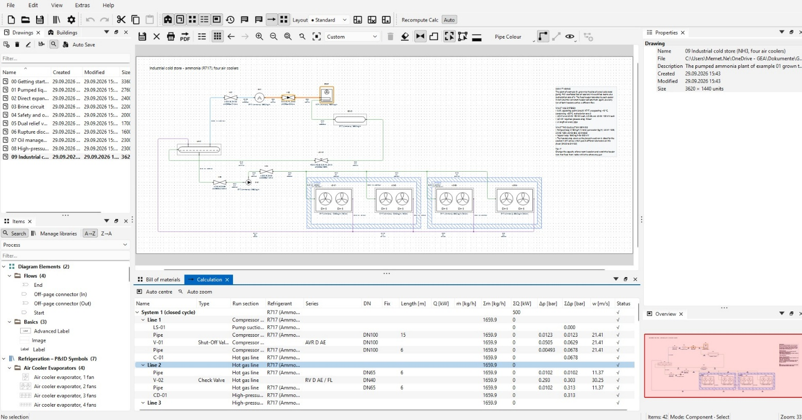

Screenshot: GEA AWP is expanding and optimizing its sizing software for industrial refrigeration and heating applications. (Screenshot: GEA AWP)

NOTES TO EDITORS
- Further information about GEA
- To the GEA Media Library
- Features on current topics
- Overview press events
- Follow GEA on  

About GEA
GEA is one of the world’s largest suppliers of systems and components to the food, beverage and pharmaceutical industries. The international technology group, founded in 1881, focuses on machinery and plants, as well as advanced process technology, components and comprehensive services. For instance, every second pharma separator for essential healthcare products such as vaccines or novel biopharmaceuticals is produced by GEA. In food, every fourth package of pasta or every third chicken nugget are processed with GEA technology.

With more than 18,000 employees, the group generated revenues of about EUR 5.5 billion in more than 150 countries in fiscal year 2025. GEA plants, processes, components and services enhance the efficiency and sustainability of customers’ production. They contribute significantly to the reduction of CO2 emissions, plastic usage and food waste. In doing so, GEA makes a key contribution toward a sustainable future, in line with the company’s purpose: “Engineering for a better world.”

GEA is listed on the DAX, the STOXX® Europe 600 Index and is also a constituent of the leading sustainability indices DAX 50 ESG, MSCI Global Sustainability and Dow Jones Best-in-Class World.

More information can be found online at gea.com.
If you do not want to receive any further information from GEA, please send an e-mail to pr@gea.com.

Media Relations
GEA Group Aktiengesellschaft
Dr. Michael Golek
Ulmenstraße 99, 40476 Düsseldorf
Telefon +4921191361505
michael.golek@gea.com

