Food processing technology

New GEA ProCoater offers food processors advanced wet coating quality and efficiency

Düsseldorf (Germany), October 19, 2026 – GEA is introducing the GEA ProCoater, a new wet coating machine developed to help food processors achieve more stable batter flow, more consistent coating pickup and higher line efficiency in the production of coated food products.

Precise and repeatable control of batter
Coated convenience foods remain a dynamic growth segment, driven by demand for crisp textures, visual appeal and new product formats such as plant-based and hybrid foods. At the same time, manufacturers must manage rising cost pressure, complex coating recipes, tighter quality requirements and limited access to skilled operators. The GEA ProCoater addresses these challenges at a critical process step by enabling precise, repeatable control of batter application for poultry, pork, fish, cheese, plant-based and hybrid products.

A key focus of the new system is batter stability. The ProCoater’s patent-pending guided return flow system reduces air entrainment and foam formation by up to 80 percent, creating a calmer batter flow and a more uniform curtain. This helps processors reduce defects such as voids and white spots, while maintaining coating performance over long production runs and across a wide range of batter viscosities.

Design features supporting process control
The machine combines this stable flow with practical process-control features for everyday production. Adjustable scrapers enable fine corrections during operation without stopping the line, while smart air knives deliver even blow-off across the full belt width to support accurate coating weight and uniform appearance. An optimized infeed transfer supports smooth product entry, and a patent-pending batter retention plate and an optional bottom batter layer supply device ensure full coating coverage on the product bottom side and keep products firmly positioned during coating to prevent floating or drifting.

For processors, the result is a controlled wet coating process from start-up to shut down. Consistent batter pickup helps reduce rework, B-grades and product giveaway, while efficient batter use improves yield and line cleanliness. The ProCoater is available for belt widths of 400, 600 and 1000 millimeters, allowing manufacturers to align the technology with different line layouts, capacities and product portfolios.

“With the GEA ProCoater, we focused on giving processors reliable control over one of the most quality-critical stages in coated food production,” says Ben Kop, Application Specialist at GEA. “By stabilizing batter flow and simplifying adjustment, the machine helps operators achieve consistent results with less intervention and greater confidence.”
GEA complements the new machine with application expertise, food technology support and access to Technology Centers for product testing, process validation and new product development under real production conditions. Together with GEA’s global service organization, this support helps customers optimize recipes and coating parameters, maintain equipment performance and reduce risk when scaling new coated food products.

gea.com

Picture Overview about 3 high-resolution pictures of GEA ProCoater

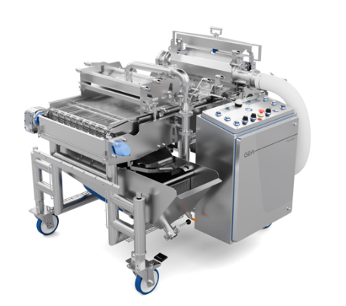
Pic. 1: The new GEA ProCoater is designed to deliver stable, consistent wet coating performance for food products including poultry, pork, fish, cheese, plant-based and hybrid applications. Source: GEA

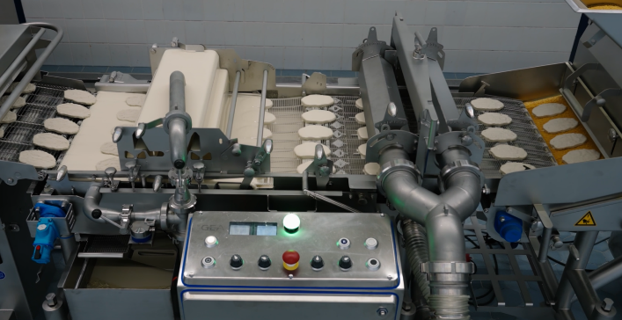

Pic. 2: The GEA ProCoater’s guided return flow system reduces air entrainment and foam formation by up to 80 percent for a calmer, more consistent batter flow. Source: GEA

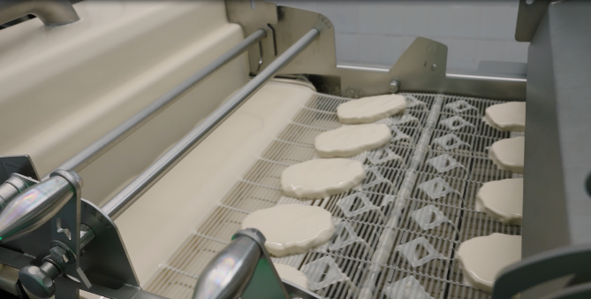
Pic. 3: Adjustable scrapers, smart air knives and an innovative batter retention plate help processors maintain coating accuracy with less operator intervention. Source: GEA

NOTES TO THE EDITORS
- Further information about GEA
- To the GEA Media Library
- Features on current topics
- Overview press events
- Follow GEA on  

Media Relations
GEA Group Aktiengesellschaft
Nicole Hoffmann
Ulmenstraße 99, 40476 Düsseldorf, Germany
Phone +49 211 9136-1503
nicole.hoffmann@gea.com

About GEA
GEA is one of the world’s largest suppliers of systems and components to the food, beverage and pharmaceutical industries. The international technology group, founded in 1881, focuses on machinery and plants, as well as advanced process technology, components and comprehensive services. For instance, every second pharma separator for essential healthcare products such as vaccines or novel biopharmaceuticals is produced by GEA. In food, every fourth package of pasta or every third chicken nugget are processed with GEA technology.

With more than 18,000 employees, the group generated revenues of about EUR 5.5 billion in more than 150 countries in fiscal year 2025. GEA plants, processes, components and services enhance the efficiency and sustainability of customers’ production. They contribute significantly to the reduction of CO2 emissions, plastic usage and food waste. In doing so, GEA makes a key contribution toward a sustainable future, in line with the company’s purpose: ”Engineering for a better world.”

GEA is listed on the DAX, the STOXX® Europe 600 Index and is also a constituent of the leading sustainability indices DAX 50 ESG, MSCI Global Sustainability and Dow Jones Best-in-Class World.

More information can be found online at gea.com.
If you do not want to receive any further information from GEA, please send an e-mail to pr@gea.com.

About the GEA Foundation
The GEA Foundation, established in 2025 by GEA Group, supports global and local projects in STEM education, child poverty reduction, infrastructure access and disaster relief. Through its Mission 30 strategy, GEA commits to donating one percent of annual net profit to build resilient communities.

More information can be found online at gea.com/foundation.

